Unit 1Foundations of Computing & Digital Logic.

[**Introduction To Computing**](https://k4y0x13.github.io/CSF101-Programming-Methodology/unit1/1.introduction-to-computing.html#introduction-to-computing)

The word **computer** derives from the word **compute** which means to calculate. The history of computers which are devices used to calculate and do simple arithmetic operation dates all the way back to ancient China where **abacus** was used to perform basic mathematical operations fast and efficicently. They were also often used to store the results of such operations.

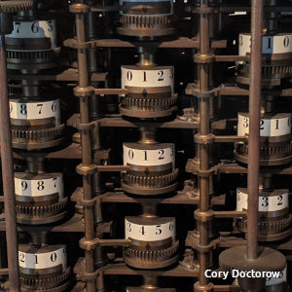

*A model of one of the world's first computers (the Difference Engine invented by Charles Babbage) at the Computer History Museum in Mountain View, California, USA*

[**History**](https://k4y0x13.github.io/CSF101-Programming-Methodology/unit1/1.introduction-to-computing.html#history)

While the evolutionary journey of computing is fascinating, its concerns lie beyond the scope of the syllabus, but feel free to read more about it [here](https://www.cs.uah.edu/~rcoleman/Common/History/History.html). What cocnerns us most now is the invention of Mark I in 1944 by Dr. Howard Aiken and Grace Hopper. This is said to be a crucial landmark for the world of computing as Mark I was considered to be worlds first electormechanical computer capable of making logical decisions.

[**Today**](https://k4y0x13.github.io/CSF101-Programming-Methodology/unit1/1.introduction-to-computing.html#today)

Our second point of concern is invention of transistors in 1948 at Bell Labs which forever changed the course of computers and modern day electronics. Ever since these signifcant milestones, computers have become smaller and faster as described by the [Moores Law](https://www.wallstreetmojo.com/moores-law/).Today, we use hand held devices with the computing power which is atleast 100,000 times more than what was used to send the [Apollo 11 mission to the moon](https://sellmycisco.co.uk/smartphone-vs-apollo-program-a-fascinating-comparison/).

[**Tomorrow**](https://k4y0x13.github.io/CSF101-Programming-Methodology/unit1/1.introduction-to-computing.html#tomorrow)

But what is in store for us tomorrow? With the growth of AI industry and improvements in GPU compute, we are pushing the limits of computing as well as data to an unimaginable scale. With the potential of [quantum computers](https://aws.amazon.com/what-is/quantum-computing/) still in the horizon the future of computers sure is promising. I hope that throughout the course of this module, we are able to give you a good feel of what computers are, what they are capable of and how you can use them to your advantage for years to come.

*Note: Dont be concerned if the terms and concepts discussed in these articles seem concerning, we will discuss the key concepts in class.*

[**Information Representation**](https://k4y0x13.github.io/CSF101-Programming-Methodology/unit1/2.information-representation.html#information-representation)

An over simplified definition of a computer would be a device that can recieve input, process this input to do some computation, store necesarry data, and retrieve this data to present an output when needed. We will discuss more about various parts of a computer and their unqiue functions in the later part of the chapter, but for now we, will take a bottom-up approach of learning the fundamental components that makes up a computer.

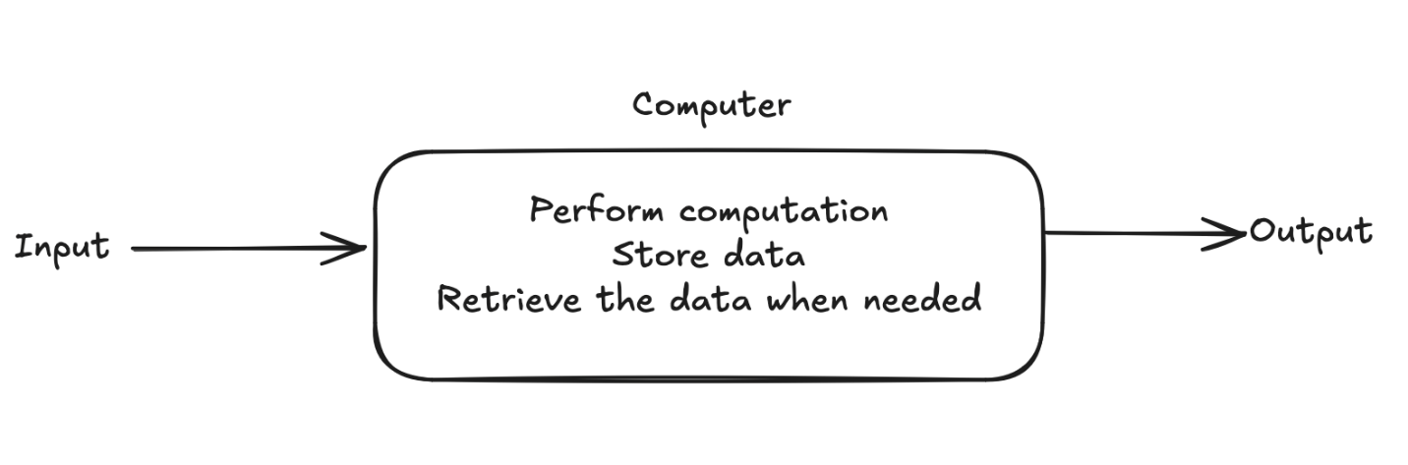

For this topic, we are to understand the following key concepts:

* How does a computer store data?
* Where does a computer store data?
* What format does a computer store data in?
* How does a computer perform basic airthmetic operations with this stored information?

[**1.2.1 Bits and Binary numbers.**](https://k4y0x13.github.io/CSF101-Programming-Methodology/unit1/2.information-representation.html#121-bits-and-binary-numbers)

Computers are made up of millions of small electronic devices. These devices are responsible for representing information, performing calculations and storing information and while these functions seem distinctly different from each other, the parts that perform these functions are all made up of the same fundamental electronic components in different configurations.

[**Bits**](https://k4y0x13.github.io/CSF101-Programming-Methodology/unit1/2.information-representation.html#bits)

Imagine a light bulb that is connected to a single switch. When the switch is turned on the bulb lights up and when it is turned off the bulb turns off. A lightbulb in this case can represent two states of either being on or off. We can then go ahead and label the off state of a light bulb to be 0 and the on state to be 1. A bulb can only have two possible states in this analogy and we can proceed to describe the nature of states of a light bulb to be binary.

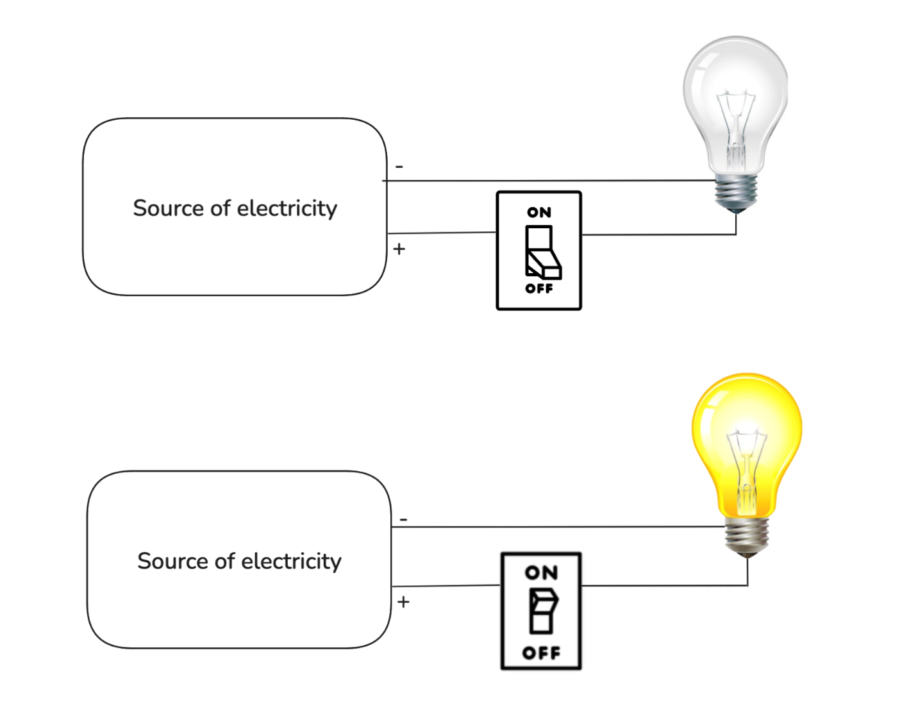

Similar to this imaginary light bulb, computer are made up of millions of parts that function similar to the aforementioned switches, where a *bit* may represent 0 or 1. Note that one bit can represent only two states, however if two bits are placed side by the side, they can represent 4 states in combination as shown in the graphic below.

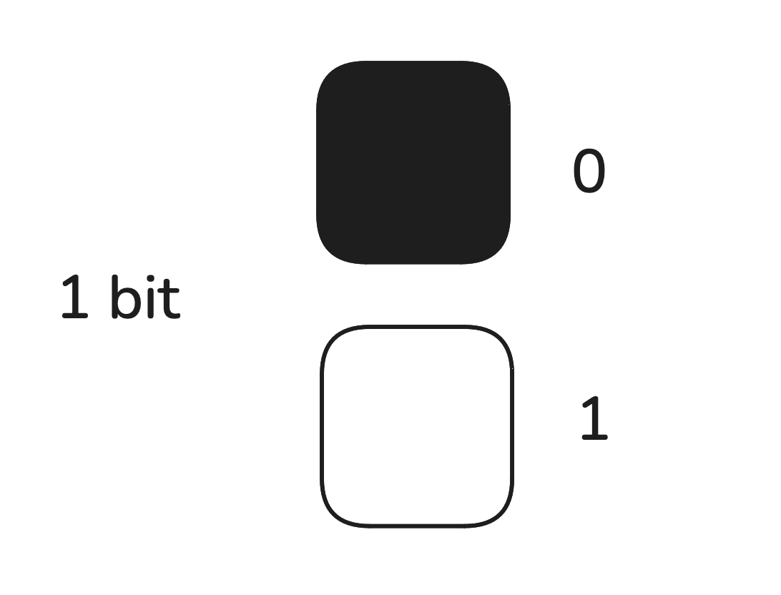

*Fig: one bit represents two states*

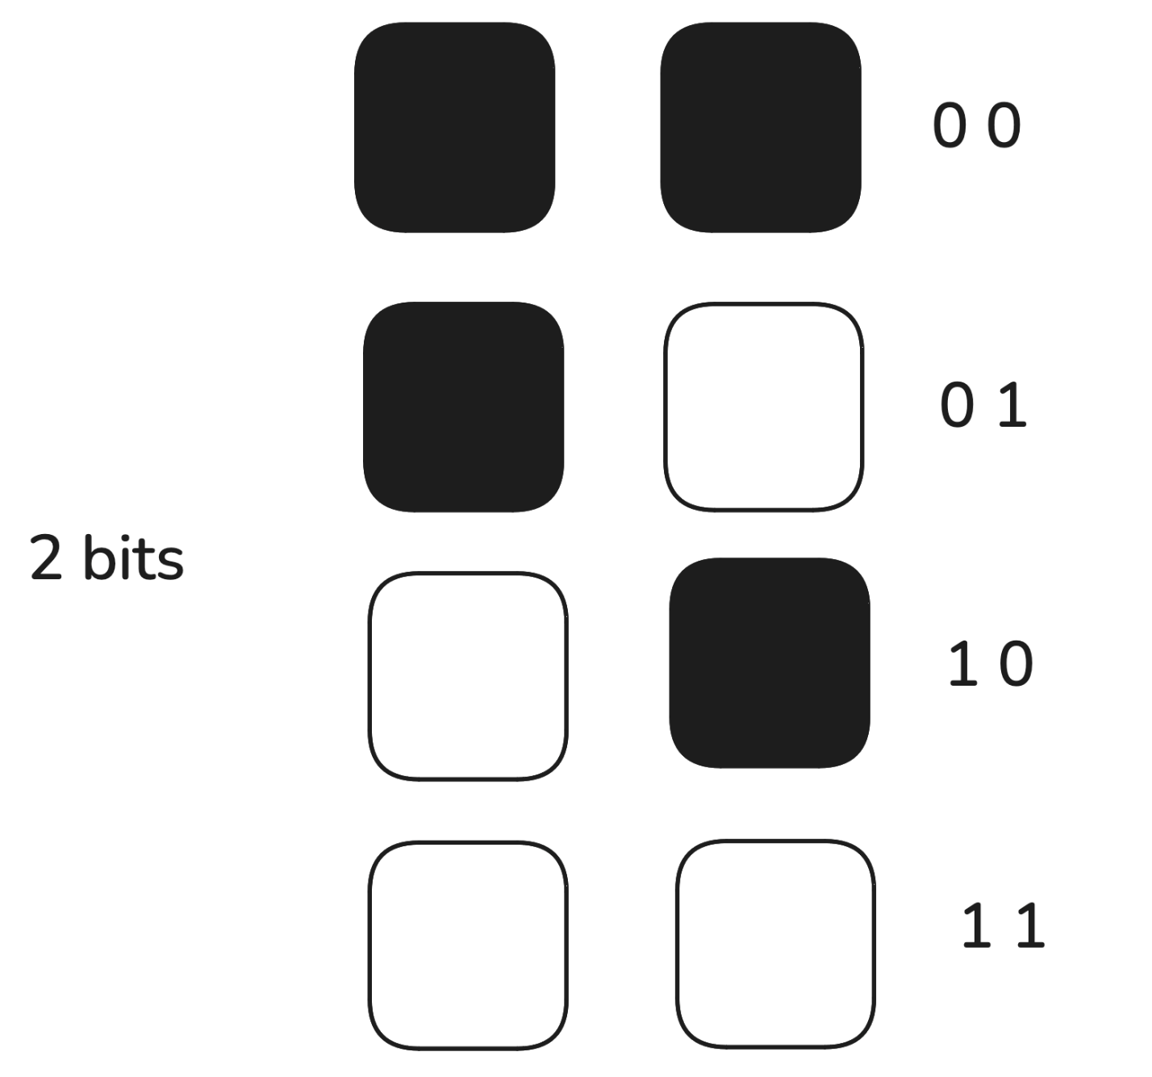

*Fig: two bits represents four states*

Similarly many bits can be used to represent many states, note that if the number of bits used is equal to n, the total number of states a combination of n bits can represent can be calculcated as 2n(where n>=1 and cannot be 0, negative or a fraction).

[**Binary Number System**](https://k4y0x13.github.io/CSF101-Programming-Methodology/unit1/2.information-representation.html#binary-number-system)

This positional number system which represents numbers using 0's and 1's is known as the binary number system.The following table highlights number of bits and its relation to number of states the bits can represent:

| **No of bits** | **No of States** |
| --- | --- |
| 1 | 2 |
| 2 | 4 |
| 3 | 8 |
| 4 | 16 |
| 5 | 32 |
| 6 | 64 |
| 7 | 128 |
| 8 | 256 |

[**Storage**](https://k4y0x13.github.io/CSF101-Programming-Methodology/unit1/2.information-representation.html#storage)

In practise, when storing information the term byte is often used which represents a total of 256 states (23) which can be represented by a combination of 8 bits. Meaning 1 byte consists of 256 possible states and one byte of information represets one such state, Similarly other units of measurements are as stated in the table below:

| **Units of measurement** | **Experession in powers of 2** |
| --- | --- |
| Byte | 23 |
| Kibibyte(KiB) | 210 |
| Mebibyte(MiB) | 220 |
| Gigibyte(GiB) | 230 |
| Tebibyte(TiB) | 240 |
| Pebibyte(PiB) | 250 |

There is a variation in how size of data is representation in terms of binary and decimal number systems. For marketing and generic purposes, the terms such as Kilobytes, Megabytes and Gigabytes are used more often. You can read more about his in the official [IBM article here](https://www.ibm.com/docs/en/storage-insights?topic=overview-units-measurement-storage-data).

[**1.2.2 Binary, Octal, and Hexadecimal, Number systems**](https://k4y0x13.github.io/CSF101-Programming-Methodology/unit1/2.information-representation.html#122-binary-octal-and-hexadecimal-number-systems)

A number can be represented with different base values. We are familiar with the numbers in the base 10 (known as decimal numbers), with digits taking values 0,1,2,…,8,9

A computer uses a Binary number system which has a base 2 and digits can have only TWO values: 0 and 1.

A decimal number with a few digits can be expressed in binary form using a large number of digits. Thus the number 65 can be expressed in binary form as 1000001.

The binary form can be expressed more compactly by grouping 3 binary digits together to form an octal number. An octal number with base 8 makes use of the EIGHT digits 0,1,2,3,4,5,6 and 7

A more compact representation is used by Hexadecimal representation which groups 4 binary digits together. It can make use of 16 digits, but since we have only 10 digits, the remaining 6 digits are made up of first 6 letters of the alphabet. Thus the hexadecimal base uses 0,1,2,….8,9,A,B,C,D,E,F as digits.

The table below shows how different number represents different number: | Decimal | Binary | Octal | Hexadecimal | |---------|--------|-------|-------------| | 0 | 0000 | 0 | 0 | | 1 | 0001 | 1 | 1 | | 2 | 0010 | 2 | 2 | | 3 | 0011 | 3 | 3 | | 4 | 0100 | 4 | 4 | | 5 | 0101 | 5 | 5 | | 6 | 0110 | 6 | 6 | | 7 | 0111 | 7 | 7 | | 8 | 1000 | 10 | 8 | | 9 | 1001 | 11 | 9 | | 10 | 1010 | 12 | A | | 11 | 1011 | 13 | B | | 12 | 1100 | 14 | C | | 13 | 1101 | 15 | D | | 14 | 1110 | 16 | E | | 15 | 1111 | 17 | F |

[**1.2.2 Twos complement representation**](https://k4y0x13.github.io/CSF101-Programming-Methodology/unit1/2.information-representation.html#122-twos-complement-representation)

The twos complement method is a common way to represent signed integers in computers. It is also often used to simplify binary operations as its used to represent negative numbers in binary. The steps for twos complement method are as follows:

* Step 1: Start with the absolute binary representation of a number
* Step 2: Ivert all bits (change 0's to 1s and vice vaersa)
* Step 3: Add 1 to this representation

The way twos complement method can be used to represent negative integers as explained in this [handout](https://www.rit.edu/academicsuccesscenter/sites/rit.edu.academicsuccesscenter/files/documents/math-handouts/DM3_TwosComplement_BP_9_22_14.pdf).

[**1.2.3 Binary operations**](https://k4y0x13.github.io/CSF101-Programming-Methodology/unit1/2.information-representation.html#123-binary-operations)

Similar to how we perform arithmetic operations such as addition and subtraction in decimal number system, we can do the same for binary numbers. For binary addition, the binary representation of both the numbers are to be placed in a cascade such that both binary representations have equal number of digits. Once this is done the digits can be compared from the position of least significant bit(right most) with the following rules:

* Rule 1: 0 + 0 = 0
* Rule 2: 0 + 0 = 1
* Rule 3: 1 + 0 = 1
* Rule 4: 1 + 1 = 0 (carry)

Similarly for binary subtraction:

* Rule 1: 0 - 0 = 0
* Rule 2: 1 - 0 = 1
* Rule 3: 0 - 1 = 1 (borrow)
* Rule 4: 1 - 1 = 0

Note that multiplication and division are just repeated addition and subtraction respectively. Examples of binary addition and subtraction operations are available in the following [video](https://www.youtube.com/watch?v=C5EkxfNEMjE).

While the above mentioned rules for binary subtraction is applicable, computers compute differences using the two's complements method. Therefore for binary subtraction using the two's complement method:

* Step 1: take the binary representation of two numbers to be subtracted.
* Step 2: identify the two's complement representation of the subtrahend
* Step 3: add the binary representation of the initial number to the two's complement representation of the subtrahend.
* Step 4: discard the most signifcant bit of the solution

[**Essential resources:**](https://k4y0x13.github.io/CSF101-Programming-Methodology/unit1/2.information-representation.html#essential-resources)

1. Half adders and full adder : [LINK](https://www.youtube.com/watch?v=ecn-8iGDRSo)
2. Binary adder implementation using full adders : [LINK](https://www.youtube.com/watch?v=3jtS-8ZF_CA&lc=Ugh-DDSOaF9szHgCoAEC)
3. Binary subtractor implementation using full adders : [LINK](https://www.youtube.com/watch?v=pD-pjBupkFg&t=20s)

[**Additional Resources**](https://k4y0x13.github.io/CSF101-Programming-Methodology/unit1/2.information-representation.html#additional-resources)

1. Binary multiplier circuits : [LINK](https://www.youtube.com/watch?v=U-RnKGMJx_0)
2. How a computer memory works : [LINK](https://youtu.be/p3q5zWCw8J4?si=AVevfn4nH8Hyc3iY)

[**Character Encoding**](https://k4y0x13.github.io/CSF101-Programming-Methodology/unit1/3.character-encoding.html#character-encoding)

[**1.3.1 The ASCII standard**](https://k4y0x13.github.io/CSF101-Programming-Methodology/unit1/3.character-encoding.html#131-the-ascii-standard)

With the understanding of binary and how it can be used to represent many states in combination, it is now important to understand how binary represents different characters in a computer. We can group characters into three main groups i.e. alphabetic characters (a z and A to Z), numeric characters (0-9) and special characters ($,%,#,@ etc).

ASCII is an international standard which stands for American Standard Code for Information Interchange, which is a character encoding standard for almost all ectronic communication. The chart below provides a visualization of how these characters are represented in binary and what is the equivalent decimal representation for each unique character.

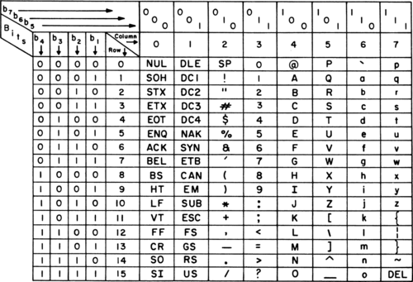

*ASCII chart (1972)*

The standard ASCII characters which adds up to 126 unique characters can be represented using [7 bits](https://www.intel.com/content/dam/www/program/education/us/en/documents/the-journery-inside/digital/tji-digital-info-handout4.pdf). However an extended version of the ASCII table called the extended ASCII can represent up to 256 characters using 8 bits.

[**Excercise: Use the standard ASCII table to write your full name.**](https://k4y0x13.github.io/CSF101-Programming-Methodology/unit1/3.character-encoding.html#excercise-use-the-standard-ascii-table-to-write-your-full-name)

[**1.3.2 Unicode and UTF8 encoding**](https://k4y0x13.github.io/CSF101-Programming-Methodology/unit1/3.character-encoding.html#132-unicode-and-utf8-encoding)

While the ASCII table was enough to represent basic alphanumeric characters and few special characters, the computers today have to store other characters such as emojis and characters from different languages. This is not simple as there are many languages with different structures, some languages use alphabets, vowels, and consonants while some langauges use strokes and other form of expression to represent different characters.

Unicode is one such standard that tries to solve the problem of storing and representing different characters in a computer. While each character is mapped to a bit representation, unicode uses codepoints where different characters are mapped to uniique hexadecimal digita. This representation is made as U+XXXX where U+ means unicode and the XXXX represents hexadecimal numbers.

The UTF-8 encoding scheme was later developed to ensure that no extra bit space is consumed while representing characters. UTF-8 representation of characters for english is very similar to that of the ASCII table where it only uses one byte(8 bits) or two hexadecimals to represent characters. However, however for more than 127 characters, several bytes are used to represent the characters. You can read more about this in the following articles and official documentation:

1. [Unicode](https://aac.unicode.org/)
2. [UTF-8](https://blog.hubspot.com/website/what-is-utf-8)
3. [General overview of character encoding](https://www.joelonsoftware.com/2003/10/08/the-absolute-minimum-every-software-developer-absolutely-positively-must-know-about-unicode-and-character-sets-no-excuses/)

[**1.4 Boolean logic and Logic gates**](https://k4y0x13.github.io/CSF101-Programming-Methodology/unit1/4.boolean-logic-and-logic-gates.html#14-boolean-logic-and-logic-gates)

[**1.4.1 Basic logic gates**](https://k4y0x13.github.io/CSF101-Programming-Methodology/unit1/4.boolean-logic-and-logic-gates.html#141-basic-logic-gates)

The expression of values in binary which uses 0's and 1's can also be used to experess simple logic such as true or false. Computers first used the binary number system as there was an entire branch of mathematics that dealt with representaition and manipulation of true and falase values known as the boolean algebra. The mathematical analysis of logic book written by George Boole in 1847 states that boolean algebra allows for truth to be systematically and formallly proven through logic equations.

There are three fundamental operations used in boolean algebra known as the AND, OR and the NOT operation. Note that these operations were later simulated into electrical components using transistors and are called logic gates which follow their respective properties as expressed in boolean algebra. A detailed video on this concept can be found [here](https://www.youtube.com/watch?v=gI-qXk7XojA&t=335s).

Transistors are electrically controlled switches whereby, when an adequate amount of electricity flows through one of the input electrode(base), the transistors allows electricity to flow through the other two electrodes(collector to emitter) as shown in the graphic below.

*A simple transistor*

We can represent various logic gates using truth tables. The AND and OR gates can be represented as shown below:

*Truth tables for AND and OR gates*

A NOT gate takes in one input and flips it to its reverse state therefore its truth table is as shown below:

*NOT gate*

[**1.2.2 Composite logic gate**](https://k4y0x13.github.io/CSF101-Programming-Methodology/unit1/4.boolean-logic-and-logic-gates.html#122-composite-logic-gate)

There are other logic gates that prove to be very useful in computers when applying more complex computations. One such example is use of logic gates to perform binary addition and subtraction. The NAND gate in particular is very important as it is also often termed as the universal gate as it can be used to constructure AND, OR and NOT gates when placed in a certain configuration.

Similarly the XOR gate is important as it is used for arithmetic computation. This can be observed in the networking module where XOR logic is used to do error checking and binary addition. There truth tables and symbols are as follows:

[**1.5 Introduction to computer architecutre**](https://k4y0x13.github.io/CSF101-Programming-Methodology/unit1/5.Introduction-to-computer-architecture.html#15-introduction-to-computer-architecutre)

Over the course of many generations in advancement of computers and technology, there has been various improvements with regard to different parts of a computer. A brief history of these generation can be found in this [article](https://vardhaman.org/wp-content/uploads/2021/03/CO.pdf).

The modern day computers have very distinct parts with specialized functions. At a high level, a computer can be escribed using the following diagram:

*Block diagram of a computer*

[**Different parts of a computer and its functions**](https://k4y0x13.github.io/CSF101-Programming-Methodology/unit1/5.Introduction-to-computer-architecture.html#different-parts-of-a-computer-and-its-functions)

1. Central Processing Unit (CPU)

* Executes instructions and performs calculations
* Key components:
  + Control Unit: Manages and coordinates CPU operations
  + Arithmetic Logic Unit (ALU): Performs arithmetic and logical operations
  + Registers: Small, fast storage locations within the CPU

1. Memory

* A physical device that stores information temporarily or permanently.
* Provides quick access to data and instructions for the CPU, act as a speed buffer, serve as an active workspace, and hold temporary data
* The two main types include:
  + Random Access Memory (RAM):
    - Volatile memory used for temporary data storage
    - Faster access times compared to storage devices
  + Read-Only Memory (ROM):
    - Non-volatile memory containing essential instructions (e.g., BIOS)

1. Storage devices

* These devices stores data into devices such as drives or disks.
* Solid state drives (SSD) and Hard disk drives(HDD) are most commonly used.

1. Input/Output devices (I/O)

* Input: Keyboard, mouse, microphone, camera
* Output: Monitor, speakers, printer

1. Bus systems

* Provides connection and enables communication between different parts of a computer
* Data Bus: Transfers data between components
* Address Bus: Carries memory addresses
* Control Bus: Carries control signal

[**The Fetch-Decode-Execute Cycle**](https://k4y0x13.github.io/CSF101-Programming-Methodology/unit1/5.Introduction-to-computer-architecture.html#the-fetch-decode-execute-cycle)

The fetch-decode-execute cycle (also known as the instruction cycle) is the basic operational process of a computer. It's the sequence of steps that the CPU follows to process each instruction in a program.

1. Fetch

* The CPU retrieves (fetches) an instruction from memory.
* This instruction is stored in a special register called the Instruction Register (IR).
* The Program Counter (PC) keeps track of which instruction to fetch next.

1. Decode

* The CPU interprets (decodes) the instruction.
* It figures out what operation needs to be performed.
* For example, it might be an addition, a memory access, or a jump to another part of the program.

1. Execute

* The CPU carries out (executes) the instruction.
* This might involve:
  + Performing a calculation
  + Moving data
  + Changing the sequence of instructions (in case of a jump)

[**1.5.1 Von Neumann Architecutre**](https://k4y0x13.github.io/CSF101-Programming-Methodology/unit1/5.Introduction-to-computer-architecture.html#151-von-neumann-architecutre)

Both Harvard and von Neumann architectures are fundamental designs for computer systems, each with its own approach to handling program instructions and data. Understanding these architectures helps in grasping how different computer systems implement the fetch-decode-execute cycle.

[**Key Characteristics:**](https://k4y0x13.github.io/CSF101-Programming-Methodology/unit1/5.Introduction-to-computer-architecture.html#key-characteristics)

* Single memory space for both data and instructions
* Uses a single bus for both data and instruction transfer

[**Fetch-Decode-Execute in von Neumann:**](https://k4y0x13.github.io/CSF101-Programming-Methodology/unit1/5.Introduction-to-computer-architecture.html#fetch-decode-execute-in-von-neumann)

* Fetch: Instructions and data are fetched from the same memory.
* Decode: The CPU decodes the instruction.
* Execute: The CPU executes the instruction, potentially accessing the same memory for data.

[**Advantages:**](https://k4y0x13.github.io/CSF101-Programming-Methodology/unit1/5.Introduction-to-computer-architecture.html#advantages)

* Simpler design
* Flexible use of memory (can allocate more space to either instructions or data as needed)

[**Disadvantages:**](https://k4y0x13.github.io/CSF101-Programming-Methodology/unit1/5.Introduction-to-computer-architecture.html#disadvantages)

* Potential bottleneck due to single bus (known as the von Neumann bottleneck)
* Instructions and data compete for memory access

[**1.5.2 Harvard Architecutre**](https://k4y0x13.github.io/CSF101-Programming-Methodology/unit1/5.Introduction-to-computer-architecture.html#152-harvard-architecutre)

[**Key Characteristics:**](https://k4y0x13.github.io/CSF101-Programming-Methodology/unit1/5.Introduction-to-computer-architecture.html#key-characteristics-1)

* Separate memory spaces for instructions and data
* Uses separate buses for instruction and data transfer

[**Fetch-Decode-Execute in Harvard:**](https://k4y0x13.github.io/CSF101-Programming-Methodology/unit1/5.Introduction-to-computer-architecture.html#fetch-decode-execute-in-harvard)

* Fetch: Instructions are fetched from instruction memory.
* Decode: The CPU decodes the instruction.
* Execute: The CPU executes the instruction, accessing data memory if needed.

[**Advantages:**](https://k4y0x13.github.io/CSF101-Programming-Methodology/unit1/5.Introduction-to-computer-architecture.html#advantages-1)

* Can fetch next instruction and access data simultaneously
* Potentially faster execution due to parallel access
* Better security (can make instruction memory read-only)

[**Disadvantages:**](https://k4y0x13.github.io/CSF101-Programming-Methodology/unit1/5.Introduction-to-computer-architecture.html#disadvantages-1)

* More complex design
* Fixed allocation of memory between instructions and data

[**Comparison in Context**](https://k4y0x13.github.io/CSF101-Programming-Methodology/unit1/5.Introduction-to-computer-architecture.html#comparison-in-context)

* Memory Access:
  + von Neumann: One memory access per cycle (either instruction or data)
  + Harvard: Can perform instruction fetch and data access in the same cycle
* Parallelism:
  + von Neumann: Limited by single bus
  + Harvard: Allows for more parallelism in instruction processing
* Impact on Fetch-Decode-Execute Cycle
  + von Neumann: The cycle may be slowed down when instruction fetch and data access compete for the same memory bus.
  + Harvard: The cycle can potentially be faster as instruction fetch doesn't compete with data access.

[**Modern Implementations:**](https://k4y0x13.github.io/CSF101-Programming-Methodology/unit1/5.Introduction-to-computer-architecture.html#modern-implementations)

Many modern CPUs use a modified Harvard architecture, with separate caches for instructions and data, but a unified main memory (like von Neumann)

Unit 2 Programming Fundamentals

[**Psuedocode**](https://k4y0x13.github.io/CSF101-Programming-Methodology/unit2/3.1-psuedocode.html#psuedocode)

[**1. Introduction to Pseudocode**](https://k4y0x13.github.io/CSF101-Programming-Methodology/unit2/3.1-psuedocode.html#1-introduction-to-pseudocode)

Pseudocode is a method of **describing algorithms** in a structured, readable format that is ***close to a programming language but is not tied to any specific language syntax***.

It allows algorithm designers to express ideas clearly without getting bogged down in language-specific details.

[**2. Key Principles of Pseudocode**](https://k4y0x13.github.io/CSF101-Programming-Methodology/unit2/3.1-psuedocode.html#2-key-principles-of-pseudocode)

[**2.1 Clarity and Readability**](https://k4y0x13.github.io/CSF101-Programming-Methodology/unit2/3.1-psuedocode.html#21-clarity-and-readability)

Pseudocode should be easy to read and understand, even for those not familiar with specific programming languages.

[**2.2 Precision**](https://k4y0x13.github.io/CSF101-Programming-Methodology/unit2/3.1-psuedocode.html#22-precision)

While not as strict as actual code, pseudocode should be precise enough to be translated into a programming language without ambiguity.

[**2.3 Abstraction**](https://k4y0x13.github.io/CSF101-Programming-Methodology/unit2/3.1-psuedocode.html#23-abstraction)

Pseudocode allows for a higher level of abstraction than actual code, focusing on the logic rather than implementation details.

[**3. Common Pseudocode Conventions**](https://k4y0x13.github.io/CSF101-Programming-Methodology/unit2/3.1-psuedocode.html#3-common-pseudocode-conventions)

[**3.1 Indentation**](https://k4y0x13.github.io/CSF101-Programming-Methodology/unit2/3.1-psuedocode.html#31-indentation)

Use indentation to show the structure and nesting of control structures.

[**3.2 Keywords**](https://k4y0x13.github.io/CSF101-Programming-Methodology/unit2/3.1-psuedocode.html#32-keywords)

Use keywords like IF, ELSE, WHILE, FOR, RETURN in **uppercase** for clarity.

[**3.3 Comments**](https://k4y0x13.github.io/CSF101-Programming-Methodology/unit2/3.1-psuedocode.html#33-comments)

Use // for single-line comments and /* */ for multi-line comments.

[**4. Basic Structures in Pseudocode**](https://k4y0x13.github.io/CSF101-Programming-Methodology/unit2/3.1-psuedocode.html#4-basic-structures-in-pseudocode)

[**4.1 Assignment**](https://k4y0x13.github.io/CSF101-Programming-Methodology/unit2/3.1-psuedocode.html#41-assignment)

x = 5

[**4.2 Input/Output**](https://k4y0x13.github.io/CSF101-Programming-Methodology/unit2/3.1-psuedocode.html#42-inputoutput)

READ x

PRINT "The value is:", x

[**4.3 Conditional Statements**](https://k4y0x13.github.io/CSF101-Programming-Methodology/unit2/3.1-psuedocode.html#43-conditional-statements)

IF condition THEN

statement1

statement2

ELSE

statement3

ENDIF

[**4.4 Loops**](https://k4y0x13.github.io/CSF101-Programming-Methodology/unit2/3.1-psuedocode.html#44-loops)

// While Loops

WHILE condition DO

statement1

statement2

ENDWHILE

// For Loops

FOR i = 1 TO n

// statements

ENDFOR

[**4.5 Functions**](https://k4y0x13.github.io/CSF101-Programming-Methodology/unit2/3.1-psuedocode.html#45-functions)

FUNCTION FunctionName(parameter1, parameter2)

// statements

RETURN value

ENDFUNCTION

[**5. Example Pseudocode Algorithms**](https://k4y0x13.github.io/CSF101-Programming-Methodology/unit2/3.1-psuedocode.html#5-example-pseudocode-algorithms)

[**5.1 Linear Search**](https://k4y0x13.github.io/CSF101-Programming-Methodology/unit2/3.1-psuedocode.html#51-linear-search)

ALGORITHM LinearSearch(A, n, x)

INPUT: An array A of n elements and a value x

OUTPUT: Index of x in A or -1 if not found

FOR i = 0 TO n - 1

IF A[i] = x THEN

RETURN i

ENDIF

ENDFOR

RETURN -1

[**5.2 Binary Search**](https://k4y0x13.github.io/CSF101-Programming-Methodology/unit2/3.1-psuedocode.html#52-binary-search)

ALGORITHM BinarySearch(A, n, x)

INPUT: A sorted array A of n elements and a value x

OUTPUT: Index of x in A or -1 if not found

left = 0

right = n - 1

WHILE left ≤ right DO

mid - ⌊(left + right) / 2⌋

IF A[mid] = x THEN

RETURN mid

ELSE IF A[mid] < x THEN

left = mid + 1

ELSE

right = mid - 1

ENDIF

ENDWHILE

RETURN -1

[**5.3 Insertion Sort**](https://k4y0x13.github.io/CSF101-Programming-Methodology/unit2/3.1-psuedocode.html#53-insertion-sort)

ALGORITHM InsertionSort(A, n)

INPUT: An array A of n elements

OUTPUT: A sorted in ascending order

FOR i = 1 TO n - 1

key = A[i]

j = i - 1

WHILE j ≥ 0 AND A[j] > key

A[j + 1] = A[j]

j = j - 1

ENDWHILE

A[j + 1] = key

ENDFOR

[**6. Advanced Pseudocode Techniques**](https://k4y0x13.github.io/CSF101-Programming-Methodology/unit2/3.1-psuedocode.html#6-advanced-pseudocode-techniques)

[**6.1 Recursive Algorithms**](https://k4y0x13.github.io/CSF101-Programming-Methodology/unit2/3.1-psuedocode.html#61-recursive-algorithms)

Example: Factorial calculation

FUNCTION Factorial(n)

IF n = 0 THEN

RETURN 1

ELSE

RETURN n * Factorial(n - 1)

ENDIF

[**7. Best Practices for Writing Pseudocode**](https://k4y0x13.github.io/CSF101-Programming-Methodology/unit2/3.1-psuedocode.html#7-best-practices-for-writing-pseudocode)

1. Be consistent in your style and notation.
2. Use meaningful variable and function names.
3. Include comments to explain complex logic.
4. Use appropriate levels of abstraction.
5. Revise and refine your pseudocode as you develop your algorithm.

**Remember, the goal of pseudocode is to communicate algorithmic ideas clearly and effectively.**

[**Flowcharts**](https://k4y0x13.github.io/CSF101-Programming-Methodology/unit2/3.2-flowcharts.html#flowcharts)

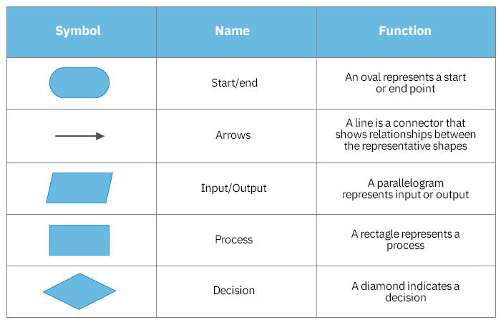

[**1. Introduction to Flowcharts**](https://k4y0x13.github.io/CSF101-Programming-Methodology/unit2/3.2-flowcharts.html#1-introduction-to-flowcharts)

Flowcharts are **graphical representations of algorithms**, workflows, or processes.

They use standardized symbols to illustrate the steps and decision points in a process, making it easier to visualize and understand complex procedures.

[**2. Key Principles of Flowcharts**](https://k4y0x13.github.io/CSF101-Programming-Methodology/unit2/3.2-flowcharts.html#2-key-principles-of-flowcharts)

[**2.1 Clarity and Readability**](https://k4y0x13.github.io/CSF101-Programming-Methodology/unit2/3.2-flowcharts.html#21-clarity-and-readability)

Flowcharts should be easy to follow and understand, even for those not familiar with the specific process being described.

[**2.2 Consistency**](https://k4y0x13.github.io/CSF101-Programming-Methodology/unit2/3.2-flowcharts.html#22-consistency)

Use standardized symbols and follow consistent conventions throughout the flowchart.

[**2.3 Simplicity**](https://k4y0x13.github.io/CSF101-Programming-Methodology/unit2/3.2-flowcharts.html#23-simplicity)

Break down complex processes into simpler steps, using sub-processes where necessary to maintain clarity.

[**3. Standard Flowchart Symbols and Their Meanings**](https://k4y0x13.github.io/CSF101-Programming-Methodology/unit2/3.2-flowcharts.html#3-standard-flowchart-symbols-and-their-meanings)

[**3.1 Oval (Terminal)**](https://k4y0x13.github.io/CSF101-Programming-Methodology/unit2/3.2-flowcharts.html#31-oval-terminal)

* Represents the start or end of a program or process.
* Typically contains "Start" or "End" text.
* Indicates the entry and exit points of a flowchart.

[**3.2 Arrow (Flow Line)**](https://k4y0x13.github.io/CSF101-Programming-Methodology/unit2/3.2-flowcharts.html#32-arrow-flow-line)

* Shows the direction of process flow.
* Connects different elements of the flowchart.
* Indicates the sequence of operations.

[**3.3 Parallelogram (Input/Output)**](https://k4y0x13.github.io/CSF101-Programming-Methodology/unit2/3.2-flowcharts.html#33-parallelogram-inputoutput)

* Represents input or output operations.
* Used for displaying data entry or results.
* Can indicate manual input, printed output, or displayed information.

[**3.4 Rectangle (Process)**](https://k4y0x13.github.io/CSF101-Programming-Methodology/unit2/3.2-flowcharts.html#34-rectangle-process)

* Represents a processing step or action.
* Indicates any operation where data is manipulated or changed.
* Can represent calculations, data transformations, or function calls.

[**3.5 Diamond (Decision)**](https://k4y0x13.github.io/CSF101-Programming-Methodology/unit2/3.2-flowcharts.html#35-diamond-decision)

* Represents a decision point or branching in the process.
* Contains a question or condition that can be answered with "Yes" or "No" (True or False).
* Has two outgoing arrows, typically labeled with the possible outcomes.

[**4. Tools for Creating Flowcharts**](https://k4y0x13.github.io/CSF101-Programming-Methodology/unit2/3.2-flowcharts.html#4-tools-for-creating-flowcharts)

Use any of the tools below to **create flowcharts for your assignments:**

* Exacalidraw
* FigJam
* Microsoft Visio
* Lucidchart
* Draw.io
* SmartDraw
* Creately

These tools provide templates and drag-and-drop interfaces for creating professional flowcharts.

[**Exercise**](https://k4y0x13.github.io/CSF101-Programming-Methodology/unit2/ex_3.1-2_flowcharts.html#exercise)

[**Create Flowcharts and Psuedocode for the following problems:**](https://k4y0x13.github.io/CSF101-Programming-Methodology/unit2/ex_3.1-2_flowcharts.html#create-flowcharts-and-psuedocode-for-the-following-problems)

**NOTE:**

* For terms and topics you do not understand: **Google** to understand what they are.
* Most of the terms are important computing terms/problems
* You need to practise Googling

[**Level 1**](https://k4y0x13.github.io/CSF101-Programming-Methodology/unit2/ex_3.1-2_flowcharts.html#level-1)

1. Calculate the area of a rectangle given its length and width.
2. Determine if a number is even or odd.
3. Find the largest of three given numbers.
4. Convert temperature from Celsius to Fahrenheit.
5. Calculate the sum of all numbers from 1 to n.
6. Check if a given year is a leap year.
7. Generate the first n terms of the Fibonacci sequence.
8. Calculate the factorial of a given number.
9. Determine if a given string is a palindrome.
10. Find the average of n numbers.
11. Convert a decimal number to binary.
12. Check if a number is prime.
13. Reverse a given string.
14. Calculate the compound interest for a given principal, rate, and time.
15. Find the GCD (Greatest Common Divisor) of two numbers.
16. Convert a given number of days to years, weeks, and days.
17. Generate a multiplication table for a given number.
18. Calculate the power of a number (x^n).
19. Find the smallest element in an array.
20. Determine if a triangle is equilateral, isosceles, or scalene given its sides.
21. Calculate the roots of a quadratic equation.
22. Convert a given number of seconds to hours, minutes, and seconds.
23. Find the number of vowels in a given string.
24. Calculate the perimeter of a circle given its radius.
25. Determine if a number is a perfect square.
26. Generate all prime numbers up to n.
27. Calculate the sum of digits of a given number.
28. Find the LCM (Least Common Multiple) of two numbers.
29. Check if a given number is a Armstrong number.
30. Calculate the simple interest for a given principal, rate, and time.

[**Level 2**](https://k4y0x13.github.io/CSF101-Programming-Methodology/unit2/ex_3.1-2_flowcharts.html#level-2)

1. Find the sum of all even numbers between 1 and n.
2. Calculate the area of a triangle given its base and height.
3. Determine if a number is positive, negative, or zero.
4. Convert a binary number to decimal.
5. Find the factors of a given number.
6. Calculate the volume of a cube given its side length.
7. Generate a sequence of n random numbers between 1 and 100.
8. Find the maximum and minimum values in an array.
9. Calculate the sum of squares of numbers from 1 to n.
10. Determine if a given character is a vowel or consonant.
11. Calculate the perimeter of a rectangle given its length and width.
12. Find the number of occurrences of a specific digit in a given number.
13. Generate a pattern of asterisks in the shape of a right-angled triangle.
14. Calculate the average of numbers in an array, excluding the largest and smallest values.
15. Determine if a given year is a century year.
16. Find the sum of all odd numbers between two given numbers.
17. Calculate the distance traveled given initial velocity, acceleration, and time.
18. Generate the first n terms of an arithmetic sequence given the first term and common difference.
19. Find the absolute difference between two numbers.
20. Calculate the area of a circle given its diameter.

[**Level 3**](https://k4y0x13.github.io/CSF101-Programming-Methodology/unit2/ex_3.1-2_flowcharts.html#level-3)

1. Implement a basic calculator that can handle multiple operations in one expression. (BEDMAS)
2. Find the second largest and second smallest elements in an array.
3. Check if a given password is strong based on criteria: length, inclusion of numbers, special characters.
4. Calculate the Body Mass Index (BMI) and categorize it (underweight, normal, overweight, obese).
5. Implement a basic Caesar cipher for encrypting and decrypting messages.
6. Find the most frequent element in an array.
7. Calculate the nth term of a geometric sequence.
8. Implement a simple game of rock-paper-scissors against the computer.
9. Convert a decimal number to its Roman numeral representation (up to 3999).
10. Calculate the area of a regular polygon given the number of sides and side length.

[**Variables & Data Types**](https://k4y0x13.github.io/CSF101-Programming-Methodology/unit2/4.variables-data-types.html#variables--data-types)

[**Variables and Data Types in Python**](https://k4y0x13.github.io/CSF101-Programming-Methodology/unit2/4.variables-data-types.html#variables-and-data-types-in-python)

Variables are **containers** for storing data values. In Python, you don't need to declare variables before using them or declare their type.

Python automatically determines the variable's **data type** based on the value assigned to it.

[**1. Primitive Data Types**](https://k4y0x13.github.io/CSF101-Programming-Methodology/unit2/4.variables-data-types.html#1-primitive-data-types)

Python has several built-in primitive data types:

[**Integers (int)**](https://k4y0x13.github.io/CSF101-Programming-Methodology/unit2/4.variables-data-types.html#integers-int)

Whole numbers, positive or negative, without decimals.

age = 25

temperature = -5

[**Floating-point numbers (float)**](https://k4y0x13.github.io/CSF101-Programming-Methodology/unit2/4.variables-data-types.html#floating-point-numbers-float)

Numbers with decimal points or in exponential form.

pi = 3.14159

avogadro = 6.022e23 # Scientific notation

[**Strings (str)**](https://k4y0x13.github.io/CSF101-Programming-Methodology/unit2/4.variables-data-types.html#strings-str)

Sequences of characters, enclosed in single or double quotes.

name = "Alice"

message = 'Hello, World!'

multiline = """This is a

multiline string."""

[**Booleans (bool)**](https://k4y0x13.github.io/CSF101-Programming-Methodology/unit2/4.variables-data-types.html#booleans-bool)

Represents True or False values.

is_python_fun = True

is_raining = False

[**None**](https://k4y0x13.github.io/CSF101-Programming-Methodology/unit2/4.variables-data-types.html#none)

Represents the absence of a value or a null value.

result = None

[**2. Composite/Compound Data Types**](https://k4y0x13.github.io/CSF101-Programming-Methodology/unit2/4.variables-data-types.html#2-compositecompound-data-types)

Composite data types are collections of other data types:

[**Lists**](https://k4y0x13.github.io/CSF101-Programming-Methodology/unit2/4.variables-data-types.html#lists)

Ordered, mutable sequences of elements.

fruits = ["apple", "banana", "cherry"]

mixed_list = [1, "two", 3.0, True]

[**Tuples**](https://k4y0x13.github.io/CSF101-Programming-Methodology/unit2/4.variables-data-types.html#tuples)

Ordered, immutable sequences of elements.

coordinates = (10, 20)

rgb = (255, 0, 128)

[**Dictionaries**](https://k4y0x13.github.io/CSF101-Programming-Methodology/unit2/4.variables-data-types.html#dictionaries)

Unordered collections of key-value pairs.

person = {

"name": "Bob",

"age": 30,

"city": "New York"

}

[**Sets**](https://k4y0x13.github.io/CSF101-Programming-Methodology/unit2/4.variables-data-types.html#sets)

Unordered collections of unique elements.

unique_numbers = {1, 2, 3, 4, 5}

vowels = set(['a', 'e', 'i', 'o', 'u'])

[**Type Conversion and Type Casting**](https://k4y0x13.github.io/CSF101-Programming-Methodology/unit2/4.variables-data-types.html#type-conversion-and-type-casting)

Python allows you to convert between different data types:

[**Implicit Type Conversion**](https://k4y0x13.github.io/CSF101-Programming-Methodology/unit2/4.variables-data-types.html#implicit-type-conversion)

Python automatically converts one data type to another if needed.

x = 5

y = 2.0

result = x + y # result will be a float (7.0)

[**Explicit Type Conversion (Type Casting)**](https://k4y0x13.github.io/CSF101-Programming-Methodology/unit2/4.variables-data-types.html#explicit-type-conversion-type-casting)

You can manually convert between types using built-in functions.

# String to Integer

age_str = "25"

age_int = int(age_str) # 25

# Integer to String

number = 42

number_str = str(number) # "42"

# String to Float

price_str = "19.99"

price_float = float(price_str) # 19.99

# Float to Integer (truncates decimal part)

height = 1.75

height_int = int(height) # 1

# Integer to Float

count = 10

count_float = float(count) # 10.0

# String to List

word = "Python"

char_list = list(word) # ['P', 'y', 't', 'h', 'o', 'n']

# List to Set (removes duplicates)

numbers = [1, 2, 2, 3, 4, 4, 5]

unique_set = set(numbers) # {1, 2, 3, 4, 5}

Remember that not all type conversions are possible, and some may result in loss of information or raise exceptions if the conversion is invalid.

[**Exercise**](https://k4y0x13.github.io/CSF101-Programming-Methodology/unit2/ex_4_variables_data_types.html#exercise)

[**Exercises: Variables and Data Types**](https://k4y0x13.github.io/CSF101-Programming-Methodology/unit2/ex_4_variables_data_types.html#exercises-variables-and-data-types)

These exercises are designed to help you practice working with variables and different data types in Python. Follow each step carefully and try to predict the output before running the code.

[**File Organization**](https://k4y0x13.github.io/CSF101-Programming-Methodology/unit2/ex_4_variables_data_types.html#file-organization)

To keep your work organized, we'll use the following file structure:

csf101-python_exercises/

│

├── basics/

│ ├── numbers.py

│ ├── strings.py

│ └── booleans.py

│

└── data_structures/

├── lists.py

└── dictionaries.py

Create a new directory called python_exercises and navigate into it. Then, create two subdirectories: basics and data_structures.

[**Exercise 1: Working with Integers and Floats**](https://k4y0x13.github.io/CSF101-Programming-Methodology/unit2/ex_4_variables_data_types.html#exercise-1-working-with-integers-and-floats)

File: basics/numbers.py

Create a new file called numbers.py in the basics directory and complete the following exercises in this file.

1. Create a variable age and assign it your age as an integer.
2. age = 25 # Replace with your actual age
3. print(age)

Expected output: 25

1. Create a variable height and assign it your height in meters as a float.
2. height = 1.75 # Replace with your actual height
3. print(height)

Expected output: 1.75

1. Calculate your age in days (assume 365 days per year) and store it in a variable age_in_days.
2. age_in_days = age * 365
3. print(age_in_days)

Expected output: 9125

1. Divide your age by 7 and print the result.
2. result = age / 7
3. print(result)

Expected output: 3.5714285714285716

Note: The result is a float, even though we started with integers.

[**Exercise 2: Working with Strings**](https://k4y0x13.github.io/CSF101-Programming-Methodology/unit2/ex_4_variables_data_types.html#exercise-2-working-with-strings)

File: basics/strings.py

Create a new file called strings.py in the basics directory and complete the following exercises in this file.

1. Create a variable name and assign it your full name as a string.
2. name = "John Doe" # Replace with your actual name
3. print(name)

Expected output: John Doe

1. Use string concatenation to create a greeting message.
2. greeting = "Hello, " + name + "!"
3. print(greeting)

Expected output: Hello, John Doe!

1. Use f-strings to create the same greeting message.
2. greeting_f = f"Hello, {name}!"
3. print(greeting_f)

Expected output: Hello, John Doe!

1. Print the length of your name.
2. name_length = len(name)
3. print(name_length)

Expected output: 8

Warning: Remember that spaces count as characters too!

[**Exercise 3: Working with Booleans**](https://k4y0x13.github.io/CSF101-Programming-Methodology/unit2/ex_4_variables_data_types.html#exercise-3-working-with-booleans)

File: basics/booleans.py

Create a new file called booleans.py in the basics directory and complete the following exercises in this file.

1. Create two boolean variables, is_student and is_employed, and assign them appropriate values.
2. is_student = True
3. is_employed = False
4. print(is_student, is_employed)

Expected output: True False

1. Use the and operator to check if you are both a student and employed.
2. is_student_and_employed = is_student and is_employed
3. print(is_student_and_employed)

Expected output: False

1. Use the or operator to check if you are either a student or employed.
2. is_student_or_employed = is_student or is_employed
3. print(is_student_or_employed)

Expected output: True

[**Exercise 4: Type Conversion**](https://k4y0x13.github.io/CSF101-Programming-Methodology/unit2/ex_4_variables_data_types.html#exercise-4-type-conversion)

File: basics/type_conversion.py

Create a new file called type_conversion.py in the basics directory and complete the following exercises in this file.

1. Convert your age to a string and concatenate it with a message.
2. age = 25 # Use the same age as in numbers.py
3. age_str = str(age)
4. message = "I am " + age_str + " years old."
5. print(message)

Expected output: I am 25 years old.

1. Try to convert a string to an integer.
2. num_str = "42"
3. num_int = int(num_str)
4. print(num_int)

Expected output: 42

1. Now try to convert a non-numeric string to an integer.
2. non_num_str = "Hello"
3. try:
4. non_num_int = int(non_num_str)
5. print(non_num_int)
6. except ValueError as e:
7. print(f"Error: {e}")

Expected output: Error: invalid literal for int() with base 10: 'Hello'

Note: This will raise a ValueError, which we catch and print.

[**Exercise 5: Working with Lists**](https://k4y0x13.github.io/CSF101-Programming-Methodology/unit2/ex_4_variables_data_types.html#exercise-5-working-with-lists)

File: data_structures/lists.py

Create a new file called lists.py in the data_structures directory and complete the following exercises in this file.

1. Create a list of your favorite fruits.
2. fruits = ["apple", "banana", "cherry"]
3. print(fruits)

Expected output: ['apple', 'banana', 'cherry']

1. Add a new fruit to your list using the append() method.
2. fruits.append("date")
3. print(fruits)

Expected output: ['apple', 'banana', 'cherry', 'date']

1. Access and print the second fruit in your list.
2. second_fruit = fruits[1]
3. print(second_fruit)

Expected output: banana

Warning: Remember that list indices start at 0!

[**Exercise 6: Working with Dictionaries**](https://k4y0x13.github.io/CSF101-Programming-Methodology/unit2/ex_4_variables_data_types.html#exercise-6-working-with-dictionaries)

File: data_structures/dictionaries.py

Create a new file called dictionaries.py in the data_structures directory and complete the following exercises in this file.

1. Create a dictionary with information about yourself.
2. name = "John Doe" # Use the same name as in strings.py
3. age = 25 # Use the same age as in numbers.py
4. height = 1.75 # Use the same height as in numbers.py
5. is_student = True # Use the same value as in booleans.py
6. person_info = {
7. "name": name,
8. "age": age,
9. "height": height,
10. "is_student": is_student
11. }
12. print(person_info)

Expected output: {'name': 'John Doe', 'age': 25, 'height': 1.75, 'is_student': True}

1. Add your favorite color to the dictionary.
2. person_info["favorite_color"] = "blue" # Replace with your actual favorite color
3. print(person_info)

Expected output: {'name': 'John Doe', 'age': 25, 'height': 1.75, 'is_student': True, 'favorite_color': 'blue'}

1. Try to access a key that doesn't exist in the dictionary.
2. try:
3. print(person_info["weight"])
4. except KeyError as e:
5. print(f"Error: {e}")

Expected output: Error: 'weight'

Note: This will raise a KeyError because 'weight' is not a key in our dictionary.

**Congratulations!**

[**Final Notes on File Organization**](https://k4y0x13.github.io/CSF101-Programming-Methodology/unit2/ex_4_variables_data_types.html#final-notes-on-file-organization)

* Keeping related concepts in the same directory (basics or data_structures) helps in organizing your learning process.
* As you progress in your Python journey, you can add more directories for advanced topics (e.g., functions, classes, modules).
* Always try to keep your code organized - it's a good habit that will help you as you work on larger projects.

Remember to run each file separately to see the output of your exercises. You can do this by navigating to the appropriate directory in your terminal and running python filename.py (e.g., python numbers.py).

[**Operators**](https://k4y0x13.github.io/CSF101-Programming-Methodology/unit2/5.operators.html#operators)

[**Python Operators**](https://k4y0x13.github.io/CSF101-Programming-Methodology/unit2/5.operators.html#python-operators)

[**Operators in Python**](https://k4y0x13.github.io/CSF101-Programming-Methodology/unit2/5.operators.html#operators-in-python)

Operators are special symbols or keywords that perform operations on one or more operands. Python provides a rich set of operators for various purposes.

[**1. Arithmetic Operators**](https://k4y0x13.github.io/CSF101-Programming-Methodology/unit2/5.operators.html#1-arithmetic-operators)

Arithmetic operators are used to perform mathematical operations.

| **Operator** | **Description** | **Example** |
| --- | --- | --- |
| + | Addition | 5 + 3 = 8 |
| - | Subtraction | 5 - 3 = 2 |
| * | Multiplication | 5 * 3 = 15 |
| / | Division (float result) | 5 / 3 = 1.6666667 |
| // | Floor Division (integer result) | 5 // 3 = 1 |
| % | Modulus (remainder) | 5 % 3 = 2 |
| ** | Exponentiation | 5 ** 3 = 125 |

Examples:

a, b = 10, 3

print(f"Addition: {a + b}") # Output: 13

print(f"Subtraction: {a - b}") # Output: 7

print(f"Multiplication: {a * b}") # Output: 30

print(f"Division: {a / b}") # Output: 3.3333333333333335

print(f"Floor Division: {a // b}") # Output: 3

print(f"Modulus: {a % b}") # Output: 1

print(f"Exponentiation: {a ** b}") # Output: 1000

Note: The division operator (/) always returns a float, even if the result is a whole number. Use floor division (//) if you need an integer result.

[**2. Unary Operators**](https://k4y0x13.github.io/CSF101-Programming-Methodology/unit2/5.operators.html#2-unary-operators)

Unary operators work with a single operand.

| **Operator** | **Description** | **Example** |
| --- | --- | --- |
| - | Negation | -5 |
| + | Positive (no effect) | +5 |

Examples:

x = 5

print(f"Negation: {-x}") # Output: -5

print(f"Positive: {+x}") # Output: 5

# Unary operators with expressions

y = 10

print(f"Negation of expression: {-(x + y)}") # Output: -15

Note: The unary + operator is rarely used as it doesn't change the value. It's included mainly for completeness and symmetry with the - operator.

[**3. Assignment Operators**](https://k4y0x13.github.io/CSF101-Programming-Methodology/unit2/5.operators.html#3-assignment-operators)

Assignment operators are used to assign values to variables.

| **Operator** | **Description** | **Example** | **Equivalent to** |
| --- | --- | --- | --- |
| = | Simple assignment | x = 5 | - |
| += | Add and assign | x += 3 | x = x + 3 |
| -= | Subtract and assign | x -= 3 | x = x - 3 |
| *= | Multiply and assign | x *= 3 | x = x * 3 |
| /= | Divide and assign | x /= 3 | x = x / 3 |
| //= | Floor divide and assign | x //= 3 | x = x // 3 |
| %= | Modulus and assign | x %= 3 | x = x % 3 |
| **= | Exponentiate and assign | x **= 3 | x = x ** 3 |

Examples:

x = 10

print(f"Initial x: {x}") # Output: 10

x += 5

print(f"After x += 5: {x}") # Output: 15

x -= 3

print(f"After x -= 3: {x}") # Output: 12

x *= 2

print(f"After x *= 2: {x}") # Output: 24

x /= 4

print(f"After x /= 4: {x}") # Output: 6.0

x //= 2

print(f"After x //= 2: {x}") # Output: 3.0

x %= 2

print(f"After x %= 2: {x}") # Output: 1.0

x **= 3

print(f"After x **= 3: {x}") # Output: 1.0

Note: Assignment operators modify the variable in-place. They're a shorthand for longer expressions and can make code more readable.

[**4. Comparison Operators**](https://k4y0x13.github.io/CSF101-Programming-Methodology/unit2/5.operators.html#4-comparison-operators)

Comparison operators are used to compare values. They return Boolean results (True or False).

| **Operator** | **Description** | **Example** |
| --- | --- | --- |
| == | Equal to | 5 == 5 returns True |
| != | Not equal to | 5 != 4 returns True |
| < | Less than | 3 < 5 returns True |
| > | Greater than | 5 > 3 returns True |
| <= | Less than or equal to | 3 <= 3 returns True |
| >= | Greater than or equal to | 5 >= 5 returns True |

Examples:

a, b = 10, 5

print(f"a == b: {a == b}") # Output: False

print(f"a != b: {a != b}") # Output: True

print(f"a < b: {a < b}") # Output: False

print(f"a > b: {a > b}") # Output: True

print(f"a <= b: {a <= b}") # Output: False

print(f"a >= b: {a >= b}") # Output: True

# Comparison chaining

x = 5

print(f"1 < x < 10: {1 < x < 10}") # Output: True

Note: Python allows comparison chaining, which is a concise way to write multiple comparisons in a single expression.

[**5. Logical Operators**](https://k4y0x13.github.io/CSF101-Programming-Methodology/unit2/5.operators.html#5-logical-operators)

Logical operators are used to combine conditional statements.

| **Operator** | **Description** | **Example** |
| --- | --- | --- |
| and | Returns True if both statements are true | x < 5 and x < 10 |
| or | Returns True if one of the statements is true | x < 5 or x < 4 |
| not | Reverses the result, returns False if the result is true | not(x < 5 and x < 10) |

Examples:

x = 5

y = 10

print(f"x < 10 and y > 5: {x < 10 and y > 5}") # Output: True

print(f"x > 10 or y > 5: {x > 10 or y > 5}") # Output: True

print(f"not(x < 10): {not(x < 10)}") # Output: False

# Short-circuit evaluation

def true_func():

print("true_func called")

return True

def false_func():

print("false_func called")

return False

print(f"false_func() and true_func(): {false_func() and true_func()}")

# Output: false_func called

# False

print(f"true_func() or false_func(): {true_func() or false_func()}")

# Output: true_func called

# True

Note: Python uses short-circuit evaluation for logical operators. In and operations, if the first operand is False, the second operand is not evaluated. In or operations, if the first operand is True, the second operand is not evaluated.

[**6. Bitwise Operators**](https://k4y0x13.github.io/CSF101-Programming-Methodology/unit2/5.operators.html#6-bitwise-operators)

Bitwise operators perform operations on the binary representations of numbers.

| **Operator** | **Description** | **Example** |
| --- | --- | --- |
| & | AND | 5 & 3 = 1 |
| ^ | XOR | 5 ^ 3 = 6 |
| ~ | NOT | ~5 = -6 |
| << | Left shift | 5 << 1 = 10 |
| >> | Right shift | 5 >> 1 = 2 |

Examples:

a, b = 5, 3 # In binary: a = 101, b = 011

print(f"a & b: {a & b}") # Output: 1 (001 in binary)

print(f"a | b: {a | b}") # Output: 7 (111 in binary)

print(f"a ^ b: {a ^ b}") # Output: 6 (110 in binary)

print(f"~a: {~a}") # Output: -6 (Two's complement representation)

print(f"a << 1: {a << 1}") # Output: 10 (1010 in binary)

print(f"a >> 1: {a >> 1}") # Output: 2 (10 in binary)

# Practical use: Checking if a number is even or odd

num = 42

is_even = not (num & 1) # If the least significant bit is 0, the number is even

print(f"{num} is {'even' if is_even else 'odd'}") # Output: 42 is even

Note: Bitwise operators are less commonly used in everyday programming but are important in certain areas like low-level programming, cryptography, and optimization.

[**7. Conditional Operators (Ternary Operator)**](https://k4y0x13.github.io/CSF101-Programming-Methodology/unit2/5.operators.html#7-conditional-operators-ternary-operator)

Python provides a conditional expression, often called the ternary operator, which is a shorthand way of writing an if-else statement in a single line.

Syntax: value_if_true if condition else value_if_false

Examples:

# Basic usage

x = 10

result = "Even" if x % 2 == 0 else "Odd"

print(f"{x} is {result}") # Output: 10 is Even

# Ternary operator in a function

def abs_value(num):

return num if num >= 0 else -num

print(f"Absolute value of -5: {abs_value(-5)}") # Output: 5

print(f"Absolute value of 3: {abs_value(3)}") # Output: 3

# Nested ternary operator (use with caution for readability)

a, b = 5, 10

result = "a is greater" if a > b else "b is greater" if b > a else "a and b are equal"

print(result) # Output: b is greater

# Ternary operator with function calls

def is_even(n):

return n % 2 == 0

numbers = [1, 2, 3, 4, 5]

even_odd = ['even' if is_even(n) else 'odd' for n in numbers]

print(even_odd) # Output: ['odd', 'even', 'odd', 'even', 'odd']

Note: While the ternary operator can make code more concise, it's important to use it judiciously. For complex conditions or when clarity is more important than brevity, it's often better to use a full if-else statement.

[**Summary**](https://k4y0x13.github.io/CSF101-Programming-Methodology/unit2/5.operators.html#summary)

1. **Arithmetic Operators**: Covers basic mathematical operations with examples.
2. **Unary Operators**: Explains operators that work with a single operand.
3. **Assignment Operators**: Details various ways to assign values to variables.
4. **Comparison Operators**: Covers operators used for comparing values.
5. **Logical Operators**: Explains how to combine conditional statements.
6. **Bitwise Operators**: Describes operators that work on the binary representation of numbers.
7. **Conditional Operators**: Covers the ternary operator for concise if-else statements.

For each type of operator, I've included:

* A table explaining each operator
* Python code examples demonstrating their use
* Expected outputs for each example
* Additional notes on behavior, common use cases, or potential pitfalls

Some key points to note:

* I've used f-strings extensively in the examples for clear and readable output formatting.
* For *bitwise operators*, I included a practical example of checking if a number is even or odd.
* The section on logical operators includes an example of short-circuit evaluation.
* The conditional operator section shows how it can be used in list comprehensions and with function calls.

[**Exercise**](https://k4y0x13.github.io/CSF101-Programming-Methodology/unit2/ex_5_operators.html#exercise)

[**Python Operators**](https://k4y0x13.github.io/CSF101-Programming-Methodology/unit2/ex_5_operators.html#python-operators)

These exercises are designed to help you practice working with various operators in Python. Follow each step carefully and try to predict the output before running the code.

[**File Organization**](https://k4y0x13.github.io/CSF101-Programming-Methodology/unit2/ex_5_operators.html#file-organization)

We'll add a new directory called operators to your existing file structure. The updated structure will look like this:

csf101-python_exercises/

│

├── basics/

│ ├── numbers.py

│ ├── strings.py

│ └── booleans.py

│

├── data_structures/

│ ├── lists.py

│ └── dictionaries.py

│

└── operators/

├── arithmetic.py

├── assignment.py

├── comparison.py

├── logical.py

└── bitwise.py

Create a new directory called operators inside your csf101-python_exercises directory.

[**Exercise 1: Arithmetic Operators**](https://k4y0x13.github.io/CSF101-Programming-Methodology/unit2/ex_5_operators.html#exercise-1-arithmetic-operators)

File: operators/arithmetic.py

Create a new file called arithmetic.py in the operators directory and complete the following exercises in this file.

1. Create two variables a and b with values 15 and 4 respectively.
2. a, b = 15, 4
3. print(f"a = {a}, b = {b}")

Expected output: a = 15, b = 4

1. Perform addition, subtraction, multiplication, and division with these variables.
2. print(f"Addition: {a + b}")
3. print(f"Subtraction: {a - b}")
4. print(f"Multiplication: {a * b}")
5. print(f"Division: {a / b}")

Expected output:

Addition: 19

Subtraction: 11

Multiplication: 60

Division: 3.75

1. Use the modulus operator to find the remainder when a is divided by b.
2. print(f"Modulus: {a % b}")

Expected output: Modulus: 3

1. Use the exponentiation operator to calculate a to the power of b.
2. print(f"Exponentiation: {a ** b}")

Expected output: Exponentiation: 50625

1. Use floor division to divide a by b.
2. print(f"Floor Division: {a // b}")

Expected output: Floor Division: 3

[**Exercise 2: Assignment Operators**](https://k4y0x13.github.io/CSF101-Programming-Methodology/unit2/ex_5_operators.html#exercise-2-assignment-operators)

File: operators/assignment.py

Create a new file called assignment.py in the operators directory and complete the following exercises in this file.

1. Create a variable x with an initial value of 10.
2. x = 10
3. print(f"Initial x: {x}")

Expected output: Initial x: 10

1. Use the += operator to add 5 to x.
2. x += 5
3. print(f"After x += 5: {x}")

Expected output: After x += 5: 15

1. Use the -= operator to subtract 3 from x.
2. x -= 3
3. print(f"After x -= 3: {x}")

Expected output: After x -= 3: 12

1. Use the *= operator to multiply x by 2.
2. x *= 2
3. print(f"After x *= 2: {x}")

Expected output: After x *= 2: 24

1. Use the /= operator to divide x by 4.
2. x /= 4
3. print(f"After x /= 4: {x}")

Expected output: After x /= 4: 6.0

[**Exercise 3: Comparison Operators**](https://k4y0x13.github.io/CSF101-Programming-Methodology/unit2/ex_5_operators.html#exercise-3-comparison-operators)

File: operators/comparison.py

Create a new file called comparison.py in the operators directory and complete the following exercises in this file.

1. Create two variables a and b with values 10 and 5 respectively.
2. a, b = 10, 5
3. print(f"a = {a}, b = {b}")

Expected output: a = 10, b = 5

1. Use comparison operators to compare a and b.
2. print(f"a == b: {a == b}")
3. print(f"a != b: {a != b}")
4. print(f"a > b: {a > b}")
5. print(f"a < b: {a < b}")
6. print(f"a >= b: {a >= b}")
7. print(f"a <= b: {a <= b}")

Expected output:

a == b: False

a != b: True

a > b: True

a < b: False

a >= b: True

a <= b: False

1. Create a variable c with value 10 and compare it with a.
2. c = 10
3. print(f"a == c: {a == c}")

Expected output: a == c: True

[**Exercise 4: Logical Operators**](https://k4y0x13.github.io/CSF101-Programming-Methodology/unit2/ex_5_operators.html#exercise-4-logical-operators)

File: operators/logical.py

Create a new file called logical.py in the operators directory and complete the following exercises in this file.

1. Create two boolean variables x and y.
2. x = True
3. y = False
4. print(f"x = {x}, y = {y}")

Expected output: x = True, y = False

1. Use the and operator with x and y.
2. print(f"x and y: {x and y}")

Expected output: x and y: False

1. Use the or operator with x and y.
2. print(f"x or y: {x or y}")

Expected output: x or y: True

1. Use the not operator with x and y.
2. print(f"not x: {not x}")
3. print(f"not y: {not y}")

Expected output:

not x: False

not y: True

[**Exercise 5: Bitwise Operators**](https://k4y0x13.github.io/CSF101-Programming-Methodology/unit2/ex_5_operators.html#exercise-5-bitwise-operators)

File: operators/bitwise.py

Create a new file called bitwise.py in the operators directory and complete the following exercises in this file.

1. Create two variables a and b with values 5 (101 in binary) and 3 (011 in binary) respectively.
2. a, b = 5, 3
3. print(f"a = {a} (binary: {bin(a)}), b = {b} (binary: {bin(b)})")

Expected output: a = 5 (binary: 0b101), b = 3 (binary: 0b11)

1. Use the bitwise AND operator on a and b.
2. print(f"a & b: {a & b} (binary: {bin(a & b)})")

Expected output: a & b: 1 (binary: 0b1)

1. Use the bitwise OR operator on a and b.
2. print(f"a | b: {a | b} (binary: {bin(a | b)})")

Expected output: a | b: 7 (binary: 0b111)

Congratulations!

Remember to run each file separately to see the output of your exercises. You can do this by navigating to the appropriate directory in your terminal and running python filename.py (e.g., python arithmetic.py).

[**Control Structures**](https://k4y0x13.github.io/CSF101-Programming-Methodology/unit2/6.control-structures.html#control-structures)

[**Python Control Structures**](https://k4y0x13.github.io/CSF101-Programming-Methodology/unit2/6.control-structures.html#python-control-structures)

[**Control Structures in Python**](https://k4y0x13.github.io/CSF101-Programming-Methodology/unit2/6.control-structures.html#control-structures-in-python)

Control structures are programming constructs that allow you to control the flow of your program's execution. They enable you to make decisions, repeat actions, and organize your code into logical blocks.

[**1. Conditional Statements**](https://k4y0x13.github.io/CSF101-Programming-Methodology/unit2/6.control-structures.html#1-conditional-statements)

Conditional statements allow your program to make decisions based on certain conditions.

[**If-Else Statements**](https://k4y0x13.github.io/CSF101-Programming-Methodology/unit2/6.control-structures.html#if-else-statements)

The if-else statement is the most common type of conditional statement.

Syntax:

if condition:

# code to execute if condition is True

elif another_condition:

# code to execute if another_condition is True

else:

# code to execute if all conditions are False

Examples:

1. Basic if-else:

age = 20

if age >= 18:

print("You are an adult.")

else:

print("You are a minor.")

# Output: You are an adult.

1. If-elif-else chain:

score = 85

if score >= 90:

grade = "A"

elif score >= 80:

grade = "B"

elif score >= 70:

grade = "C"

elif score >= 60:

grade = "D"

else:

grade = "F"

print(f"Your grade is: {grade}")

# Output: Your grade is: B

1. Nested if statements:

x = 10

y = 5

if x > 0:

if y > 0:

print("Both x and y are positive.")

else:

print("x is positive, but y is not.")

else:

print("x is not positive.")

# Output: Both x and y are positive.

1. Ternary operator (conditional expression):

age = 20

status = "adult" if age >= 18 else "minor"

print(status)

# Output: adult

[**Switch-Case Equivalent in Python**](https://k4y0x13.github.io/CSF101-Programming-Methodology/unit2/6.control-structures.html#switch-case-equivalent-in-python)

Python doesn't have a built-in switch-case statement, but you can achieve similar functionality using dictionaries or if-elif chains.

Example using a dictionary:

def switch_demo(argument):

switcher = {

1: "January",

2: "February",

3: "March",

4: "April"

}

return switcher.get(argument, "Invalid month")

print(switch_demo(2)) # Output: February

print(switch_demo(5)) # Output: Invalid month

[**2. Loops**](https://k4y0x13.github.io/CSF101-Programming-Methodology/unit2/6.control-structures.html#2-loops)

Loops allow you to execute a block of code repeatedly.

[**For Loops**](https://k4y0x13.github.io/CSF101-Programming-Methodology/unit2/6.control-structures.html#for-loops)

For loops are used to iterate over a sequence (like a list, tuple, string, or range) or other iterable objects.

Syntax:

for item in iterable:

# code to execute for each item

Examples:

1. Iterating over a list:

fruits = ["apple", "banana", "cherry"]

for fruit in fruits:

print(fruit)

# Output:

# apple

# banana

# cherry

1. Using range():

for i in range(5):

print(i)

# Output:

# 0

# 1

# 2

# 3

# 4

1. Enumerating a list:

fruits = ["apple", "banana", "cherry"]

for index, fruit in enumerate(fruits):

print(f"Index {index}: {fruit}")

# Output:

# Index 0: apple

# Index 1: banana

# Index 2: cherry

1. Nested for loops:

for i in range(1, 4):

for j in range(1, 4):

print(f"{i} * {j} = {i*j}")

print() # Print a newline after each inner loop

# Output:

# 1 * 1 = 1

# 1 * 2 = 2

# 1 * 3 = 3

# 2 * 1 = 2

# 2 * 2 = 4

# 2 * 3 = 6

# 3 * 1 = 3

# 3 * 2 = 6

# 3 * 3 = 9

[**While Loops**](https://k4y0x13.github.io/CSF101-Programming-Methodology/unit2/6.control-structures.html#while-loops)

While loops execute a block of code as long as a condition is true.

Syntax:

while condition:

# code to execute while condition is True

Examples:

1. Basic while loop:

count = 0

while count < 5:

print(count)

count += 1

# Output:

# 0

# 1

# 2

# 3

# 4

1. While loop with user input:

user_input = ""

while user_input.lower() != "quit":

user_input = input("Enter a command (type 'quit' to exit): ")

print(f"You entered: {user_input}")

print("Program ended.")

# Sample run:

# Enter a command (type 'quit' to exit): hello

# You entered: hello

# Enter a command (type 'quit' to exit): python

# You entered: python

# Enter a command (type 'quit' to exit): quit

# You entered: quit

# Program ended.

1. Infinite loop with a break condition:

while True:

number = int(input("Enter a positive number: "))

if number <= 0:

print("That's not a positive number. Try again.")

else:

print(f"You entered: {number}")

break

print("Loop ended.")

# Sample run:

# Enter a positive number: -5

# That's not a positive number. Try again.

# Enter a positive number: 0

# That's not a positive number. Try again.

# Enter a positive number: 10

# You entered: 10

# Loop ended.

[**3. Break and Continue Statements**](https://k4y0x13.github.io/CSF101-Programming-Methodology/unit2/6.control-structures.html#3-break-and-continue-statements)

Break and continue statements allow you to control the flow of loops more precisely.

[**Break Statement**](https://k4y0x13.github.io/CSF101-Programming-Methodology/unit2/6.control-structures.html#break-statement)

The break statement terminates the loop containing it. Control of the program flows to the statement immediately after the body of the loop.

Example:

for number in range(1, 10):

if number == 5:

break

print(number)

print("Loop ended")

# Output:

# 1

# 2

# 3

# 4

# Loop ended

[**Continue Statement**](https://k4y0x13.github.io/CSF101-Programming-Methodology/unit2/6.control-structures.html#continue-statement)

The continue statement skips the rest of the code inside the loop for the current iteration only. Loop does not terminate but continues on with the next iteration.

Example:

for number in range(1, 6):

if number == 3:

continue

print(number)

# Output:

# 1

# 2

# 4

# 5

[**Using Break and Continue in While Loops**](https://k4y0x13.github.io/CSF101-Programming-Methodology/unit2/6.control-structures.html#using-break-and-continue-in-while-loops)

Example:

count = 0

while True:

count += 1

if count == 3:

continue

if count == 5:

break

print(count)

print("Loop ended")

# Output:

# 1

# 2

# 4

# Loop ended

[**Else Clause in Loops**](https://k4y0x13.github.io/CSF101-Programming-Methodology/unit2/6.control-structures.html#else-clause-in-loops)

Python allows the use of else clauses with both for and while loops. The else block is executed when the loop condition becomes false.

Example with for loop:

for i in range(5):

print(i)

else:

print("Loop completed normally")

# Output:

# 0

# 1

# 2

# 3

# 4

# Loop completed normally

Example with while loop and break:

n = 0

while n < 5:

if n == 3:

break

print(n)

n += 1

else:

print("Loop completed normally")

print("Outside the loop")

# Output:

# 0

# 1

# 2

# Outside the loop

Note that in the second example, the else block is not executed because the loop was terminated by a break statement.

These control structures form the backbone of program flow in Python. Understanding and effectively using them will greatly enhance your ability to write complex and efficient Python programs. Remember to practice these concepts with your own examples to reinforce your learning!

[**Summary**](https://k4y0x13.github.io/CSF101-Programming-Methodology/unit2/6.control-structures.html#summary)

**Conditional Statements:**

* If-Else statements with examples of basic, chained, and nested conditions
* Ternary operator for concise conditional expressions
* Switch-case equivalent using dictionaries

**Loops**:

* For loops with examples of iterating over lists, using range(), enumeration, and nested loops
* While loops with examples of basic usage, user input handling, and infinite loops with break conditions

**Break and Continue Statements:**

* Examples of using break to exit loops early
* Examples of using continue to skip iterations
* Demonstration of break and continue in both for and while loops

**Additional Topics:**

* Else clause in loops, showing how it works with both for and while loops
* Examples of how break affects the else clause in loops

[**Exercise**](https://k4y0x13.github.io/CSF101-Programming-Methodology/unit2/ex_6_control_structures.html#exercise)

[**Python Control Structures**](https://k4y0x13.github.io/CSF101-Programming-Methodology/unit2/ex_6_control_structures.html#python-control-structures)

These exercises are designed to help you practice working with control structures in Python. Follow each step carefully and try to predict the output before running the code.

[**File Organization**](https://k4y0x13.github.io/CSF101-Programming-Methodology/unit2/ex_6_control_structures.html#file-organization)

We'll add a new directory called control_structures to your existing file structure. The updated structure will look like this:

csf101-python_exercises/

│

├── basics/

│ ├── numbers.py

│ ├── strings.py

│ └── booleans.py

│

├── data_structures/

│ ├── lists.py

│ └── dictionaries.py

│

├── operators/

│ ├── arithmetic.py

│ ├── assignment.py

│ ├── comparison.py

│ ├── logical.py

│ └── bitwise.py

│

└── control_structures/

├── conditionals.py

├── loops.py

└── break_continue.py

Create a new directory called control_structures inside your csf101-python_exercises directory.

[**Exercise 1: Conditional Statements**](https://k4y0x13.github.io/CSF101-Programming-Methodology/unit2/ex_6_control_structures.html#exercise-1-conditional-statements)

File: control_structures/conditionals.py

Create a new file called conditionals.py in the control_structures directory and complete the following exercises in this file.

1. Write an if-else statement to check if a number is positive or negative.
2. number = 10
3. if number > 0:
4. print("The number is positive.")
5. else:
6. print("The number is non-positive.")

Expected output: The number is positive.

1. Extend the previous example to include zero as a separate case.
2. number = 0
3. if number > 0:
4. print("The number is positive.")
5. elif number < 0:
6. print("The number is negative.")
7. else:
8. print("The number is zero.")

Expected output: The number is zero.

1. Write a program that assigns a letter grade based on a numerical score.
2. score = 85
3. if score >= 90:
4. grade = "A"
5. elif score >= 80:
6. grade = "B"
7. elif score >= 70:
8. grade = "C"
9. elif score >= 60:
10. grade = "D"
11. else:
12. grade = "F"
13. print(f"Your grade is: {grade}")

Expected output: Your grade is: B

1. Use a ternary operator to check if a number is even or odd.
2. number = 7
3. result = "even" if number % 2 == 0 else "odd"
4. print(f"The number is {result}.")

Expected output: The number is odd.

1. Implement a simple calculator using if-elif-else statements.
2. num1 = 10
3. num2 = 5
4. operator = "+"
5. if operator == "+":
6. result = num1 + num2
7. elif operator == "-":
8. result = num1 - num2
9. elif operator == "*":
10. result = num1 * num2
11. elif operator == "/":
12. result = num1 / num2 if num2 != 0 else "Error: Division by zero"
13. else:
14. result = "Error: Invalid operator"
15. print(f"Result: {result}")

Expected output: Result: 15

[**Exercise 2: Loops**](https://k4y0x13.github.io/CSF101-Programming-Methodology/unit2/ex_6_control_structures.html#exercise-2-loops)

File: control_structures/loops.py

Create a new file called loops.py in the control_structures directory and complete the following exercises in this file.

1. Write a for loop to print numbers from 1 to 5.
2. for i in range(1, 6):
3. print(i)

Expected output:

1

2

3

4

5

1. Use a while loop to print numbers from 5 to 1 in reverse order.
2. count = 5
3. while count > 0:
4. print(count)
5. count -= 1

Expected output:

5

4

3

2

1

1. Write a for loop to calculate the sum of numbers from 1 to 10.
2. total = 0
3. for num in range(1, 11):
4. total += num
5. print(f"The sum of numbers from 1 to 10 is: {total}")

Expected output: The sum of numbers from 1 to 10 is: 55

1. Use a for loop to iterate over a list and print each item.
2. fruits = ["apple", "banana", "cherry"]
3. for fruit in fruits:
4. print(fruit)

Expected output:

apple

banana

cherry

1. Write a nested loop to create a multiplication table for numbers 1 to 3.
2. for i in range(1, 4):
3. for j in range(1, 4):
4. print(f"{i} * {j} = {i*j}")
5. print() # Print a newline after each inner loop

Expected output:

1 * 1 = 1

1 * 2 = 2

1 * 3 = 3

2 * 1 = 2

2 * 2 = 4

2 * 3 = 6

3 * 1 = 3

3 * 2 = 6

3 * 3 = 9

[**Exercise 3: Break and Continue Statements**](https://k4y0x13.github.io/CSF101-Programming-Methodology/unit2/ex_6_control_structures.html#exercise-3-break-and-continue-statements)

File: control_structures/break_continue.py

Create a new file called break_continue.py in the control_structures directory and complete the following exercises in this file.

1. Use a break statement to exit a while loop when a certain condition is met.
2. count = 0
3. while True:
4. print(count)
5. count += 1
6. if count >= 5:
7. break
8. print("Loop ended")

Expected output:

0

1

2

3

4

Loop ended

1. Use a continue statement to skip even numbers in a for loop.
2. for num in range(1, 6):
3. if num % 2 == 0:
4. continue
5. print(num)

Expected output:

1

3

5

1. Write a loop that searches for a specific number in a list and stops when it's found.
2. numbers = [4, 2, 7, 1, 8, 3, 6]
3. search_for = 8
4. for num in numbers:
5. if num == search_for:
6. print(f"Found {search_for}!")
7. break
8. print(f"Not {search_for}...")

Expected output:

Not 8...

Not 8...

Not 8...

Not 8...

Found 8!

1. Implement a simple number guessing game using a while loop and break statement.
2. import random
3. secret_number = random.randint(1, 10)
4. attempts = 0
5. while True:
6. guess = int(input("Guess the number (1-10): "))
7. attempts += 1
8. if guess == secret_number:
9. print(f"Congratulations! You guessed it in {attempts} attempts.")
10. break
11. elif guess < secret_number:
12. print("Too low. Try again.")
13. else:
14. print("Too high. Try again.")

Sample run:

Guess the number (1-10): 5

Too low. Try again.

Guess the number (1-10): 8

Too high. Try again.

Guess the number (1-10): 7

Congratulations! You guessed it in 3 attempts.

1. Use a for loop with else to check if a number is prime.
2. def is_prime(n):
3. if n < 2:
4. return False
5. for i in range(2, int(n ** 0.5) + 1):
6. if n % i == 0:
7. return False
8. return True
9. number = 17
10. if is_prime(number):
11. print(f"{number} is prime.")
12. else:
13. print(f"{number} is not prime.")

Expected output: 17 is prime.

Congratulations!

**Remember** to run each file separately to see the output of your exercises. You can do this by navigating to the appropriate directory in your terminal and running python filename.py (e.g., python conditionals.py).

[**Functions & Scope**](https://k4y0x13.github.io/CSF101-Programming-Methodology/unit2/7.functions-scope.html#functions--scope)

[**Python Functions and Scope**](https://k4y0x13.github.io/CSF101-Programming-Methodology/unit2/7.functions-scope.html#python-functions-and-scope)

[**Functions and Scope in Python**](https://k4y0x13.github.io/CSF101-Programming-Methodology/unit2/7.functions-scope.html#functions-and-scope-in-python)

Functions are reusable blocks of code that perform a specific task. They help in organizing code, improving readability, and reducing repetition. Understanding function scope is crucial for writing efficient and bug-free code.

[**1. Function Definition and Invocation**](https://k4y0x13.github.io/CSF101-Programming-Methodology/unit2/7.functions-scope.html#1-function-definition-and-invocation)

[**Function Definition**](https://k4y0x13.github.io/CSF101-Programming-Methodology/unit2/7.functions-scope.html#function-definition)

In Python, functions are defined using the def keyword, followed by the function name and parentheses containing any parameters.

Syntax:

def function_name(parameter1, parameter2, ...):

# Function body

# Code to be executed

return value # Optional

[**Function Invocation**](https://k4y0x13.github.io/CSF101-Programming-Methodology/unit2/7.functions-scope.html#function-invocation)

To use a function, you need to call it. This is done by using the function name followed by parentheses containing any required arguments.

Examples:

1. Simple function definition and invocation:

def greet():

print("Hello, World!")

greet() # Function call

# Output: Hello, World!

1. Function with parameters:

def greet_person(name):

print(f"Hello, {name}!")

greet_person("Alice") # Function call with argument

# Output: Hello, Alice!

1. Function with return value:

def add_numbers(a, b):

return a + b

result = add_numbers(5, 3) # Function call with arguments

print(result)

# Output: 8

[**2. Parameters and Return Values**](https://k4y0x13.github.io/CSF101-Programming-Methodology/unit2/7.functions-scope.html#2-parameters-and-return-values)

[**Parameters**](https://k4y0x13.github.io/CSF101-Programming-Methodology/unit2/7.functions-scope.html#parameters)

Parameters are variables listed in the function definition. They act as placeholders for the values that will be passed to the function when it's called.

1. Default parameters:

def greet(name, greeting="Hello"):

print(f"{greeting}, {name}!")

greet("Bob") # Uses default greeting

greet("Alice", "Hi") # Overrides default greeting

# Output:

# Hello, Bob!

# Hi, Alice!

1. Keyword arguments:

def describe_pet(animal_type, pet_name):

print(f"I have a {animal_type} named {pet_name}.")

describe_pet(animal_type="dog", pet_name="Rex")

describe_pet(pet_name="Whiskers", animal_type="cat")

# Output:

# I have a dog named Rex.

# I have a cat named Whiskers.

1. Variable-length arguments:
   * *args for non-keyword arguments
   * **kwargs for keyword arguments

def print_args(*args, **kwargs):

for arg in args:

print(arg)

for key, value in kwargs.items():

print(f"{key}: {value}")

print_args(1, 2, 3, name="Alice", age=30)

# Output:

# 1

# 2

# 3

# name: Alice

# age: 30

[**Return Values**](https://k4y0x13.github.io/CSF101-Programming-Methodology/unit2/7.functions-scope.html#return-values)

Functions can return values using the return statement. A function can return a single value, multiple values, or nothing (implicitly returns None).

1. Returning a single value:

def square(n):

return n ** 2

result = square(4)

print(result) # Output: 16

1. Returning multiple values:

def min_max(numbers):

return min(numbers), max(numbers)

lowest, highest = min_max([1, 2, 3, 4, 5])

print(f"Lowest: {lowest}, Highest: {highest}")

# Output: Lowest: 1, Highest: 5

1. Early return:

def absolute_value(n):

if n >= 0:

return n

else:

return -n

print(absolute_value(-5)) # Output: 5

print(absolute_value(3)) # Output: 3

[**3. Local and Global Scope**](https://k4y0x13.github.io/CSF101-Programming-Methodology/unit2/7.functions-scope.html#3-local-and-global-scope)

[**Local Scope**](https://k4y0x13.github.io/CSF101-Programming-Methodology/unit2/7.functions-scope.html#local-scope)

Variables defined inside a function have a local scope and can only be accessed within that function.

Example:

def local_example():

x = 10 # Local variable

print(f"Inside function: {x}")

local_example()

# print(x) # This would raise a NameError

# Output: Inside function: 10

[**Global Scope**](https://k4y0x13.github.io/CSF101-Programming-Methodology/unit2/7.functions-scope.html#global-scope)

Variables defined outside of any function have a global scope and can be accessed from anywhere in the module.

Example:

y = 20 # Global variable

def global_example():

print(f"Inside function: {y}")

global_example()

print(f"Outside function: {y}")

# Output:

# Inside function: 20

# Outside function: 20

[**Modifying Global Variables**](https://k4y0x13.github.io/CSF101-Programming-Methodology/unit2/7.functions-scope.html#modifying-global-variables)

To modify a global variable inside a function, you need to use the global keyword.

Example:

count = 0

def increment():

global count

count += 1

print(f"Inside function: {count}")

increment()

print(f"Outside function: {count}")

# Output:

# Inside function: 1

# Outside function: 1

[**Nonlocal Variables**](https://k4y0x13.github.io/CSF101-Programming-Methodology/unit2/7.functions-scope.html#nonlocal-variables)

For nested functions, you can use the nonlocal keyword to work with variables in the nearest enclosing scope.

Example:

def outer():

x = "local"

def inner():

nonlocal x

x = "nonlocal"

print(f"Inner: {x}")

inner()

print(f"Outer: {x}")

outer()

# Output:

# Inner: nonlocal

# Outer: nonlocal

[**4. Function Call Stack & Recursion**](https://k4y0x13.github.io/CSF101-Programming-Methodology/unit2/7.functions-scope.html#4-function-call-stack--recursion)

[**Function Call Stack**](https://k4y0x13.github.io/CSF101-Programming-Methodology/unit2/7.functions-scope.html#function-call-stack)

When a function is called, Python creates a new local namespace for that function. This is added to the call stack, which keeps track of the point to which each active function should return control when it finishes executing.

Example:

def func1():

print("In func1")

func2()

print("Back in func1")

def func2():

print("In func2")

func1()

# Output:

# In func1

# In func2

# Back in func1

[**Recursion**](https://k4y0x13.github.io/CSF101-Programming-Methodology/unit2/7.functions-scope.html#recursion)

Recursion is a programming technique where a function calls itself to solve a problem by breaking it down into smaller, similar sub-problems.

Example: Calculating factorial

def factorial(n):

if n == 0 or n == 1:

return 1

else:

return n * factorial(n - 1)

print(factorial(5)) # Output: 120

How it works:

1. factorial(5)
   * 5 * factorial(4)
     + 4 * factorial(3)
       - 3 * factorial(2)
         * 2 * factorial(1)

Returns 1

* + - * + Returns 2 * 1 = 2
      * Returns 3 * 2 = 6
    - Returns 4 * 6 = 24
  + Returns 5 * 24 = 120

[**Tail Recursion**](https://k4y0x13.github.io/CSF101-Programming-Methodology/unit2/7.functions-scope.html#tail-recursion)

Tail recursion is a special case of recursion where the recursive call is the last operation in the function. Python doesn't optimize for tail recursion, but it's a useful concept to understand.

Example: Tail-recursive factorial

def factorial_tail(n, accumulator=1):

if n == 0 or n == 1:

return accumulator

else:

return factorial_tail(n - 1, n * accumulator)

print(factorial_tail(5)) # Output: 120

[**Recursion vs. Iteration**](https://k4y0x13.github.io/CSF101-Programming-Methodology/unit2/7.functions-scope.html#recursion-vs-iteration)

While recursion can lead to elegant solutions for some problems, it's important to consider the trade-offs. Recursive functions can be more memory-intensive and slower than their iterative counterparts for large inputs.

Example: Fibonacci sequence (recursive vs. iterative)

def fib_recursive(n):

if n <= 1:

return n

else:

return fib_recursive(n-1) + fib_recursive(n-2)

def fib_iterative(n):

a, b = 0, 1

for _ in range(n):

a, b = b, a + b

return a

# Compare performance

import time

n = 30

start = time.time()

print(f"Recursive result: {fib_recursive(n)}")

print(f"Recursive time: {time.time() - start}")

start = time.time()

print(f"Iterative result: {fib_iterative(n)}")

print(f"Iterative time: {time.time() - start}")

# Sample Output:

# Recursive result: 832040

# Recursive time: 0.2814083099365234

# Iterative result: 832040

# Iterative time: 0.0000240802764892578

As you can see, for larger values of n, the iterative solution is significantly faster than the recursive one.

Understanding functions and scope in Python is crucial for writing efficient, organized, and maintainable code. Practice these concepts regularly to become proficient in using them effectively in your programs.

[**Summary**](https://k4y0x13.github.io/CSF101-Programming-Methodology/unit2/7.functions-scope.html#summary)

**Function Definition and Invocation:**

* Syntax for defining functions
* Examples of simple functions, functions with parameters, and functions with return values

**Parameters and Return Values:**

* Different types of parameters (default, keyword, variable-length)
* Examples of returning single and multiple values
* Early return demonstration

**Local and Global Scope:**

* Explanation of local and global scopes with examples
* How to modify global variables within functions
* Nonlocal variables in nested functions

**Function Call Stack & Recursion:**

* Explanation of the function call stack
* Recursive functions with factorial example
* Tail recursion concept
* Comparison of recursion vs. iteration with Fibonacci sequence example

[**Exercise**](https://k4y0x13.github.io/CSF101-Programming-Methodology/unit2/ex_7_functions_scope.html#exercise)

[**Python Functions and Scope**](https://k4y0x13.github.io/CSF101-Programming-Methodology/unit2/ex_7_functions_scope.html#python-functions-and-scope)

These exercises are designed to help you practice working with functions and scope in Python. Follow each step carefully and try to predict the output before running the code.

[**File Organization**](https://k4y0x13.github.io/CSF101-Programming-Methodology/unit2/ex_7_functions_scope.html#file-organization)

We'll add a new directory called functions_and_scope to your existing file structure. The updated structure will look like this:

csf101-python_exercises/

│

├── basics/

│ ├── numbers.py

│ ├── strings.py

│ └── booleans.py

│

├── data_structures/

│ ├── lists.py

│ └── dictionaries.py

│

├── operators/

│ ├── arithmetic.py

│ ├── assignment.py

│ ├── comparison.py

│ ├── logical.py

│ └── bitwise.py

│

├── control_structures/

│ ├── conditionals.py

│ ├── loops.py

│ └── break_continue.py

│

└── functions_and_scope/

├── basic_functions.py

├── parameters_and_returns.py

├── scope.py

└── recursion.py

Create a new directory called functions_and_scope inside your csf101-python_exercises directory.

[**Exercise 1: Basic Functions**](https://k4y0x13.github.io/CSF101-Programming-Methodology/unit2/ex_7_functions_scope.html#exercise-1-basic-functions)

File: functions_and_scope/basic_functions.py

Create a new file called basic_functions.py in the functions_and_scope directory and complete the following exercises in this file.

1. Write a function called greet that prints "Hello, World!".
2. def greet():
3. print("Hello, World!")
4. greet()

Expected output: Hello, World!

1. Modify the greet function to take a name parameter and greet that person.
2. def greet(name):
3. print(f"Hello, {name}!")
4. greet("Alice")

Expected output: Hello, Alice!

1. Write a function called square that takes a number and returns its square.
2. def square(number):
3. return number ** 2
4. result = square(5)
5. print(result)

Expected output: 25

1. Create a function called is_even that takes a number and returns True if it's even, False otherwise.
2. def is_even(number):
3. return number % 2 == 0
4. print(is_even(4))
5. print(is_even(7))

Expected output:

True

False

1. Write a function called print_numbers that prints numbers from 1 to n (inclusive).
2. def print_numbers(n):
3. for i in range(1, n + 1):
4. print(i)
5. print_numbers(5)

Expected output:

1

2

3

4

5

[**Exercise 2: Parameters and Return Values**](https://k4y0x13.github.io/CSF101-Programming-Methodology/unit2/ex_7_functions_scope.html#exercise-2-parameters-and-return-values)

File: functions_and_scope/parameters_and_returns.py

Create a new file called parameters_and_returns.py in the functions_and_scope directory and complete the following exercises in this file.

1. Write a function called greet_with_default that takes a name parameter with a default value of "Guest".
2. def greet_with_default(name="Guest"):
3. print(f"Hello, {name}!")
4. greet_with_default()
5. greet_with_default("Bob")

Expected output:

Hello, Guest!

Hello, Bob!

1. Create a function called calculate_rectangle_area that takes width and height as parameters and returns the area.
2. def calculate_rectangle_area(width, height):
3. return width * height
4. area = calculate_rectangle_area(5, 3)
5. print(f"The area of the rectangle is: {area}")

Expected output: The area of the rectangle is: 15

1. Write a function called print_info that takes any number of keyword arguments and prints them.
2. def print_info(**kwargs):
3. for key, value in kwargs.items():
4. print(f"{key}: {value}")
5. print_info(name="Alice", age=30, city="New York")

Expected output:

name: Alice

age: 30

city: New York

1. Create a function called min_max that takes a list of numbers and returns both the minimum and maximum values.
2. def min_max(numbers):
3. return min(numbers), max(numbers)
4. result = min_max([5, 2, 8, 1, 9])
5. print(f"Min: {result[0]}, Max: {result[1]}")

Expected output: Min: 1, Max: 9

1. Write a function called safe_divide that takes two numbers and returns their division, or returns "Cannot divide by zero" if the second number is 0.
2. def safe_divide(a, b):
3. if b == 0:
4. return "Cannot divide by zero"
5. return a / b
6. print(safe_divide(10, 2))
7. print(safe_divide(5, 0))

Expected output:

5.0

Cannot divide by zero

[**Exercise 3: Scope**](https://k4y0x13.github.io/CSF101-Programming-Methodology/unit2/ex_7_functions_scope.html#exercise-3-scope)

File: functions_and_scope/scope.py

Create a new file called scope.py in the functions_and_scope directory and complete the following exercises in this file.

1. Demonstrate the difference between local and global variables.
2. x = 10 # Global variable
3. def print_x():
4. x = 20 # Local variable
5. print(f"Local x: {x}")
6. print_x()
7. print(f"Global x: {x}")

Expected output:

Local x: 20

Global x: 10

1. Modify a global variable from within a function.
2. count = 0
3. def increment():
4. global count
5. count += 1
6. print(f"Count: {count}")
7. increment()
8. increment()
9. print(f"Final count: {count}")

Expected output:

Count: 1

Count: 2

Final count: 2

1. Create a function that uses a nonlocal variable.
2. def outer():
3. x = "outer"
4. def inner():
5. nonlocal x
6. x = "inner"
7. print(f"Inner x: {x}")
8. inner()
9. print(f"Outer x: {x}")
10. outer()

Expected output:

Inner x: inner

Outer x: inner

[**Exercise 4: Recursion**](https://k4y0x13.github.io/CSF101-Programming-Methodology/unit2/ex_7_functions_scope.html#exercise-4-recursion)

File: functions_and_scope/recursion.py

Create a new file called recursion.py in the functions_and_scope directory and complete the following exercises in this file.

1. Write a recursive function to calculate the factorial of a number.
2. def factorial(n):
3. if n == 0 or n == 1:
4. return 1
5. else:
6. return n * factorial(n - 1)
7. print(factorial(5))

Expected output: 120

1. Create a recursive function to generate the nth Fibonacci number.
2. def fibonacci(n):
3. if n <= 1:
4. return n
5. else:
6. return fibonacci(n - 1) + fibonacci(n - 2)
7. print(fibonacci(7))

Expected output: 13

Congratulations!

Remember to run each file separately to see the output of your exercises. You can do this by navigating to the appropriate directory in your terminal and running python filename.py (e.g., python basic_functions.py).

[**File Operations**](https://k4y0x13.github.io/CSF101-Programming-Methodology/unit2/8.file-operations.html#file-operations)

[**Python File Operations**](https://k4y0x13.github.io/CSF101-Programming-Methodology/unit2/8.file-operations.html#python-file-operations)

[**File Input/Output and File Handling in Python**](https://k4y0x13.github.io/CSF101-Programming-Methodology/unit2/8.file-operations.html#file-inputoutput-and-file-handling-in-python)

File operations are crucial for many programming tasks, allowing you to read from and write to files on your computer. Python provides powerful and easy-to-use functions for file handling.

[**1. File Input/Output**](https://k4y0x13.github.io/CSF101-Programming-Methodology/unit2/8.file-operations.html#1-file-inputoutput)

[**Opening a File**](https://k4y0x13.github.io/CSF101-Programming-Methodology/unit2/8.file-operations.html#opening-a-file)

To work with a file, you first need to open it. The open() function is used for this purpose.

Syntax:

file = open(filename, mode)

* filename: the name or path of the file
* mode: specifies the purpose of opening the file (read, write, append, etc.)

Common modes:

* 'r': Read (default)
* 'w': Write (overwrites the file if it exists)
* 'a': Append (adds to the end of the file)
* 'x': Exclusive creation (fails if the file already exists)
* 'b': Binary mode
* 't': Text mode (default)

Example:

# Opening a file for reading

file = open('example.txt', 'r')

# Opening a file for writing

file = open('new_file.txt', 'w')

[**Closing a File**](https://k4y0x13.github.io/CSF101-Programming-Methodology/unit2/8.file-operations.html#closing-a-file)

It's important to close a file after you're done with it to free up system resources.

file.close()

[**Using with Statement**](https://k4y0x13.github.io/CSF101-Programming-Methodology/unit2/8.file-operations.html#using-with-statement)

The with statement is recommended as it automatically closes the file after you're done:

with open('example.txt', 'r') as file:

# File operations here

content = file.read()

print(content)

# File is automatically closed outside the with block

[**Reading from a File**](https://k4y0x13.github.io/CSF101-Programming-Methodology/unit2/8.file-operations.html#reading-from-a-file)

There are several methods to read from a file:

1. read(): Reads the entire file

with open('example.txt', 'r') as file:

content = file.read()

print(content)

1. readline(): Reads a single line

with open('example.txt', 'r') as file:

first_line = file.readline()

print(first_line)

1. readlines(): Reads all lines into a list

with open('example.txt', 'r') as file:

lines = file.readlines()

for line in lines:

print(line.strip()) # strip() removes leading/trailing whitespace

1. Iterating over the file object

with open('example.txt', 'r') as file:

for line in file:

print(line.strip())

[**Writing to a File**](https://k4y0x13.github.io/CSF101-Programming-Methodology/unit2/8.file-operations.html#writing-to-a-file)

1. write(): Writes a string to the file

with open('new_file.txt', 'w') as file:

file.write("Hello, World!\n")

file.write("This is a new line.")

1. writelines(): Writes a list of strings to the file

lines = ["Line 1\n", "Line 2\n", "Line 3\n"]

with open('new_file.txt', 'w') as file:

file.writelines(lines)

[**Appending to a File**](https://k4y0x13.github.io/CSF101-Programming-Methodology/unit2/8.file-operations.html#appending-to-a-file)

To add content to the end of an existing file, use the 'a' mode:

with open('existing_file.txt', 'a') as file:

file.write("\nThis line is appended.")

[**2. Text and Binary File Handling**](https://k4y0x13.github.io/CSF101-Programming-Methodology/unit2/8.file-operations.html#2-text-and-binary-file-handling)

[**Text Files**](https://k4y0x13.github.io/CSF101-Programming-Methodology/unit2/8.file-operations.html#text-files)

Text files contain human-readable characters. When working with text files, Python handles line endings and character encoding.

Example: Reading and writing a CSV file

import csv

# Writing to a CSV file

data = [

['Name', 'Age', 'City'],

['Alice', '30', 'New York'],

['Bob', '25', 'Los Angeles']

]

with open('data.csv', 'w', newline='') as file:

writer = csv.writer(file)

writer.writerows(data)

# Reading from a CSV file

with open('data.csv', 'r') as file:

reader = csv.reader(file)

for row in reader:

print(', '.join(row))

[**Binary Files**](https://k4y0x13.github.io/CSF101-Programming-Methodology/unit2/8.file-operations.html#binary-files)

Binary files contain data in binary format, which is not human-readable. They are used for non-text data like images, audio files, etc.

Example: Copying an image file

# Copying a binary file (e.g., an image)

with open('original_image.jpg', 'rb') as source:

with open('copy_image.jpg', 'wb') as dest:

dest.write(source.read())

[**Working with JSON Files**](https://k4y0x13.github.io/CSF101-Programming-Methodology/unit2/8.file-operations.html#working-with-json-files)

JSON is a popular data format. Python's json module makes it easy to work with JSON data.

import json

# Writing JSON to a file

data = {

"name": "Alice",

"age": 30,

"city": "New York"

}

with open('data.json', 'w') as file:

json.dump(data, file, indent=4)

# Reading JSON from a file

with open('data.json', 'r') as file:

loaded_data = json.load(file)

print(loaded_data)

[**File Pointer and Seeking**](https://k4y0x13.github.io/CSF101-Programming-Methodology/unit2/8.file-operations.html#file-pointer-and-seeking)

You can move the file pointer to different positions using seek():

with open('example.txt', 'r') as file:

file.seek(5) # Move to the 6th byte in the file

print(file.read(10)) # Read 10 characters from that position

[**Error Handling in File Operations**](https://k4y0x13.github.io/CSF101-Programming-Methodology/unit2/8.file-operations.html#error-handling-in-file-operations)

It's good practice to use try-except blocks when working with files:

try:

with open('nonexistent_file.txt', 'r') as file:

content = file.read()

except FileNotFoundError:

print("The file does not exist.")

except IOError:

print("An error occurred while reading the file.")

[**Working with Paths**](https://k4y0x13.github.io/CSF101-Programming-Methodology/unit2/8.file-operations.html#working-with-paths)

The os and pathlib modules provide functions for working with file paths:

import os

from pathlib import Path

# Using os

current_dir = os.getcwd()

file_path = os.path.join(current_dir, 'example.txt')

# Using pathlib

current_path = Path.cwd()

file_path = current_path / 'example.txt'

print(f"File exists: {file_path.exists()}")

[**Temporary Files**](https://k4y0x13.github.io/CSF101-Programming-Methodology/unit2/8.file-operations.html#temporary-files)

For temporary file operations, you can use the tempfile module:

import tempfile

with tempfile.TemporaryFile('w+t') as temp:

temp.write('This is a temporary file')

temp.seek(0)

print(temp.read())

# File is automatically deleted after the with block

File operations are fundamental in many programming tasks. They allow you to persist data, read configurations, process large datasets, and much more. Understanding these concepts will greatly enhance your ability to work with files efficiently in Python.

[**Summary**](https://k4y0x13.github.io/CSF101-Programming-Methodology/unit2/8.file-operations.html#summary)

**File Input/Output:**

* Opening and closing files
* Using the with statement
* Reading from files (whole file, line by line, into a list)
* Writing to files
* Appending to files

**Text and Binary File Handling:**

* Working with text files (including CSV example)
* Handling binary files
* JSON file operations
* File pointer and seeking
* Error handling in file operations
* Working with file paths using os and pathlib
* Using temporary files

[**Exercise**](https://k4y0x13.github.io/CSF101-Programming-Methodology/unit2/ex_8_file_operations.html#exercise)

[**Python File Operations**](https://k4y0x13.github.io/CSF101-Programming-Methodology/unit2/ex_8_file_operations.html#python-file-operations)

These exercises are designed to help you practice working with file operations in Python. Follow each step carefully and try to predict the output before running the code.

**Important:** Be cautious when working with file operations, especially when deleting or overwriting files. Always make sure you're working in the ***correct directory*** and with the intended files.

[**File Organization**](https://k4y0x13.github.io/CSF101-Programming-Methodology/unit2/ex_8_file_operations.html#file-organization)

We'll add a new directory called file_operations to your existing file structure. The updated structure will look like this:

csf101-python_exercises/

│

├── basics/

│ ├── numbers.py

│ ├── strings.py

│ └── booleans.py

│

├── data_structures/

│ ├── lists.py

│ └── dictionaries.py

│

├── operators/

│ ├── arithmetic.py

│ ├── assignment.py

│ ├── comparison.py

│ ├── logical.py

│ └── bitwise.py

│

├── control_structures/

│ ├── conditionals.py

│ ├── loops.py

│ └── break_continue.py

│

├── functions_and_scope/

│ ├── basic_functions.py

│ ├── parameters_and_returns.py

│ ├── scope.py

│ └── recursion.py

│

└── file_operations/

├── text_files.py

├── binary_files.py

└── file_management.py

Create a new directory called file_operations inside your csf101-python_exercises directory.

[**Exercise 1: Working with Text Files**](https://k4y0x13.github.io/CSF101-Programming-Methodology/unit2/ex_8_file_operations.html#exercise-1-working-with-text-files)

File: file_operations/text_files.py

Create a new file called text_files.py in the file_operations directory and complete the following exercises in this file.

1. Write a function that creates a new text file and writes a few lines to it.
2. def create_and_write_file(filename):
3. with open(filename, 'w') as file:
4. file.write("This is the first line.\n")
5. file.write("This is the second line.\n")
6. file.write("This is the third line.\n")
7. create_and_write_file('sample.txt')
8. print("File created and written successfully.")
9. Write a function that reads and prints the contents of the file you just created.
10. def read_and_print_file(filename):
11. with open(filename, 'r') as file:
12. content = file.read()
13. print(content)
14. read_and_print_file('sample.txt')
15. Write a function that appends a new line to an existing file.
16. def append_to_file(filename, new_line):
17. with open(filename, 'a') as file:
18. file.write(new_line + "\n")
19. append_to_file('sample.txt', "This is an appended line.")
20. print("Line appended successfully.")
21. read_and_print_file('sample.txt') # Verify the appended line
22. Write a function that reads a file line by line and prints each line with its line number.
23. def print_lines_with_numbers(filename):
24. with open(filename, 'r') as file:
25. for index, line in enumerate(file, start=1):
26. print(f"{index}: {line.strip()}")
27. print_lines_with_numbers('sample.txt')
28. Write a function that counts the number of words in a text file.
29. def count_words(filename):
30. with open(filename, 'r') as file:
31. content = file.read()
32. words = content.split()
33. return len(words)
34. word_count = count_words('sample.txt')
35. print(f"The file contains {word_count} words.")

[**Exercise 2: Working with Binary Files**](https://k4y0x13.github.io/CSF101-Programming-Methodology/unit2/ex_8_file_operations.html#exercise-2-working-with-binary-files)

File: file_operations/binary_files.py

Create a new file called binary_files.py in the file_operations directory and complete the following exercises in this file.

1. Write a function that creates a binary file containing some bytes.
2. def create_binary_file(filename):
3. data = bytes([0, 1, 2, 3, 4, 5])
4. with open(filename, 'wb') as file:
5. file.write(data)
6. create_binary_file('binary_sample.bin')
7. print("Binary file created successfully.")
8. Write a function that reads and prints the contents of the binary file as bytes.
9. def read_binary_file(filename):
10. with open(filename, 'rb') as file:
11. content = file.read()
12. print("Binary content:", content)
13. read_binary_file('binary_sample.bin')
14. Write a function that appends bytes to an existing binary file.
15. def append_to_binary_file(filename, data):
16. with open(filename, 'ab') as file:
17. file.write(data)
18. append_to_binary_file('binary_sample.bin', bytes([6, 7, 8, 9]))
19. print("Bytes appended to binary file.")
20. read_binary_file('binary_sample.bin') # Verify the appended bytes

[**Exercise 3: File Management**](https://k4y0x13.github.io/CSF101-Programming-Methodology/unit2/ex_8_file_operations.html#exercise-3-file-management)

File: file_operations/file_management.py

Create a new file called file_management.py in the file_operations directory and complete the following exercises in this file.

1. Write a function that checks if a file exists.
2. import os
3. def file_exists(filename):
4. return os.path.exists(filename)
5. print(f"'sample.txt' exists: {file_exists('sample.txt')}")
6. print(f"'nonexistent.txt' exists: {file_exists('nonexistent.txt')}")
7. Write a function that renames a file.
8. import os
9. def rename_file(old_name, new_name):
10. os.rename(old_name, new_name)
11. rename_file('sample.txt', 'renamed_sample.txt')
12. print("File renamed successfully.")
13. print(f"'renamed_sample.txt' exists: {file_exists('renamed_sample.txt')}")
14. Write a function that deletes a file.
15. import os
16. def delete_file(filename):
17. if os.path.exists(filename):
18. os.remove(filename)
19. print(f"{filename} has been deleted.")
20. else:
21. print(f"{filename} does not exist.")
22. delete_file('binary_sample.bin')
23. Write a function that creates a new directory.
24. import os
25. def create_directory(directory_name):
26. if not os.path.exists(directory_name):
27. os.makedirs(directory_name)
28. print(f"Directory '{directory_name}' created successfully.")
29. else:
30. print(f"Directory '{directory_name}' already exists.")
31. create_directory('new_folder')
32. Write a function that lists all files in a directory.
33. import os
34. def list_files(directory):
35. files = os.listdir(directory)
36. for file in files:
37. print(file)
38. print("Files in the current directory:")
39. list_files('.')
40. Write a function that copies a file from one location to another.
41. import shutil
42. def copy_file(source, destination):
43. shutil.copy2(source, destination)
44. print(f"File copied from {source} to {destination}")
45. copy_file('renamed_sample.txt', 'new_folder/copied_sample.txt')
46. Write a function that reads a CSV file and prints its contents.
47. import csv
48. def read_csv_file(filename):
49. with open(filename, 'r', newline='') as file:
50. csv_reader = csv.reader(file)
51. for row in csv_reader:
52. print(', '.join(row))
53. # First, create a sample CSV file
54. with open('sample.csv', 'w', newline='') as file:
55. csv_writer = csv.writer(file)
56. csv_writer.writerow(['Name', 'Age', 'City'])
57. csv_writer.writerow(['Alice', '30', 'New York'])
58. csv_writer.writerow(['Bob', '25', 'Los Angeles'])
59. print("Contents of sample.csv:")
60. read_csv_file('sample.csv')

Congratulations!

Remember to run each file separately to see the output of your exercises. You can do this by navigating to the appropriate directory in your terminal and running python filename.py (e.g., python text_files.py).

**Important:** Be cautious when working with file operations, especially when deleting or overwriting files. Always make sure you're working in the correct directory and with the intended files.

[**Unit 1 Challange Ex**](https://k4y0x13.github.io/CSF101-Programming-Methodology/unit2/unit2-challange-ex.html#unit-1-challange-ex)

[**Fruit Transaction Analysis**](https://k4y0x13.github.io/CSF101-Programming-Methodology/unit2/unit2-challange-ex.html#fruit-transaction-analysis)

In this challenge, you'll work with a file containing fruit transaction data. Your task is to read the file, process the data, and perform some calculations. Follow the steps below to complete the challenge.

[**Setup**](https://k4y0x13.github.io/CSF101-Programming-Methodology/unit2/unit2-challange-ex.html#setup)

1. Make sure you're in the challenge-ex directory.
2. Create a new file called ex-ch1.py.
3. Get the input file fruit_transactions.txt from your CSF Tutor (Kamal).

At the end of the challenge, your directory should look like this:

csf101-python_exercises/

│

├── challenge-ex/

├── ex-ch1.py # Student's solution file

├── fruit_transactions.txt # Input data file

└── transaction_summary.txt # Output summary file (created by student's code)

[**Exercise Steps**](https://k4y0x13.github.io/CSF101-Programming-Methodology/unit2/unit2-challange-ex.html#exercise-steps)

1. Open the file:
   * Use the with statement to open fruit_transactions.txt in read mode.

Hint: Remember to use the open() function and specify the file mode.

1. Read the file contents:
   * Read all lines from the file into a list.

Hint: You can use the readlines() method or a list comprehension.

1. Process the data:
   * For each line in the file: a. Split the line into its components (name, action, quantity, item, price). b. Convert quantity to an integer and price to a float.
   * Store this processed data in a suitable data structure (e.g., a list of tuples or dictionaries).

Hint: The split() method will be useful here. Don't forget to handle the newline character.

1. Calculate total sales:
   * Sum up the total value of all "sold" transactions.
   * Print the result.

Hint: You'll need to use a loop and an if statement to check the action.

1. Find the most popular fruit:
   * Determine which fruit was involved in the most transactions (regardless of action).
   * Print the fruit name and the number of transactions.

Hint: Consider using a dictionary to keep track of fruit counts.

1. Calculate average transaction value:
   * Compute the average value of all transactions (price * quantity).
   * Print the result rounded to two decimal places.

Hint: You'll need to keep a running sum and count of transactions.

1. Identify the biggest spender:
   * Find the person who spent the most money on "bought" transactions.
   * Print their name and the total amount they spent.

Hint: Another good use case for a dictionary!

1. Write a summary report:
   * Create a new file called transaction_summary.txt.
   * Write a summary of your findings (total sales, most popular fruit, average transaction value, biggest spender) to this file.

Hint: Use the with statement again, but this time open the file in write mode.

[**Bonus Challenge**](https://k4y0x13.github.io/CSF101-Programming-Methodology/unit2/unit2-challange-ex.html#bonus-challenge)

If you finish early, try to create a simple bar chart using ASCII characters to visualize the popularity of each fruit.

Remember to add comments to your code explaining what each section does. Good luck!

UNIT 3

[**Introduction to storing data: The "WHY?"**](https://k4y0x13.github.io/CSF101-Programming-Methodology/unit3/1-intro-why.html#introduction-to-storing-data-the-why)

[**1. Introduction to Storing Data**](https://k4y0x13.github.io/CSF101-Programming-Methodology/unit3/1-intro-why.html#1-introduction-to-storing-data)

[**Why it matters:**](https://k4y0x13.github.io/CSF101-Programming-Methodology/unit3/1-intro-why.html#why-it-matters)

Understanding how data is stored is fundamental to computer science and programming. It directly impacts how efficiently a program can run and how **effectively** it can utilize a computer's resources.

[**Historical context:**](https://k4y0x13.github.io/CSF101-Programming-Methodology/unit3/1-intro-why.html#historical-context)

In the early days of computing, memory was extremely limited and expensive. Programmers had to be incredibly efficient with how they stored and manipulated data.

As computers evolved, memory became more abundant, but the principles of efficient data storage remained crucial for performance.

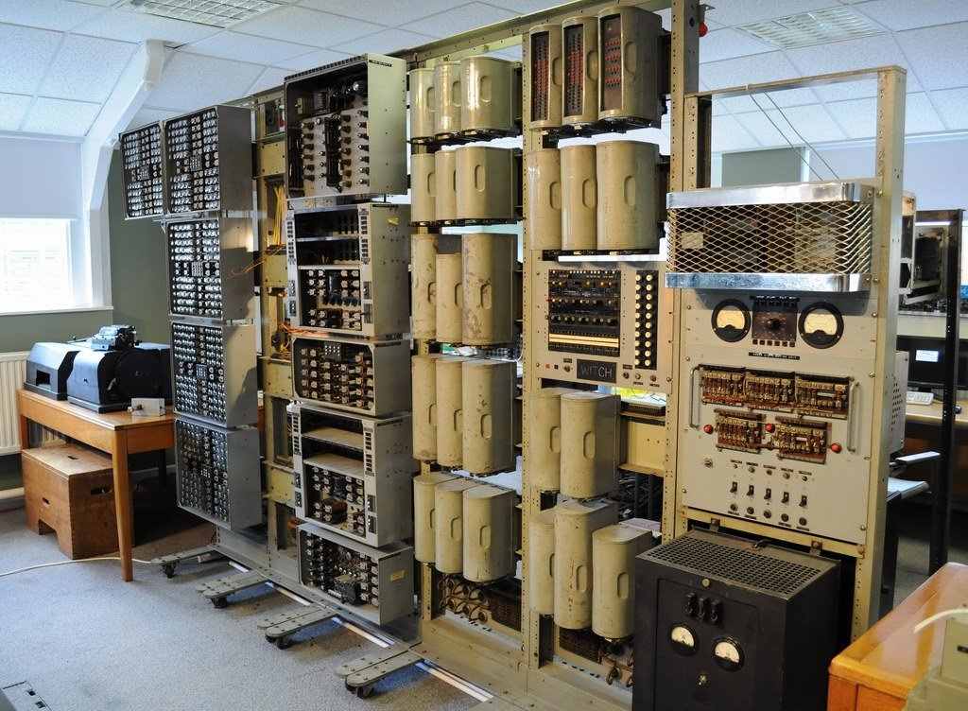

[**How computers work:**](https://k4y0x13.github.io/CSF101-Programming-Methodology/unit3/1-intro-why.html#how-computers-work)

At its core, a computer stores data in binary format (0s and 1s) in its memory. How this data is organized and accessed can significantly affect the speed and efficiency of operations.

Different data structures provide *different ways to organize this binary data* for various use cases.

[**Evolution:**](https://k4y0x13.github.io/CSF101-Programming-Methodology/unit3/1-intro-why.html#evolution)

As programming languages evolved from low-level (like assembly) to high-level languages, **abstractions** were created to make data storage more intuitive. However, understanding the underlying principles remains crucial for writing efficient code.

[**2. Static vs Dynamic Data Structures**](https://k4y0x13.github.io/CSF101-Programming-Methodology/unit3/1-intro-why.html#2-static-vs-dynamic-data-structures)

[**Why it matters:**](https://k4y0x13.github.io/CSF101-Programming-Methodology/unit3/1-intro-why.html#why-it-matters-1)

The choice between static and dynamic data structures impacts memory usage, performance, and the flexibility of your program. Understanding both types allows programmers to make informed decisions based on their specific needs.

[**How computers work:**](https://k4y0x13.github.io/CSF101-Programming-Methodology/unit3/1-intro-why.html#how-computers-work-1)

* Static structures: These have a fixed size, allocated at compile time. They're stored in a part of memory called the stack, which is fast but limited in size.
* Dynamic structures: These can grow or shrink at runtime. They're stored in the heap, a larger but slower part of memory.

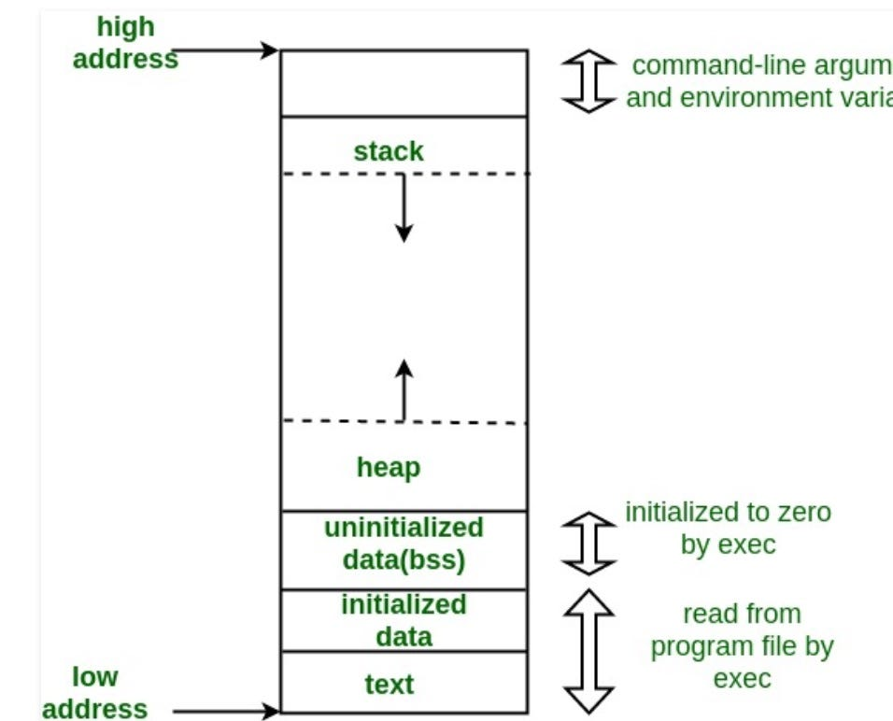

[**Historical context:**](https://k4y0x13.github.io/CSF101-Programming-Methodology/unit3/1-intro-why.html#historical-context-1)

Early programs primarily used static structures due to limited memory and the need for predictability. As memory became more abundant and programs more complex, dynamic structures became increasingly important.

[**Evolution:**](https://k4y0x13.github.io/CSF101-Programming-Methodology/unit3/1-intro-why.html#evolution-1)

1. Early days: Programs used mostly static arrays and structures.
2. Introduction of pointers: Allowed for more flexible memory management.
3. Development of dynamic allocation: Enabled the creation of data structures that could grow and shrink as needed.
4. Modern era: High-level languages often abstract away the details, but understanding the underlying principles remains crucial for optimization.

[**Impact on programming:**](https://k4y0x13.github.io/CSF101-Programming-Methodology/unit3/1-intro-why.html#impact-on-programming)

* Static structures are still used for their speed and simplicity in certain scenarios.
* Dynamic structures enable more flexible and scalable programs, crucial for modern software development.
* Understanding both allows programmers to make informed decisions based on performance needs, memory constraints, and problem requirements.

In conclusion, learning about data structures, including the fundamental concepts of data storage and the distinction between static and dynamic structures, is essential for any programmer. It provides the foundation for writing efficient, scalable, and robust software, regardless of the evolution of computer hardware and programming languages.

[**Elementary Data Structure: The Array**](https://k4y0x13.github.io/CSF101-Programming-Methodology/unit3/2-elementary-ds-array.html#elementary-data-structure-the-array)

[**Definition**](https://k4y0x13.github.io/CSF101-Programming-Methodology/unit3/2-elementary-ds-array.html#definition)

An Array is a fundamental data structure that stores a fixed-size sequential collection of elements of the same type.

[**Key Properties**](https://k4y0x13.github.io/CSF101-Programming-Methodology/unit3/2-elementary-ds-array.html#key-properties)

1. **Fixed Size**: Once declared, the size of an array is fixed.
2. **Homogeneous**: All elements in an array must be of the same data type.
3. **Contiguous Memory**: Elements are stored in contiguous memory locations.
4. **Zero-Indexed**: The first element is typically accessed with index 0 (in most programming languages).
5. **Random Access**: Elements can be accessed directly using their index.

[**\*Time Complexity**](https://k4y0x13.github.io/CSF101-Programming-Methodology/unit3/2-elementary-ds-array.html#time-complexity)

* Access: O(1)
* Search: O(n) for unsorted, O(log n) for sorted (using binary search)
* Insertion: O(n)
* Deletion: O(n)

[**Memory Usage**](https://k4y0x13.github.io/CSF101-Programming-Methodology/unit3/2-elementary-ds-array.html#memory-usage)

* Memory = (size of data type) * (number of elements)

[**Advantages**](https://k4y0x13.github.io/CSF101-Programming-Methodology/unit3/2-elementary-ds-array.html#advantages)

1. Simple and easy to use
2. Fast access to elements (constant time)
3. Efficient for storing and accessing sequential data

[**Disadvantages**](https://k4y0x13.github.io/CSF101-Programming-Methodology/unit3/2-elementary-ds-array.html#disadvantages)

1. Fixed size (can't be changed after declaration)
2. Inefficient insertion and deletion
3. Wasted memory if not all elements are used

[**\*Common Operations**](https://k4y0x13.github.io/CSF101-Programming-Methodology/unit3/2-elementary-ds-array.html#common-operations)

1. **Traversal**: Visiting each element of the array
2. **Insertion**: Adding an element at a given index
3. **Deletion**: Removing an element from a given index
4. **Search**: Finding the index of a given element
5. **Update**: Modifying the value of an existing element

[**\*Types of Arrays**](https://k4y0x13.github.io/CSF101-Programming-Methodology/unit3/2-elementary-ds-array.html#types-of-arrays)

1. **One-dimensional**: Linear array (e.g., [1, 2, 3, 4, 5])
2. **Multi-dimensional** (Matrices): Array of arrays (e.g., 2D array: [[1, 2], [3, 4]])

[**Use Cases**](https://k4y0x13.github.io/CSF101-Programming-Methodology/unit3/2-elementary-ds-array.html#use-cases)

1. Storing and manipulating sequential data
2. Implementing other data structures (e.g., stacks, queues)
3. Buffering in I/O operations
4. Lookup tables and hash tables

[**Real World Applications**](https://k4y0x13.github.io/CSF101-Programming-Methodology/unit3/2-elementary-ds-array.html#real-world-applications)

Arrays are versatile data structures that can be applied to solve various real-world problems. Here are some examples:

1. **Image Processing**
   * Representing digital images as 2D arrays of pixels
   * Applying filters and transformations to images
2. **Financial Applications**
   * Storing and analyzing time series data (e.g., stock prices over time)
   * Managing portfolios and calculating returns
3. **Inventory Management**
   * Tracking product quantities and locations in warehouses
   * Managing stock levels and reordering
4. **Scheduling and Calendars**
   * Representing days, weeks, or months in calendar applications
   * Managing time slots for appointments or reservations
5. **Sensor Data Collection**
   * Storing readings from multiple sensors over time
   * Analyzing environmental data (e.g., temperature, humidity)
6. **Game Development**
   * Representing game boards (e.g., chess, tic-tac-toe)
   * Managing character inventories or attributes
7. **Audio Processing**
   * Storing and manipulating audio samples
   * Implementing digital audio effects
8. **Database Systems**
   * Implementing index structures for faster data retrieval
   * Storing and managing records in memory
9. **Text Editors and Word Processors**
   * Storing lines of text for efficient editing and display
   * Implementing undo/redo functionality
10. **Network Packet Management**
    * Buffering and processing network packets
    * Implementing network protocols
11. **Scientific Computing**
    * Storing and manipulating matrices for linear algebra operations
    * Implementing numerical methods and simulations
12. **Geographic Information Systems (GIS)**
    * Representing map data as grids
    * Storing and analyzing spatial information
13. **Memory Management in Operating Systems**
    * Managing memory allocation and deallocation
    * Implementing page tables for virtual memory
14. **Compiler Design**
    * Storing and manipulating tokens during lexical analysis
    * Managing symbol tables
15. **Data Compression**
    * Implementing run-length encoding
    * Storing frequency tables for Huffman coding

[**Memory Techniques for Retention**](https://k4y0x13.github.io/CSF101-Programming-Methodology/unit3/2-elementary-ds-array.html#memory-techniques-for-retention)

1. **Visualization**: Imagine an array as a row of boxes, each containing a value.
2. **Analogy**: Compare an array to building with ground floor 0.
3. **Acronym**: FHCRZ (Fixed, Homogeneous, Contiguous, Random access, Zero-indexed)

[**Code Example (Python)**](https://k4y0x13.github.io/CSF101-Programming-Methodology/unit3/2-elementary-ds-array.html#code-example-python)

# Creating an array

fruits = ["apple", "banana", "cherry", "date", "elderberry"]

# Accessing elements

print(fruits[0]) # Output: apple

print(fruits[-1]) # Output: elderberry

# Updating an element

fruits[1] = "blackberry"

# Traversing the array

for fruit in fruits:

print(fruit)

# Finding the length

print(len(fruits)) # Output: 5

# Slicing

print(fruits[1:4]) # Output: ['blackberry', 'cherry', 'date']

[**List (Dynamic Array) Data Structure**](https://k4y0x13.github.io/CSF101-Programming-Methodology/unit3/3.1-list-ds.html#list-dynamic-array-data-structure)

[**Definition**](https://k4y0x13.github.io/CSF101-Programming-Methodology/unit3/3.1-list-ds.html#definition)

A List, also known as a Dynamic Array, is a data structure that allows elements to be added or removed, and can grow or shrink in size automatically.

[**Definition**](https://k4y0x13.github.io/CSF101-Programming-Methodology/unit3/3.2-stack-ds.html#definition)

A Stack is a linear data structure that follows the **Last-In-First-Out (LIFO)** principle. Elements are added to and removed from the same end, called the "top" of the stack.

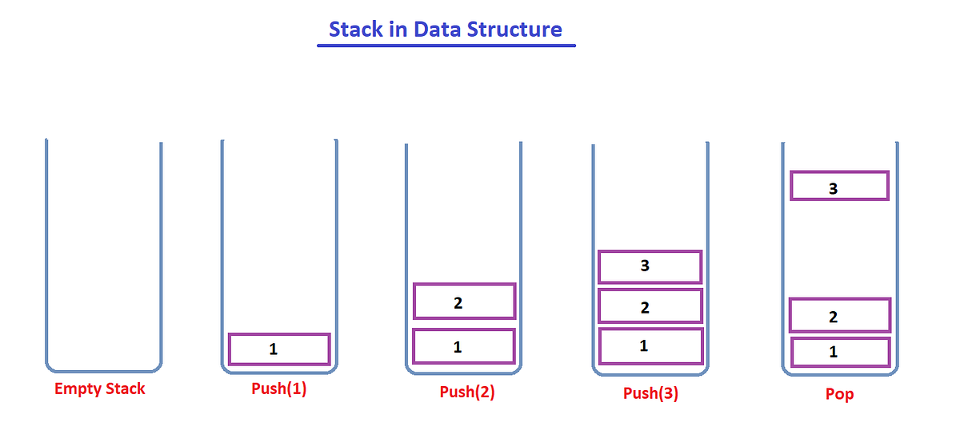

[**Key Properties**](https://k4y0x13.github.io/CSF101-Programming-Methodology/unit3/3.2-stack-ds.html#key-properties)

1. **LIFO (Last-In-First-Out)**: The last element added is the first one to be removed.
2. **Single-ended**: Elements are added and removed only from one end (the top).
3. **Abstract Data Type (ADT)**: Can be implemented using arrays or linked lists.
4. **Dynamic Size**: Typically grows and shrinks as elements are pushed and popped.

[**Basic Operations**](https://k4y0x13.github.io/CSF101-Programming-Methodology/unit3/3.2-stack-ds.html#basic-operations)

1. **Push**: Add an element to the top of the stack
2. **Pop**: Remove and return the top element from the stack
3. **Peek/Top**: View the top element without removing it
4. **isEmpty**: Check if the stack is empty

[**Time Complexity**](https://k4y0x13.github.io/CSF101-Programming-Methodology/unit3/3.2-stack-ds.html#time-complexity)

* Push: O(1)
* Pop: O(1)
* Peek: O(1)
* Search: O(n)

[**Memory Usage**](https://k4y0x13.github.io/CSF101-Programming-Methodology/unit3/3.2-stack-ds.html#memory-usage)

* Depends on the underlying implementation (array-based or linked list-based)
* Memory = (size of data type) * (number of elements)

[**Advantages**](https://k4y0x13.github.io/CSF101-Programming-Methodology/unit3/3.2-stack-ds.html#advantages)

1. Simple and easy to implement
2. Efficient insertion and deletion (constant time)
3. Memory efficient (when implemented with a linked list)
4. Useful for tracking state in algorithms

[**Disadvantages**](https://k4y0x13.github.io/CSF101-Programming-Methodology/unit3/3.2-stack-ds.html#disadvantages)

1. Limited access (only to the top element)
2. Not suitable for certain types of data access patterns
3. Potential for stack overflow if not managed properly

[**Common Use Cases**](https://k4y0x13.github.io/CSF101-Programming-Methodology/unit3/3.2-stack-ds.html#common-use-cases)

1. Function call stack in programming languages
2. Undo mechanisms in text editors
3. Expression evaluation and syntax parsing
4. Backtracking algorithms
5. Browser history (back button functionality)

[**Real-World Applications of Stack Data Structure**](https://k4y0x13.github.io/CSF101-Programming-Methodology/unit3/3.2-stack-ds.html#real-world-applications-of-stack-data-structure)

1. Web Browsing History

* **Scenario**: Implementing the "Back" button in web browsers.
* **How Stack is Used**: Each visited page URL is pushed onto a stack. When the user clicks "Back", the top URL is popped and loaded.

1. Undo Functionality in Software

* **Scenario**: Providing undo capability in text editors, graphic design software, etc.
* **How Stack is Used**: Each action is pushed onto a stack. When the user requests an undo, the last action is popped and reversed.

1. Function Call Management in Programming

* **Scenario**: Managing function calls and local variables in program execution.
* **How Stack is Used**: When a function is called, its context (parameters, local variables, return address) is pushed onto the call stack. When the function returns, its context is popped.

1. Expression Evaluation in Calculators

* **Scenario**: Evaluating mathematical expressions, especially those with parentheses.
* **How Stack is Used**: Operators and operands are pushed and popped from the stack to handle operator precedence and nested expressions.

1. Backtracking Algorithms

* **Scenario**: Solving mazes, puzzles, or in game AI for chess.
* **How Stack is Used**: Possible moves or states are pushed onto the stack. If a path leads to a dead-end, the program backtracks by popping the stack.

1. Syntax Parsing in Compilers

* **Scenario**: Checking for balanced parentheses or brackets in code.
* **How Stack is Used**: Opening brackets are pushed onto the stack. Each closing bracket is matched with the top of the stack.

1. Memory Management

* **Scenario**: Managing memory allocation in operating systems.
* **How Stack is Used**: Memory blocks are allocated and deallocated in a LIFO manner for efficient memory management.

1. Recursion Simulation

* **Scenario**: Implementing or optimizing recursive algorithms.
* **How Stack is Used**: Instead of using actual recursion, which can lead to stack overflow, an explicit stack can be used to simulate recursive calls.

1. Graph Algorithms

* **Scenario**: Depth-First Search (DFS) in graph traversal.
* **How Stack is Used**: Vertices to be visited are pushed onto the stack. The algorithm pops a vertex, processes it, and pushes its unvisited neighbors.

1. Clipboard History

* **Scenario**: Maintaining a history of copied items in an operating system.
* **How Stack is Used**: Each copied item is pushed onto a stack. Users can cycle through previous copies by popping from the stack.

1. Call Center Systems

* **Scenario**: Managing customer service calls in a Last-In-First-Out manner.
* **How Stack is Used**: Incoming calls are pushed onto a stack. The most recent caller is served first (popped) when an agent becomes available.

1. Plate Stacking in Restaurants

* **Scenario**: Managing a stack of plates in a cafeteria or buffet.
* **How Stack is Used**: Clean plates are pushed onto the stack. Diners take plates from the top (pop operation).

[**Variations**](https://k4y0x13.github.io/CSF101-Programming-Methodology/unit3/3.2-stack-ds.html#variations)

1. **Min Stack**: Keeps track of the minimum element
2. **Max Stack**: Keeps track of the maximum element
3. **Double-ended Stack**: Allows push and pop from both ends

[**Implementation Approaches**](https://k4y0x13.github.io/CSF101-Programming-Methodology/unit3/3.2-stack-ds.html#implementation-approaches)

1. **Array-based**: Uses a dynamic array to store elements
2. **Linked List-based**: Uses a singly linked list with head as top

[**Memory Techniques for Retention**](https://k4y0x13.github.io/CSF101-Programming-Methodology/unit3/3.2-stack-ds.html#memory-techniques-for-retention)

1. **Visualization**: Imagine a stack of plates where you can only add or remove from the top
2. **Analogy**: Compare to a Pringles can - you can only add or remove chips from the top
3. **Acronym**: LIPS (Last-In, Push-Pop Stack)
4. **Mnemonic**: "Last to arrive, first to leave" (like at a party)

[**Code Example (Python)**](https://k4y0x13.github.io/CSF101-Programming-Methodology/unit3/3.2-stack-ds.html#code-example-python)

class Stack:

def __init__(self):

self.items = []

def is_empty(self):

return len(self.items) == 0

def push(self, item):

self.items.append(item)

def pop(self):

if not self.is_empty():

return self.items.pop()

else:

raise IndexError("Stack is empty")

def peek(self):

if not self.is_empty():

return self.items[-1]

else:

raise IndexError("Stack is empty")

def size(self):

return len(self.items)

# Usage example

stack = Stack()

stack.push(1)

stack.push(2)

stack.push(3)

print(stack.pop()) # Output: 3

print(stack.peek()) # Output: 2

print(stack.size()) # Output: 2

[**Queue Data Structure**](https://k4y0x13.github.io/CSF101-Programming-Methodology/unit3/3.3-queue-ds.html#queue-data-structure)

[**Definition**](https://k4y0x13.github.io/CSF101-Programming-Methodology/unit3/3.3-queue-ds.html#definition)

A Queue is a linear data structure that follows the **First-In-First-Out (FIFO)** principle. Elements are added at one end (rear) and removed from the other end (front).

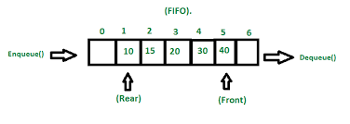

[**Key Properties**](https://k4y0x13.github.io/CSF101-Programming-Methodology/unit3/3.3-queue-ds.html#key-properties)

1. **FIFO (First-In-First-Out)**: The first element added is the first one to be removed.
2. **Two-ended**: Elements are added at the rear and removed from the front.
3. **Abstract Data Type (ADT)**: Can be implemented using arrays or linked lists.
4. **Dynamic Size**: Typically grows and shrinks as elements are enqueued and dequeued.

[**Basic Operations**](https://k4y0x13.github.io/CSF101-Programming-Methodology/unit3/3.3-queue-ds.html#basic-operations)

1. **Enqueue**: Add an element to the rear of the queue
2. **Dequeue**: Remove and return the front element from the queue
3. **Front**: View the front element without removing it
4. **isEmpty**: Check if the queue is empty
5. **Size**: Get the number of elements in the queue

[**Time Complexity**](https://k4y0x13.github.io/CSF101-Programming-Methodology/unit3/3.3-queue-ds.html#time-complexity)

* Enqueue: O(1)
* Dequeue: O(1)
* Front: O(1)
* isEmpty: O(1)
* Size: O(1)

[**Memory Usage**](https://k4y0x13.github.io/CSF101-Programming-Methodology/unit3/3.3-queue-ds.html#memory-usage)

* Depends on the underlying implementation (array-based or linked list-based)
* Memory = (size of data type) * (number of elements)

[**Advantages**](https://k4y0x13.github.io/CSF101-Programming-Methodology/unit3/3.3-queue-ds.html#advantages)

1. Maintains order of insertion
2. Efficient insertion and deletion (constant time)
3. Useful for managing resources and scheduling
4. Supports both synchronous and asynchronous processing

[**Disadvantages**](https://k4y0x13.github.io/CSF101-Programming-Methodology/unit3/3.3-queue-ds.html#disadvantages)

1. Fixed size in array-based implementation (can be mitigated with circular queue)
2. Potential for queue overflow or underflow if not managed properly
3. No random access to elements

[**Common Use Cases**](https://k4y0x13.github.io/CSF101-Programming-Methodology/unit3/3.3-queue-ds.html#common-use-cases)

1. Task scheduling in operating systems
2. Breadth-First Search algorithm in graphs
3. Print job spooling
4. Handling of requests on a single shared resource (e.g., CPU)
5. Buffering for data streams

[**Real World Application**](https://k4y0x13.github.io/CSF101-Programming-Methodology/unit3/3.3-queue-ds.html#real-world-application)

Queues are widely used in computer science and everyday life to manage processes where first-come, first-served order is important. Here are some practical applications:

1. Customer Service Systems

* **Call Centers**: Incoming calls are placed in a queue and answered in the order they were received.
* **Help Desk Ticketing**: Support requests are processed in the order they are submitted.

1. Transportation and Logistics

* **Traffic Management**: Vehicles at a traffic signal are served in the order they arrive.
* **Airline Boarding**: Passengers board the plane based on their order in the queue.
* **Shipping and Delivery**: Orders are processed and shipped based on their order in the queue.

1. Operating Systems

* **CPU Scheduling**: Processes waiting for CPU time are managed in a queue.
* **Print Spooling**: Print jobs are processed in the order they are received.
* **I/O Buffer Management**: Data is read from or written to devices in a queued order.

1. Networking

* **Routers and Switches**: Network packets are queued before being transmitted.
* **Web Servers**: HTTP requests are often processed in a FIFO manner.

1. Healthcare

* **Emergency Room Triage**: While not strictly FIFO due to severity considerations, queues help manage patient wait times.
* **Organ Donation Lists**: Patients waiting for organ transplants are often managed in a queue-like system.

1. Entertainment and Services

* **Ticket Sales**: Online queuing systems for high-demand event tickets.
* **Amusement Park Ride Lines**: Physical queues for managing ride access.
* **Streaming Services**: Video or audio buffers use queues to ensure smooth playback.

1. Manufacturing and Production

* **Assembly Lines**: Products move through stages of assembly in a queue-like manner.
* **Inventory Management**: First-In-First-Out (FIFO) method for perishable goods.

1. Software and Web Development

* **Task Scheduling**: Background jobs or tasks are often managed in queues.
* **Message Brokers**: Systems like RabbitMQ use queues to manage message passing between services.

1. Financial Systems

* **Transaction Processing**: Banking transactions are often processed in the order they are received.
* **Stock Market Orders**: Some types of stock market orders are processed in a FIFO manner.

1. Education

* **Course Waitlists**: Students are added to course waitlists in the order they apply.
* **Grading Systems**: Some professors grade assignments in the order they were submitted.

[**Variations**](https://k4y0x13.github.io/CSF101-Programming-Methodology/unit3/3.3-queue-ds.html#variations)

1. **Circular Queue**: Efficient use of fixed-size array
2. **Double-ended Queue (Deque)**: Allows insertion and deletion at both ends
3. **Priority Queue**: Elements have associated priorities

[**Implementation Approaches**](https://k4y0x13.github.io/CSF101-Programming-Methodology/unit3/3.3-queue-ds.html#implementation-approaches)

1. **Array-based**: Uses a dynamic or circular array to store elements
2. **Linked List-based**: Uses a singly linked list with front and rear pointers

[**Memory Techniques for Retention**](https://k4y0x13.github.io/CSF101-Programming-Methodology/unit3/3.3-queue-ds.html#memory-techniques-for-retention)

1. **Visualization**: Imagine a line of people waiting for a bus - first in line is first to board
2. **Analogy**: Compare to a pipe where items enter one end and exit the other
3. **Acronym**: FIFE (First-In, First-Exit)
4. **Mnemonic**: "First to arrive, first to leave" (like at a bakery)

[**Code Example (Python)**](https://k4y0x13.github.io/CSF101-Programming-Methodology/unit3/3.3-queue-ds.html#code-example-python)

from collections import deque

class Queue:

def __init__(self):

self.items = deque()

def is_empty(self):

return len(self.items) == 0

def enqueue(self, item):

self.items.append(item)

def dequeue(self):

if not self.is_empty():

return self.items.popleft()

else:

raise IndexError("Queue is empty")

def front(self):

if not self.is_empty():

return self.items[0]

else:

raise IndexError("Queue is empty")

def size(self):

return len(self.items)

# Usage example

queue = Queue()

queue.enqueue("Task 1")

queue.enqueue("Task 2")

queue.enqueue("Task 3")

print(queue.dequeue()) # Output: Task 1

print(queue.front()) # Output: Task 2

print(queue.size()) # Output: 2

Remember: Implement and experiment with queues in your preferred programming language to reinforce your understanding!

[**Deque (Double-ended Queue) Data Structure**](https://k4y0x13.github.io/CSF101-Programming-Methodology/unit3/3.4-dequeue-ds.html#deque-double-ended-queue-data-structure)

[**Definition**](https://k4y0x13.github.io/CSF101-Programming-Methodology/unit3/3.4-dequeue-ds.html#definition)

A Deque (pronounced "deck") is a linear data structure that allows insertion and deletion of elements from both ends. It combines the features of both stacks and queues.

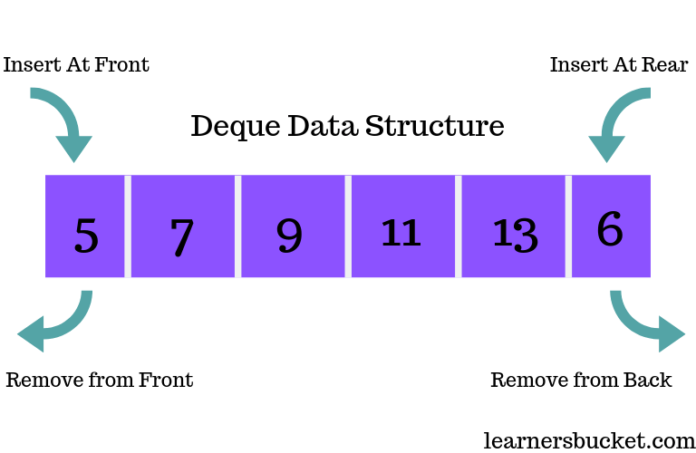

[**Key Properties**](https://k4y0x13.github.io/CSF101-Programming-Methodology/unit3/3.4-dequeue-ds.html#key-properties)

1. **Double-ended**: Elements can be added or removed from both front and rear.
2. **Flexible**: Supports both LIFO (Last-In-First-Out) and FIFO (First-In-First-Out) operations.
3. **Abstract Data Type (ADT)**: Can be implemented using dynamic arrays or doubly linked lists.
4. **Dynamic Size**: Typically grows and shrinks as elements are added and removed.

[**Basic Operations**](https://k4y0x13.github.io/CSF101-Programming-Methodology/unit3/3.4-dequeue-ds.html#basic-operations)

1. **insertFront**: Add an element to the front of the deque
2. **insertRear**: Add an element to the rear of the deque
3. **deleteFront**: Remove and return the front element
4. **deleteRear**: Remove and return the rear element
5. **getFront**: View the front element without removing it
6. **getRear**: View the rear element without removing it
7. **isEmpty**: Check if the deque is empty
8. **size**: Get the number of elements in the deque

[**Time Complexity**](https://k4y0x13.github.io/CSF101-Programming-Methodology/unit3/3.4-dequeue-ds.html#time-complexity)

* All basic operations (insertFront, insertRear, deleteFront, deleteRear, getFront, getRear): O(1)
* isEmpty: O(1)
* size: O(1)

[**Memory Usage**](https://k4y0x13.github.io/CSF101-Programming-Methodology/unit3/3.4-dequeue-ds.html#memory-usage)

* Depends on the underlying implementation (array-based or linked list-based)
* Memory = (size of data type) * (number of elements) + overhead for pointers (in linked list implementation)

[**Advantages**](https://k4y0x13.github.io/CSF101-Programming-Methodology/unit3/3.4-dequeue-ds.html#advantages)

1. Combines functionality of both stacks and queues
2. Efficient insertion and deletion at both ends (constant time)
3. Flexible for various use cases
4. Supports both LIFO and FIFO operations

[**Disadvantages**](https://k4y0x13.github.io/CSF101-Programming-Methodology/unit3/3.4-dequeue-ds.html#disadvantages)

1. More complex implementation compared to simple stacks or queues
2. Slightly higher memory usage due to additional pointers (in linked list implementation)
3. No random access to elements (except in array-based implementations)

[**Common Use Cases**](https://k4y0x13.github.io/CSF101-Programming-Methodology/unit3/3.4-dequeue-ds.html#common-use-cases)

1. Implementing undo-redo functionality
2. Managing work stealing in multiprocessing environments
3. Palindrome checking
4. Sliding window problems in algorithms
5. Browser history (forward and backward navigation)

[**Real-World Use Cases for Deques (Double-ended Queues)**](https://k4y0x13.github.io/CSF101-Programming-Methodology/unit3/3.4-dequeue-ds.html#real-world-use-cases-for-deques-double-ended-queues)

1. Undo-Redo Functionality in Applications

* **Scenario**: Text editors, graphic design software, or any application with undo-redo features.
* **Solution**: Use a deque to store user actions. Recent actions are added to one end for undo, and when undone, they're moved to the other end for potential redo.
* **Benefit**: Efficient O(1) operations for both undo and redo actions.

1. Browser History Navigation

* **Scenario**: Implementing forward and backward navigation in web browsers.
* **Solution**: Use a deque to store visited web pages. The current page is at one end, previously visited pages at the other. New pages are added to the front, and navigation uses both ends.
* **Benefit**: Quick access to both recently visited and older pages.

1. Task Scheduling in Operating Systems

* **Scenario**: Managing processes or tasks in a multi-tasking environment.
* **Solution**: Use a deque for task queues. High-priority tasks can be added to the front, while regular tasks are added to the rear.
* **Benefit**: Flexible prioritization of tasks without separate data structures.

1. Palindrome Checking

* **Scenario**: Efficiently checking if a word or phrase is a palindrome.
* **Solution**: Use a deque to store characters. Compare characters from both ends, moving inwards.
* **Benefit**: O(n/2) comparisons, with easy handling of even and odd-length strings.

1. Sliding Window Problems in Data Analysis

* **Scenario**: Analyzing time series data or streaming data with a fixed-size window.
* **Solution**: Use a deque to represent the sliding window. Add new elements to one end and remove old elements from the other.
* **Benefit**: Efficient updates to the window contents as it slides over the data.

1. A-Steal Work Scheduling Algorithm

* **Scenario**: Load balancing in parallel computing environments.
* **Solution**: Each processor maintains a deque of tasks. Busy processors add tasks to one end, while idle processors can steal tasks from the other end of busy processors' deques.
* **Benefit**: Efficient work distribution and load balancing.

1. Network Packet Processing

* **Scenario**: Managing network packets in routers or switches.
* **Solution**: Use deques to handle packet queues. High-priority packets can be inserted at the front, while normal packets are added to the rear.
* **Benefit**: Flexible packet prioritization and efficient processing.

1. Music Player Playlist Management

* **Scenario**: Implementing features like "play next" and "add to queue" in music players.
* **Solution**: Use a deque to manage the playlist. New songs can be added to either the front ("play next") or the back ("add to queue").
* **Benefit**: Flexible playlist management with efficient insertions at both ends.

1. Customer Service Queue Management

* **Scenario**: Managing customer service requests with priority handling.
* **Solution**: Use a deque for the customer queue. VIP customers can be added to the front, while regular customers join at the rear.
* **Benefit**: Efficient prioritization without multiple separate queues.

1. Memory-Efficient Caching

* **Scenario**: Implementing a cache with both FIFO and LIFO eviction policies.
* **Solution**: Use a deque to store cached items. New items can be added to one end, and eviction can happen from either end based on the desired policy.
* **Benefit**: Flexible caching strategy with efficient insertions and deletions.

Remember: The key advantage of deques in these scenarios is their ability to efficiently handle operations at both ends, providing flexibility that single-ended data structures like stacks or queues cannot match.

[**Variations**](https://k4y0x13.github.io/CSF101-Programming-Methodology/unit3/3.4-dequeue-ds.html#variations)

1. **Scroll Buffer**: Used in text editors for efficient insertion and deletion
2. **A-Steal Deque**: Used in work-stealing schedulers

[**Implementation Approaches**](https://k4y0x13.github.io/CSF101-Programming-Methodology/unit3/3.4-dequeue-ds.html#implementation-approaches)

1. **Array-based**: Uses a dynamic circular array
2. **Linked List-based**: Uses a doubly linked list

[**Memory Techniques for Retention**](https://k4y0x13.github.io/CSF101-Programming-Methodology/unit3/3.4-dequeue-ds.html#memory-techniques-for-retention)

1. **Visualization**: Imagine a double-ended subway train where passengers can board and exit from both ends
2. **Analogy**: Compare to a deck of cards where you can add or remove cards from both top and bottom
3. **Acronym**: DIDO (Double-In, Double-Out)
4. **Mnemonic**: "First or last, in or out, deque handles it all about"

[**Code Example (Python)**](https://k4y0x13.github.io/CSF101-Programming-Methodology/unit3/3.4-dequeue-ds.html#code-example-python)

from collections import deque

class Deque:

def __init__(self):

self.items = deque()

def is_empty(self):

return len(self.items) == 0

def insert_front(self, item):

self.items.appendleft(item)

def insert_rear(self, item):

self.items.append(item)

def delete_front(self):

if not self.is_empty():

return self.items.popleft()

else:

raise IndexError("Deque is empty")

def delete_rear(self):

if not self.is_empty():

return self.items.pop()

else:

raise IndexError("Deque is empty")

def get_front(self):

if not self.is_empty():

return self.items[0]

else:

raise IndexError("Deque is empty")

def get_rear(self):

if not self.is_empty():

return self.items[-1]

else:

raise IndexError("Deque is empty")

def size(self):

return len(self.items)

# Usage example

deque = Deque()

deque.insert_front("A")

deque.insert_rear("B")

deque.insert_front("C")

print(deque.delete_front()) # Output: C

print(deque.delete_rear()) # Output: B

print(deque.get_front()) # Output: A

print(deque.size()) # Output: 1

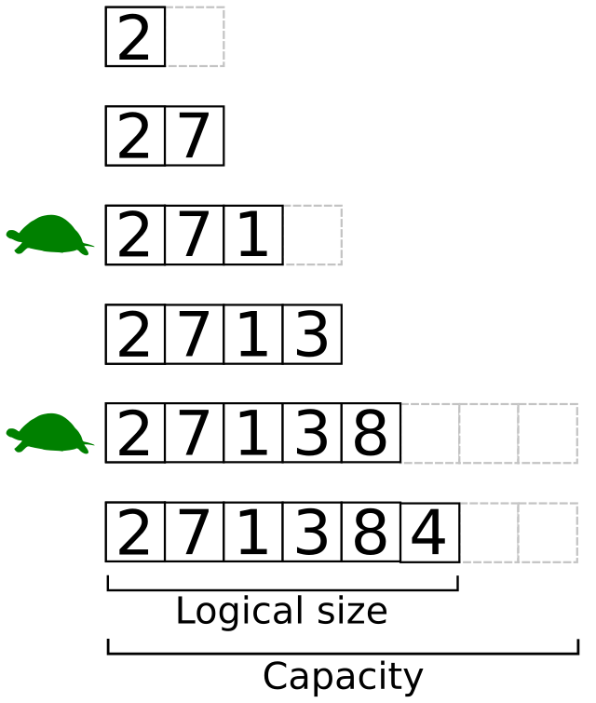

[**Key Properties**](https://k4y0x13.github.io/CSF101-Programming-Methodology/unit3/3.1-list-ds.html#key-properties)

1. **Dynamic Size**: Can grow or shrink as needed.
2. **Heterogeneous** (in some languages): Can store elements of different data types (e.g., in Python).
3. **Contiguous Memory**: Elements are stored in contiguous memory locations.
4. **Zero-Indexed**: The first element is typically accessed with index 0 (in most programming languages).
5. **Random Access**: Elements can be accessed directly using their index.

[**Time Complexity**](https://k4y0x13.github.io/CSF101-Programming-Methodology/unit3/3.1-list-ds.html#time-complexity)

* Access: O(1)
* Search: O(n) for unsorted, O(log n) for sorted (using binary search)
* Insertion: O(1) amortized for append, O(n) for arbitrary position
* Deletion: O(n)

[**Memory Usage**](https://k4y0x13.github.io/CSF101-Programming-Methodology/unit3/3.1-list-ds.html#memory-usage)

* Initial Memory = (size of data type) * (initial capacity)
* Grows dynamically, often doubling in size when capacity is reached

[**Advantages**](https://k4y0x13.github.io/CSF101-Programming-Methodology/unit3/3.1-list-ds.html#advantages)

1. Flexible size (can grow or shrink as needed)
2. Fast access to elements (constant time)
3. Efficient for storing and accessing sequential data
4. Supports various built-in operations and methods

[**Disadvantages**](https://k4y0x13.github.io/CSF101-Programming-Methodology/unit3/3.1-list-ds.html#disadvantages)

1. Slower insertions and deletions compared to linked lists
2. May waste some memory due to over-allocation
3. Resizing operations can be costly

[**Common Operations**](https://k4y0x13.github.io/CSF101-Programming-Methodology/unit3/3.1-list-ds.html#common-operations)

1. **Append**: Adding an element to the end of the list
2. **Insert**: Adding an element at a specific index
3. **Remove**: Deleting an element by value or index
4. **Pop**: Removing and returning the last element
5. **Index**: Finding the position of a given element
6. **Slice**: Extracting a portion of the list
7. **Sort**: Arranging elements in a specific order

[**Implementation Details**](https://k4y0x13.github.io/CSF101-Programming-Methodology/unit3/3.1-list-ds.html#implementation-details)

1. **Resizing**: When capacity is reached, a new, larger array is allocated (typically 2x size)
2. **Amortized Analysis**: Explains O(1) average time for append operations

[**Use Cases**](https://k4y0x13.github.io/CSF101-Programming-Methodology/unit3/3.1-list-ds.html#use-cases)

1. Implementing stacks and queues
2. Managing collections of data in memory
3. Representing polynomials or sparse matrices
4. Building more complex data structures

[**Memory Techniques for Retention**](https://k4y0x13.github.io/CSF101-Programming-Methodology/unit3/3.1-list-ds.html#memory-techniques-for-retention)

1. **Visualization**: Imagine a rubber band that can stretch to accommodate more items
2. **Analogy**: Compare a list to an accordion folder that can expand or contract
3. **Acronym**: DCHRO (Dynamic, Contiguous, Heterogeneous, Resizable, Operations-rich)
4. **Chunking**: Group properties into categories (e.g., structural, performance, operations)

[**Code Example (Python)**](https://k4y0x13.github.io/CSF101-Programming-Methodology/unit3/3.1-list-ds.html#code-example-python)

# Creating a list

fruits = ["apple", "banana", "cherry"]

# Appending elements

fruits.append("date")

fruits.extend(["elderberry", "fig"])

# Inserting at a specific index

fruits.insert(1, "blackberry")

# Removing elements

fruits.remove("cherry")

last_fruit = fruits.pop()

# Accessing elements

print(fruits[0]) # Output: apple

print(fruits[-1]) # Output: elderberry

# Slicing

print(fruits[1:4]) # Output: ['blackberry', 'banana', 'date']

# Sorting

fruits.sort()

print(fruits) # Output: ['apple', 'banana', 'blackberry', 'date', 'elderberry']

# List comprehension

squares = [x**2 for x in range(5)]

print(squares) # Output: [0, 1, 4, 9, 16]

[**Linked List Data Structure**](https://k4y0x13.github.io/CSF101-Programming-Methodology/unit3/3.4.1-linked-list-ds.html#linked-list-data-structure)

[**Definition**](https://k4y0x13.github.io/CSF101-Programming-Methodology/unit3/3.4.1-linked-list-ds.html#definition)

A Linked List is a linear data structure where elements are stored in **nodes**. Each node contains a data field and a reference (or link) to the next node in the sequence.

[**Key Properties**](https://k4y0x13.github.io/CSF101-Programming-Methodology/unit3/3.4.1-linked-list-ds.html#key-properties)

1. **Dynamic Size**: Can grow or shrink in size during execution.
2. **Non-contiguous Memory**: Nodes can be stored anywhere in memory.
3. **Efficient Insertion/Deletion**: Adding or removing elements doesn't require shifting other elements.
4. **Sequential Access**: Elements are accessed sequentially starting from the first node.

[**Types of Linked Lists**](https://k4y0x13.github.io/CSF101-Programming-Methodology/unit3/3.4.1-linked-list-ds.html#types-of-linked-lists)

1. **Singly Linked List**: Each node points to the next node.
2. **Doubly Linked List**: Each node has pointers to both next and previous nodes.
3. **Circular Linked List**: Last node points back to the first node.

[**Basic Components**](https://k4y0x13.github.io/CSF101-Programming-Methodology/unit3/3.4.1-linked-list-ds.html#basic-components)

1. **Node**: Contains data and pointer(s) to other node(s).
2. **Head**: Points to the first node in the list.
3. **Tail**: Points to the last node in the list (in some implementations).

[**Basic Operations**](https://k4y0x13.github.io/CSF101-Programming-Methodology/unit3/3.4.1-linked-list-ds.html#basic-operations)

1. **Insertion**: Add a new node (at the beginning, end, or middle).
2. **Deletion**: Remove a node (from the beginning, end, or middle).
3. **Traversal**: Visit each node in the list.
4. **Search**: Find a node with a specific value.

[**Time Complexity**](https://k4y0x13.github.io/CSF101-Programming-Methodology/unit3/3.4.1-linked-list-ds.html#time-complexity)

* Access: O(n)
* Search: O(n)
* Insertion: O(1) if inserting at known position, O(n) if searching first
* Deletion: O(1) if deleting known position, O(n) if searching first

[**Memory Usage**](https://k4y0x13.github.io/CSF101-Programming-Methodology/unit3/3.4.1-linked-list-ds.html#memory-usage)

* Memory = (size of data + size of pointer) * (number of nodes)
* Additional memory for head (and tail) pointers

[**Advantages**](https://k4y0x13.github.io/CSF101-Programming-Methodology/unit3/3.4.1-linked-list-ds.html#advantages)

1. Dynamic size
2. Efficient insertions and deletions
3. No memory wastage (allocates exact memory required)
4. Implementation of other data structures (stacks, queues, etc.)

[**Disadvantages**](https://k4y0x13.github.io/CSF101-Programming-Methodology/unit3/3.4.1-linked-list-ds.html#disadvantages)

1. Sequential access (no random access)
2. Extra memory for pointers
3. Not cache-friendly due to non-contiguous memory allocation

[**Common Use Cases**](https://k4y0x13.github.io/CSF101-Programming-Methodology/unit3/3.4.1-linked-list-ds.html#common-use-cases)

1. Implementation of stacks, queues, and graphs
2. Undo functionality in applications
3. Hash tables (chaining for collision resolution)
4. Polynomial arithmetic
5. Music playlists

[**Real-World Applications of Linked Lists**](https://k4y0x13.github.io/CSF101-Programming-Methodology/unit3/3.4.1-linked-list-ds.html#real-world-applications-of-linked-lists)

Linked Lists are versatile data structures that find applications in various real-world scenarios. Here are some practical situations where Linked Lists are commonly used:

1. Music Player Playlists

* **Scenario**: Managing a list of songs in a music player.
* **Application**: Each node represents a song, containing metadata and a pointer to the next song.
* **Benefit**: Easy to add, remove, or reorder songs without affecting the entire playlist.

1. Browser History

* **Scenario**: Implementing forward and backward navigation in web browsers.
* **Application**: Each node represents a webpage, with links to both previous and next pages (doubly linked list).
* **Benefit**: Efficient navigation through browser history in both directions.

1. Image Viewer Carousel

* **Scenario**: Creating a circular image gallery or slideshow.
* **Application**: Each node contains an image, with the last image linking back to the first (circular linked list).
* **Benefit**: Smooth, continuous navigation through images in both directions.

1. Undo Functionality in Text Editors

* **Scenario**: Implementing undo/redo features in word processors or text editors.
* **Application**: Each node represents a state of the document, allowing easy traversal through edit history.
* **Benefit**: Efficient storage and navigation of document states for undo/redo operations.

1. Memory Management in Operating Systems

* **Scenario**: Managing free memory blocks in an operating system.
* **Application**: Each node represents a free memory block, easily split or merged as needed.
* **Benefit**: Efficient allocation and deallocation of memory without fragmentation.

1. Job Queue in Print Spoolers

* **Scenario**: Managing print jobs in a printer queue.
* **Application**: Each node represents a print job, easily added or removed from the queue.
* **Benefit**: Flexible management of print jobs, allowing priority insertions or cancellations.

1. Polynomial Arithmetic

* **Scenario**: Representing and manipulating polynomials in mathematical software.
* **Application**: Each node represents a term in the polynomial, with easy insertion and removal of terms.
* **Benefit**: Efficient storage and manipulation of polynomials with varying numbers of terms.

1. Card Games

* **Scenario**: Implementing a deck of cards in digital card games.
* **Application**: Each node represents a card, allowing easy shuffling, dealing, and returning to the deck.
* **Benefit**: Flexible manipulation of the deck without need for shifting elements.

1. Symbol Tables in Compilers

* **Scenario**: Managing symbols (variables, functions) during compilation.
* **Application**: Each node represents a symbol, with easy insertion, deletion, and lookup.
* **Benefit**: Efficient management of symbols with varying lifetimes during compilation.

1. Social Media Feed

* **Scenario**: Implementing an infinite scroll feature in social media apps.
* **Application**: Each node represents a post, with new posts easily added to the top or bottom of the feed.
* **Benefit**: Efficient insertion of new content and removal of old content in the feed.

Remember: These applications leverage the key strengths of Linked Lists, such as dynamic size, efficient insertions and deletions, and flexible memory allocation. Understanding these real-world use cases can provide valuable context for when to consider using Linked Lists in your own projects.

[**Variations**](https://k4y0x13.github.io/CSF101-Programming-Methodology/unit3/3.4.1-linked-list-ds.html#variations)

1. **Skip List**: Multiple layers of linked lists for faster searching
2. **Unrolled Linked List**: Storing multiple elements in each node
3. **XOR Linked List**: Memory-efficient doubly linked list using bitwise XOR

[**Memory Techniques for Retention**](https://k4y0x13.github.io/CSF101-Programming-Methodology/unit3/3.4.1-linked-list-ds.html#memory-techniques-for-retention)

1. **Visualization**: Imagine a train where each car (node) is connected to the next by a coupling (pointer).
2. **Analogy**: Compare to a scavenger hunt where each clue points to the location of the next clue.
3. **Acronym**: LEND (Linked Elements with Node Data)
4. **Mnemonic**: "Link by link, the chain grows long, each points ahead, where it belongs"

[**Code Example (Python)**](https://k4y0x13.github.io/CSF101-Programming-Methodology/unit3/3.4.1-linked-list-ds.html#code-example-python)

class Node:

def __init__(self, data):

self.data = data

self.next = None

class LinkedList:

def __init__(self):

self.head = None

def is_empty(self):

return self.head is None

def insert_front(self, data):

new_node = Node(data)

new_node.next = self.head

self.head = new_node

def insert_end(self, data):

new_node = Node(data)

if self.is_empty():

self.head = new_node

else:

current = self.head

while current.next:

current = current.next

current.next = new_node

def delete_front(self):

if not self.is_empty():

self.head = self.head.next

else:

raise IndexError("List is empty")

def search(self, data):

current = self.head

while current:

if current.data == data:

return True

current = current.next

return False

def display(self):

elements = []

current = self.head

while current:

elements.append(current.data)

current = current.next

return ' -> '.join(map(str, elements))

# Usage example

ll = LinkedList()

ll.insert_end(1)

ll.insert_end(2)

ll.insert_front(0)

print(ll.display()) # Output: 0 -> 1 -> 2

print(ll.search(1)) # Output: True

ll.delete_front()

print(ll.display()) # Output: 1 -> 2

[**Doubly Linked List Data Structure**](https://k4y0x13.github.io/CSF101-Programming-Methodology/unit3/3.4.2-doubly-linked-list-ds.html#doubly-linked-list-data-structure)

[**Definition**](https://k4y0x13.github.io/CSF101-Programming-Methodology/unit3/3.4.2-doubly-linked-list-ds.html#definition)

A Doubly Linked List is a linear data structure where each node contains data and two references (or links): one to the next node and one to the previous node in the sequence.

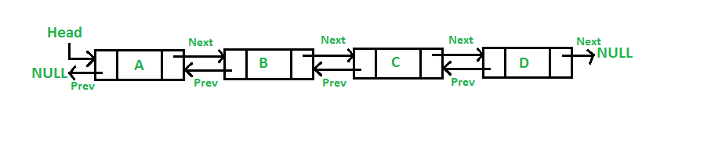

[**Key Properties**](https://k4y0x13.github.io/CSF101-Programming-Methodology/unit3/3.4.2-doubly-linked-list-ds.html#key-properties)

1. **Bidirectional**: Can be traversed in both forward and backward directions.
2. **Dynamic Size**: Can grow or shrink in size during execution.
3. **Non-contiguous Memory**: Nodes can be stored anywhere in memory.
4. **Efficient Insertion/Deletion**: Adding or removing elements is O(1) when position is known.

[**Basic Components**](https://k4y0x13.github.io/CSF101-Programming-Methodology/unit3/3.4.2-doubly-linked-list-ds.html#basic-components)

1. **Node**: Contains data, a pointer to the next node, and a pointer to the previous node.
2. **Head**: Points to the first node in the list.
3. **Tail**: Points to the last node in the list.

[**Basic Operations**](https://k4y0x13.github.io/CSF101-Programming-Methodology/unit3/3.4.2-doubly-linked-list-ds.html#basic-operations)

1. **Insertion**: Add a new node (at the beginning, end, or middle).
2. **Deletion**: Remove a node (from the beginning, end, or middle).
3. **Forward Traversal**: Visit each node from head to tail.
4. **Backward Traversal**: Visit each node from tail to head.
5. **Search**: Find a node with a specific value.

[**Time Complexity**](https://k4y0x13.github.io/CSF101-Programming-Methodology/unit3/3.4.2-doubly-linked-list-ds.html#time-complexity)

* Access: O(n)
* Search: O(n)
* Insertion: O(1) if inserting at known position, O(n) if searching first
* Deletion: O(1) if deleting known position, O(n) if searching first

[**Memory Usage**](https://k4y0x13.github.io/CSF101-Programming-Methodology/unit3/3.4.2-doubly-linked-list-ds.html#memory-usage)

* Memory = (size of data + size of two pointers) * (number of nodes)
* Additional memory for head and tail pointers

[**Advantages**](https://k4y0x13.github.io/CSF101-Programming-Methodology/unit3/3.4.2-doubly-linked-list-ds.html#advantages)

1. Bidirectional traversal
2. Efficient insertions and deletions at both ends
3. Easy implementation of certain algorithms (e.g., LRU cache)
4. Simpler to reverse the list compared to singly linked list

[**Disadvantages**](https://k4y0x13.github.io/CSF101-Programming-Methodology/unit3/3.4.2-doubly-linked-list-ds.html#disadvantages)

1. More memory usage due to extra pointer
2. Slightly more complex implementation than singly linked list
3. Still no random access
4. Potential for inconsistency if pointers are not updated correctly

[**Common Use Cases**](https://k4y0x13.github.io/CSF101-Programming-Methodology/unit3/3.4.2-doubly-linked-list-ds.html#common-use-cases)

1. Implementation of advanced data structures (e.g., deques)
2. Browser's forward and backward navigation
3. Undo and redo functionality in applications
4. Music player (next and previous track)
5. Implementing LRU (Least Recently Used) cache

[**Real-World Use Cases of Doubly Linked Lists**](https://k4y0x13.github.io/CSF101-Programming-Methodology/unit3/3.4.2-doubly-linked-list-ds.html#real-world-use-cases-of-doubly-linked-lists)

Doubly Linked Lists find applications in various real-world scenarios due to their unique properties, particularly their ability to traverse in both directions and efficiently insert or delete elements at any position. Here are some prominent use cases:

1. **Browser History Navigation**
   * Implementing the back and forward functionality in web browsers.
   * Each node represents a webpage, allowing quick navigation in both directions.
2. **Music Player Playlists**
   * Managing playlists where users can move both forward and backward through tracks.
   * Efficient for adding or removing songs from any position in the playlist.
3. **Undo-Redo Functionality**
   * In text editors, graphic design software, or any application with undo-redo features.
   * Each node represents a state, allowing easy navigation through edit history.
4. **Cache Management (e.g., LRU Cache)**
   * Implementing Least Recently Used (LRU) cache, where both ends of the list need to be accessed quickly.
   * Efficient for moving recently used items to the front and removing least used items from the end.
5. **Image Viewer Applications**
   * Allowing users to scroll through images in both directions.
   * Efficient for loading next/previous images and maintaining a viewing history.
6. **Text Editors with Cursor Movement**
   * Implementing efficient cursor movement in both directions in text editors.
   * Facilitates operations like insert, delete, and navigate through text.
7. **Palindrome Checking**
   * Efficient algorithm for checking if a long string or linked list is a palindrome.
   * Can traverse from both ends towards the middle simultaneously.
8. **Train Carriage Management Systems**
   * Modeling train compositions where carriages can be added or removed from either end.
   * Useful for efficiently reorganizing carriages.
9. **Multi-level Undo in CAD Software**
   * Computer-Aided Design (CAD) software often requires complex undo-redo functionality.
   * Doubly linked lists can manage multiple levels of undo and redo operations.
10. **Blockchain Implementation**
    * In some blockchain designs, where each block needs to reference both the previous and next blocks.
    * Allows for efficient verification and traversal of the blockchain in both directions.
11. **Memory Management in Operating Systems**
    * Managing free and allocated memory blocks.
    * Efficient for splitting and merging memory blocks as needed.
12. **Implementation of Advanced Data Structures**
    * Used as a building block for more complex data structures like:
      + Deques (double-ended queues)
      + Circular buffers with efficient wraparound
      + Specialized graph representations
13. **DNA Sequence Analysis**
    * Representing DNA sequences for efficient forward and backward analysis.
    * Useful in bioinformatics algorithms that require bidirectional traversal of genetic data.
14. **Elevator Systems**
    * Managing elevator requests and optimizing elevator movement.
    * Efficient for handling requests in both up and down directions.

These use cases leverage the doubly linked list's ability to efficiently insert, delete, and traverse in both directions, making it a versatile data structure for scenarios requiring bidirectional access or manipulation of sequential data.

[**Variations**](https://k4y0x13.github.io/CSF101-Programming-Methodology/unit3/3.4.2-doubly-linked-list-ds.html#variations)

1. **Circular Doubly Linked List**: Last node's next points to first, first node's previous points to last
2. **XOR Linked List**: Memory-efficient version using bitwise XOR of addresses

[**Memory Techniques for Retention**](https://k4y0x13.github.io/CSF101-Programming-Methodology/unit3/3.4.2-doubly-linked-list-ds.html#memory-techniques-for-retention)

1. **Visualization**: Imagine a two-way street where you can move in both directions.
2. **Analogy**: Compare to a railway train where each car is connected to both the car in front and behind.
3. **Acronym**: BOND (Bidirectional Ordered Node Data)
4. **Mnemonic**: "Double the links, double the direction, forward and back without objection"

[**Code Example (Python)**](https://k4y0x13.github.io/CSF101-Programming-Methodology/unit3/3.4.2-doubly-linked-list-ds.html#code-example-python)

class Node:

def __init__(self, data):

self.data = data

self.next = None

self.prev = None

class DoublyLinkedList:

def __init__(self):

self.head = None

self.tail = None

def is_empty(self):

return self.head is None

def insert_front(self, data):

new_node = Node(data)

if self.is_empty():

self.head = self.tail = new_node

else:

new_node.next = self.head

self.head.prev = new_node

self.head = new_node

def insert_end(self, data):

new_node = Node(data)

if self.is_empty():

self.head = self.tail = new_node

else:

new_node.prev = self.tail

self.tail.next = new_node

self.tail = new_node

def delete_front(self):

if not self.is_empty():

if self.head == self.tail:

self.head = self.tail = None

else:

self.head = self.head.next

self.head.prev = None

else:

raise IndexError("List is empty")

def delete_end(self):

if not self.is_empty():

if self.head == self.tail:

self.head = self.tail = None

else:

self.tail = self.tail.prev

self.tail.next = None

else:

raise IndexError("List is empty")

def display_forward(self):

elements = []

current = self.head

while current:

elements.append(current.data)

current = current.next

return ' <-> '.join(map(str, elements))

def display_backward(self):

elements = []

current = self.tail

while current:

elements.append(current.data)

current = current.prev

return ' <-> '.join(map(str, elements))

# Usage example

dll = DoublyLinkedList()

dll.insert_end(1)

dll.insert_end(2)

dll.insert_front(0)

print(dll.display_forward()) # Output: 0 <-> 1 <-> 2

print(dll.display_backward()) # Output: 2 <-> 1 <-> 0

dll.delete_front()

dll.delete_end()

print(dll.display_forward()) # Output: 1

[**Circular Linked List Data Structure**](https://k4y0x13.github.io/CSF101-Programming-Methodology/unit3/3.4.3-circular-linked-list-ds.html#circular-linked-list-data-structure)

[**Definition**](https://k4y0x13.github.io/CSF101-Programming-Methodology/unit3/3.4.3-circular-linked-list-ds.html#definition)

A Circular Linked List is a variation of linked list in which the last node points back to the first node, creating a circle-like structure.

[**Key Properties**](https://k4y0x13.github.io/CSF101-Programming-Methodology/unit3/3.4.3-circular-linked-list-ds.html#key-properties)

1. **Circular Structure**: The last node points to the first node, forming a closed loop.
2. **No Null Termination**: There's no null at the end of the list.
3. **Dynamic Size**: Can grow or shrink in size during execution.
4. **Continuous Traversal**: Can be traversed starting from any point in the list.

[**Types of Circular Linked Lists**](https://k4y0x13.github.io/CSF101-Programming-Methodology/unit3/3.4.3-circular-linked-list-ds.html#types-of-circular-linked-lists)

1. **Singly Circular Linked List**: Each node has a single pointer to the next node.
2. **Doubly Circular Linked List**: Each node has pointers to both next and previous nodes.

[**Basic Components**](https://k4y0x13.github.io/CSF101-Programming-Methodology/unit3/3.4.3-circular-linked-list-ds.html#basic-components)

1. **Node**: Contains data and pointer(s) to other node(s).
2. **Head**: Points to any node in the list (often the first inserted node).

[**Basic Operations**](https://k4y0x13.github.io/CSF101-Programming-Methodology/unit3/3.4.3-circular-linked-list-ds.html#basic-operations)

1. **Insertion**: Add a new node (at the beginning, end, or middle).
2. **Deletion**: Remove a node (from the beginning, end, or middle).
3. **Traversal**: Visit each node in the list.
4. **Search**: Find a node with a specific value.

[**Time Complexity**](https://k4y0x13.github.io/CSF101-Programming-Methodology/unit3/3.4.3-circular-linked-list-ds.html#time-complexity)

* Access: O(n)
* Search: O(n)
* Insertion: O(1) if inserting at known position, O(n) if searching first
* Deletion: O(1) if deleting known position, O(n) if searching first

[**Memory Usage**](https://k4y0x13.github.io/CSF101-Programming-Methodology/unit3/3.4.3-circular-linked-list-ds.html#memory-usage)

* Memory = (size of data + size of pointer) * (number of nodes)
* No additional memory for tail pointer needed

[**Advantages**](https://k4y0x13.github.io/CSF101-Programming-Methodology/unit3/3.4.3-circular-linked-list-ds.html#advantages)

1. Constant-time insertion at the beginning and end of the list
2. Simplified list operations (no need to check for null)
3. Useful for applications that require repetitive cycling through a list
4. Efficient memory utilization (no null pointers)

[**Real-World Use Cases of Circular Linked Lists**](https://k4y0x13.github.io/CSF101-Programming-Methodology/unit3/3.4.3-circular-linked-list-ds.html#real-world-use-cases-of-circular-linked-lists)

Circular Linked Lists find applications in various domains due to their unique properties. Here are some notable real-world use cases:

1. **Operating System Resource Management**
   * Process Scheduling: Used in round-robin scheduling algorithms where each process gets a fixed time slice in a cyclic manner.
   * Memory Management: In systems using circular memory allocation strategies.
2. **Computer Networking**
   * Token Ring Networks: In this network topology, a token is passed around the network in a circular manner.
   * Bluetooth Device Discovery: For managing the list of discoverable devices in a circular fashion.
3. **Multimedia Applications**
   * Playlist Management: For creating looping playlists in music or video players.
   * Image Carousel: In web and mobile applications for cycling through images.
4. **Gaming**
   * Turn-Based Board Games: To manage player turns in multiplayer games.
   * Circular Buffering in Game Engines: For efficient memory management in game loops.
5. **Embedded Systems**
   * Task Scheduling: In real-time operating systems for cyclic execution of tasks.
   * Circular Buffers: Used in data logging and communication protocols.
6. **Database Systems**
   * Query Optimization: For managing circular dependencies in query execution plans.
   * Buffer Pool Management: In database management systems for cyclical page replacement.
7. **Computer Graphics**
   * Vertex Management: In 3D graphics for closed polygonal models.
   * Animation Loops: For creating seamless looping animations.
8. **Timekeeping and Scheduling Applications**
   * Circular Clock Representations: For digital clock implementations.
   * Appointment Scheduling: In calendar applications for recurring events.
9. **Text Editing and Word Processing**
   * Undo-Redo Functionality: Maintaining a circular history of document changes.
   * Cursor Movement: For wrapping cursor movement in text editors.
10. **Financial Systems**
    * Rotating Savings and Credit Associations (ROSCAs): For managing cyclical distribution of funds.
    * Circular Debt Management: In financial modeling of circular debt scenarios.
11. **Transportation and Logistics**
    * Traffic Light Control Systems: For cyclic management of traffic signal phases.
    * Delivery Route Optimization: In logistics for routes that return to the starting point.
12. **Telecommunications**
    * Call Center Queue Management: For fair distribution of incoming calls to agents.
    * Cellular Network Channel Allocation: In mobile networks for frequency reuse patterns.
13. **Manufacturing and Industrial Automation**
    * Assembly Line Management: For cyclical process control in manufacturing.
    * Robotic Arm Movement: In industrial robots for repetitive task execution.
14. **Scientific Simulations**
    * Planetary Orbit Calculations: In astrophysics simulations.
    * Molecular Structure Modeling: For cyclic molecular structures in chemistry.

These use cases demonstrate the versatility of Circular Linked Lists in solving problems that involve cyclic or repetitive processes, resource sharing, and efficient memory management across various fields and industries.

[**Disadvantages**](https://k4y0x13.github.io/CSF101-Programming-Methodology/unit3/3.4.3-circular-linked-list-ds.html#disadvantages)

1. Slightly more complex implementation than singly linked list
2. Risk of infinite loops if not implemented carefully
3. No natural end point, requiring special consideration during traversal

[**Common Use Cases**](https://k4y0x13.github.io/CSF101-Programming-Methodology/unit3/3.4.3-circular-linked-list-ds.html#common-use-cases)

1. Round-robin scheduling in operating systems
2. Implementing circular buffers
3. Managing computer resources in a multi-user environment
4. Multiplayer board games (turn rotation)
5. Repetitive task management in embedded systems

[**Variations**](https://k4y0x13.github.io/CSF101-Programming-Methodology/unit3/3.4.3-circular-linked-list-ds.html#variations)

1. **Josephus Problem**: A counting-out game, often implemented using circular linked lists
2. **Circular Buffer**: Also known as a ring buffer, used in embedded systems and data streaming

[**Memory Techniques for Retention**](https://k4y0x13.github.io/CSF101-Programming-Methodology/unit3/3.4.3-circular-linked-list-ds.html#memory-techniques-for-retention)

1. **Visualization**: Imagine a merry-go-round where you can start from any horse and go around indefinitely.
2. **Analogy**: Compare to a circular race track where runners keep going around without a finish line.
3. **Acronym**: CIRCLE (Circularly Interconnected Repeating Cyclic Linked Elements)
4. **Mnemonic**: "Round and round the list we go, where it stops, there's no null to show"

[**Code Example (Python)**](https://k4y0x13.github.io/CSF101-Programming-Methodology/unit3/3.4.3-circular-linked-list-ds.html#code-example-python)

class Node:

def __init__(self, data):

self.data = data

self.next = None

class CircularLinkedList:

def __init__(self):

self.head = None

def is_empty(self):

return self.head is None

def insert_end(self, data):

new_node = Node(data)

if self.is_empty():

self.head = new_node

new_node.next = self.head

else:

current = self.head

while current.next != self.head:

current = current.next

current.next = new_node

new_node.next = self.head

def insert_beginning(self, data):

new_node = Node(data)

if self.is_empty():

self.head = new_node

new_node.next = self.head

else:

current = self.head

while current.next != self.head:

current = current.next

new_node.next = self.head

current.next = new_node

self.head = new_node

def delete(self, key):

if self.is_empty():

return

if self.head.data == key and self.head.next == self.head:

self.head = None

elif self.head.data == key:

current = self.head

while current.next != self.head:

current = current.next

current.next = self.head.next

self.head = self.head.next

else:

current = self.head

prev = None

while current.next != self.head:

prev = current

current = current.next

if current.data == key:

prev.next = current.next

break

def display(self):

if self.is_empty():

return "List is empty"

elements = []

current = self.head

while True:

elements.append(str(current.data))

current = current.next

if current == self.head:

break

return ' -> '.join(elements) + ' -> (back to start)'

# Usage example

cll = CircularLinkedList()

cll.insert_end(1)

cll.insert_end(2)

cll.insert_beginning(0)

print(cll.display()) # Output: 0 -> 1 -> 2 -> (back to start)

cll.delete(1)

print(cll.display()) # Output: 0 -> 2 -> (back to start)

[**Tree Data Structure**](https://k4y0x13.github.io/CSF101-Programming-Methodology/unit3/3.5-tree-ds.html#tree-data-structure)

[**Definition**](https://k4y0x13.github.io/CSF101-Programming-Methodology/unit3/3.5-tree-ds.html#definition)

A Tree is a hierarchical data structure consisting of nodes connected by edges. It starts with a root node and branches out to child nodes, forming a parent-child relationship between nodes.

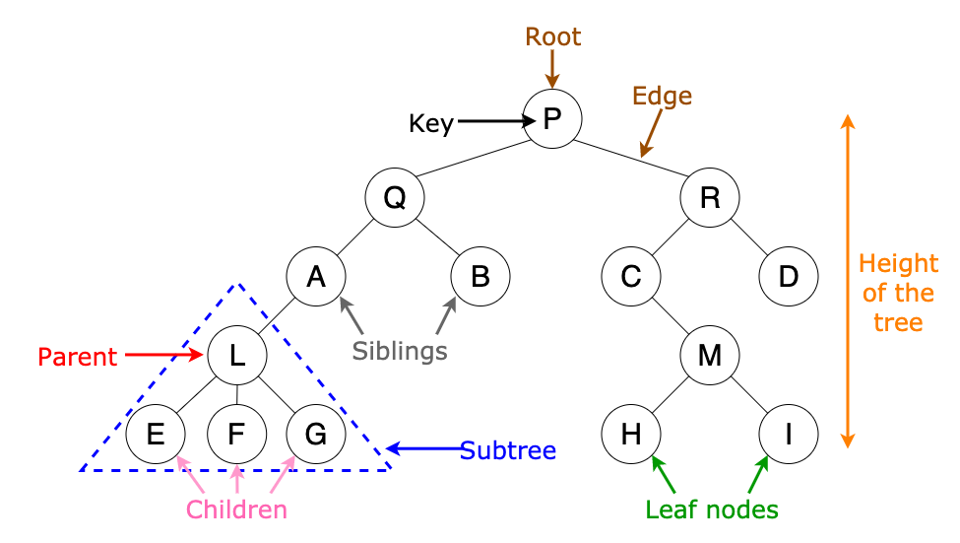

[**Key Properties**](https://k4y0x13.github.io/CSF101-Programming-Methodology/unit3/3.5-tree-ds.html#key-properties)

1. **Hierarchical Structure**: Organizes data in a parent-child relationship.
2. **Root Node**: The topmost node of the tree.
3. **Parent and Child Nodes**: Each node (except the root) has one parent and can have multiple children.
4. **Leaf Nodes**: Nodes with no children.
5. **Subtree**: A tree structure formed by a node and its descendants.
6. **Depth**: The number of edges from the root to a node.
7. **Height**: The number of edges on the longest path from a node to a leaf.

[**Types of Trees**](https://k4y0x13.github.io/CSF101-Programming-Methodology/unit3/3.5-tree-ds.html#types-of-trees)

1. **Binary Tree**: Each node has at most two children.
2. **Binary Search Tree (BST)**: A binary tree with ordered nodes.
3. **AVL Tree**: Self-balancing binary search tree.
4. **Red-Black Tree**: Self-balancing binary search tree with color properties.
5. **N-ary Tree**: Each node can have N children.
6. **Trie**: Used for storing strings, where each node represents a character.

[**Basic Components**](https://k4y0x13.github.io/CSF101-Programming-Methodology/unit3/3.5-tree-ds.html#basic-components)

1. **Node**: Contains data and references to its children.
2. **Root**: The topmost node of the tree.
3. **Edge**: The link between two nodes.

[**Basic Operations**](https://k4y0x13.github.io/CSF101-Programming-Methodology/unit3/3.5-tree-ds.html#basic-operations)

1. **Insertion**: Add a new node to the tree.
2. **Deletion**: Remove a node from the tree.
3. **Traversal**: Visit all nodes of the tree (In-order, Pre-order, Post-order, Level-order).
4. **Search**: Find a node with a specific value.

[**Time Complexity (for balanced binary trees)**](https://k4y0x13.github.io/CSF101-Programming-Methodology/unit3/3.5-tree-ds.html#time-complexity-for-balanced-binary-trees)

* Access: O(log n)
* Search: O(log n)
* Insertion: O(log n)
* Deletion: O(log n)

[**Memory Usage**](https://k4y0x13.github.io/CSF101-Programming-Methodology/unit3/3.5-tree-ds.html#memory-usage)

* Memory = (size of data + size of pointers to children) * (number of nodes)

[**Advantages**](https://k4y0x13.github.io/CSF101-Programming-Methodology/unit3/3.5-tree-ds.html#advantages)

1. Hierarchical data representation
2. Efficient searching and sorting (in balanced trees)
3. Natural representation for recursive structures
4. Basis for many advanced data structures and algorithms

[**Disadvantages**](https://k4y0x13.github.io/CSF101-Programming-Methodology/unit3/3.5-tree-ds.html#disadvantages)

1. Can become unbalanced, leading to poor performance
2. More complex to implement than linear data structures
3. May require more memory due to pointer overhead

[**Common Use Cases**](https://k4y0x13.github.io/CSF101-Programming-Methodology/unit3/3.5-tree-ds.html#common-use-cases)

1. File systems in operating systems
2. HTML DOM (Document Object Model)
3. Abstract Syntax Trees in compilers
4. Decision trees in machine learning
5. Family tree and organizational structures
6. Database indexing (B-trees and B+ trees)

[**Real-World Applications of Tree Data Structures**](https://k4y0x13.github.io/CSF101-Programming-Methodology/unit3/3.5-tree-ds.html#real-world-applications-of-tree-data-structures)

1. File Systems

* **Problem**: Organizing and managing files and directories on a computer.
* **Solution**: Use a tree structure where directories are internal nodes and files are leaf nodes.
* **Benefit**: Efficient navigation, searching, and management of hierarchical file structures.

1. Organization Charts

* **Problem**: Representing company hierarchies and reporting structures.
* **Solution**: Use a tree where each node represents an employee, with edges showing reporting relationships.
* **Benefit**: Clear visualization of organizational structure and relationships.

1. XML/HTML DOM

* **Problem**: Parsing and representing structured documents.
* **Solution**: Use a tree to represent the document structure, with elements as nodes and attributes as properties.
* **Benefit**: Enables efficient parsing, manipulation, and rendering of web documents.

1. Database Indexing

* **Problem**: Fast data retrieval in large databases.
* **Solution**: Use B-trees or B+ trees for creating database indexes.
* **Benefit**: Significantly speeds up search, insertion, and deletion operations in databases.

1. Decision Support Systems

* **Problem**: Making complex decisions based on multiple factors.
* **Solution**: Use decision trees to model various outcomes and their probabilities.
* **Benefit**: Aids in decision-making processes by clearly showing possible outcomes and their likelihoods.

1. Game AI

* **Problem**: Implementing strategic decision-making in games.
* **Solution**: Use game trees (like Minimax trees) to represent possible moves and outcomes.
* **Benefit**: Enables AI to make optimal decisions by evaluating future game states.

1. Compression Algorithms

* **Problem**: Efficient data compression.
* **Solution**: Use Huffman trees for variable-length encoding in data compression algorithms.
* **Benefit**: Achieves optimal prefix-free compression of data.

1. Network Routing

* **Problem**: Finding efficient paths in computer networks.
* **Solution**: Use spanning trees to determine optimal routing paths.
* **Benefit**: Ensures efficient and loop-free packet routing in networks.

1. Compiler Design

* **Problem**: Parsing and analyzing programming language code.
* **Solution**: Use abstract syntax trees (ASTs) to represent the structure of code.
* **Benefit**: Facilitates code analysis, optimization, and translation in compilers.

1. Biological Classification

* **Problem**: Organizing and classifying living organisms.
* **Solution**: Use phylogenetic trees to represent evolutionary relationships.
* **Benefit**: Provides a structured way to understand and study biodiversity and evolution.

1. Machine Learning

* **Problem**: Making predictions based on input features.
* **Solution**: Use decision trees and random forests for classification and regression tasks.
* **Benefit**: Creates interpretable models for prediction and feature importance analysis.

1. Spelling Checkers

* **Problem**: Efficiently storing and searching large vocabularies.
* **Solution**: Use trie data structures to store dictionaries.
* **Benefit**: Enables fast prefix-based searching and suggestions.

1. Expression Evaluation

* **Problem**: Evaluating mathematical or logical expressions.
* **Solution**: Use expression trees to represent and evaluate complex expressions.
* **Benefit**: Allows for efficient parsing, evaluation, and manipulation of expressions.

1. Genealogy

* **Problem**: Representing and analyzing family histories.
* **Solution**: Use family trees to show lineage and relationships.
* **Benefit**: Provides a clear visual representation of familial connections across generations.

Remember: The versatility of tree structures makes them applicable in many more domains. Their hierarchical nature and efficient operations make them a go-to solution for many problems involving hierarchical data or requiring fast search and insertion operations.

[**Variations**](https://k4y0x13.github.io/CSF101-Programming-Methodology/unit3/3.5-tree-ds.html#variations)

1. **Segment Tree**: Used for range query problems
2. **Fenwick Tree (Binary Indexed Tree)**: Efficient for range sum queries
3. **Suffix Tree**: Used in string processing algorithms

[**Memory Techniques for Retention**](https://k4y0x13.github.io/CSF101-Programming-Methodology/unit3/3.5-tree-ds.html#memory-techniques-for-retention)

1. **Visualization**: Imagine a family tree with generations branching out.
2. **Analogy**: Compare to a real tree with trunk (root), branches (internal nodes), and leaves.
3. **Acronym**: BRANCH (Branching Representation of Abstract Nodes in a Connected Hierarchy)
4. **Mnemonic**: "Rooted in data, branching wide, leaves at the end, information inside"

[**Code Example (Python)**](https://k4y0x13.github.io/CSF101-Programming-Methodology/unit3/3.5-tree-ds.html#code-example-python)

class TreeNode:

def __init__(self, data):

self.data = data

self.left = None

self.right = None

class BinaryTree:

def __init__(self):

self.root = None

def insert(self, data):

if not self.root:

self.root = TreeNode(data)

else:

self._insert_recursive(self.root, data)

def _insert_recursive(self, node, data):

if data < node.data:

if node.left is None:

node.left = TreeNode(data)

else:

self._insert_recursive(node.left, data)

else:

if node.right is None:

node.right = TreeNode(data)

else:

self._insert_recursive(node.right, data)

def inorder_traversal(self):

return self._inorder_recursive(self.root)

def _inorder_recursive(self, node):

if node is None:

return []

return (self._inorder_recursive(node.left) +

[node.data] +

self._inorder_recursive(node.right))

# Usage example

tree = BinaryTree()

tree.insert(5)

tree.insert(3)

tree.insert(7)

tree.insert(1)

tree.insert(9)

print(tree.inorder_traversal()) # Output: [1, 3, 5, 7, 9]

[**Binary Search Tree (BST) Data Structure**](https://k4y0x13.github.io/CSF101-Programming-Methodology/unit3/3.5.1-binary-search-tree-ds.html#binary-search-tree-bst-data-structure)

[**Definition**](https://k4y0x13.github.io/CSF101-Programming-Methodology/unit3/3.5.1-binary-search-tree-ds.html#definition)

A Binary Search Tree is a binary tree data structure with the property that for each node, all elements in its left subtree are less than the node, and all elements in its right subtree are greater than the node.

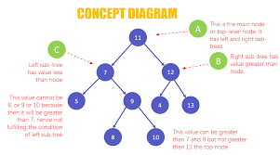

[**Key Properties**](https://k4y0x13.github.io/CSF101-Programming-Methodology/unit3/3.5.1-binary-search-tree-ds.html#key-properties)

1. **Binary Structure**: Each node has at most two children.
2. **Ordering**: Left subtree < Node < Right subtree for all nodes.
3. **Unique Elements**: Typically, all node values are distinct.
4. **Efficiency**: Provides efficient insertion, deletion, and search operations.
5. **In-order Traversal**: Produces sorted output.

[**Basic Components**](https://k4y0x13.github.io/CSF101-Programming-Methodology/unit3/3.5.1-binary-search-tree-ds.html#basic-components)

1. **Node**: Contains data and references to left and right children.
2. **Root**: The topmost node of the tree.
3. **Leaf**: A node with no children.

[**Basic Operations**](https://k4y0x13.github.io/CSF101-Programming-Methodology/unit3/3.5.1-binary-search-tree-ds.html#basic-operations)

1. **Insertion**: Add a new node while maintaining BST properties.
2. **Deletion**: Remove a node while maintaining BST properties.
3. **Search**: Find a node with a specific value.
4. **Traversal**: In-order, Pre-order, Post-order.

[**Time Complexity**](https://k4y0x13.github.io/CSF101-Programming-Methodology/unit3/3.5.1-binary-search-tree-ds.html#time-complexity)

* Average Case (balanced tree):
  + Search: O(log n)
  + Insertion: O(log n)
  + Deletion: O(log n)
* Worst Case (unbalanced tree):
  + Search: O(n)
  + Insertion: O(n)
  + Deletion: O(n)

[**Memory Usage**](https://k4y0x13.github.io/CSF101-Programming-Methodology/unit3/3.5.1-binary-search-tree-ds.html#memory-usage)

* Memory = (size of data + size of two pointers) * (number of nodes)

[**Advantages**](https://k4y0x13.github.io/CSF101-Programming-Methodology/unit3/3.5.1-binary-search-tree-ds.html#advantages)

1. Efficient searching, insertion, and deletion (in balanced trees)
2. Maintains sorted data structure
3. Allows for in-order traversal to get sorted output
4. Flexible size (can grow or shrink dynamically)

[**Disadvantages**](https://k4y0x13.github.io/CSF101-Programming-Methodology/unit3/3.5.1-binary-search-tree-ds.html#disadvantages)

1. Performance degrades if tree becomes unbalanced
2. No constant-time operations (unlike arrays)
3. More complex to implement than simple linear data structures

[**Common Use Cases**](https://k4y0x13.github.io/CSF101-Programming-Methodology/unit3/3.5.1-binary-search-tree-ds.html#common-use-cases)

1. Implementing symbol tables in compilers
2. Database indexing
3. Implementing associative arrays
4. Sorting algorithms (tree sort)
5. Expression evaluation

[**Real-World Applications of Binary Search Trees**](https://k4y0x13.github.io/CSF101-Programming-Methodology/unit3/3.5.1-binary-search-tree-ds.html#real-world-applications-of-binary-search-trees)

Binary Search Trees (BSTs) are versatile data structures that find applications in various domains due to their efficient searching, insertion, and deletion operations. Here are some real-world problems that can be solved or optimized using BSTs:

1. **File System Organization**
   * Problem: Efficiently manage and search through directory structures.
   * BST Solution: Represent the file system hierarchy, allowing for quick file/folder lookups.
2. **Database Indexing**
   * Problem: Speed up database queries on specific fields.
   * BST Solution: Create index structures (often B-trees, a variation of BST) for faster data retrieval.
3. **Autocomplete and Spell Checkers**
   * Problem: Quickly suggest words as users type.
   * BST Solution: Store dictionary words in a BST for efficient prefix-based searching.
4. **IP Routing Tables**
   * Problem: Efficiently route network packets based on IP addresses.
   * BST Solution: Organize routing information for quick lookups during packet forwarding.
5. **Compiler Symbol Tables**
   * Problem: Manage variable and function names during compilation.
   * BST Solution: Store and quickly retrieve symbol information for efficient compilation.
6. **Game Development: Scene Graphs**
   * Problem: Organize and render game objects efficiently.
   * BST Solution: Represent hierarchical relationships between game objects for optimized rendering and collision detection.
7. **Appointment Scheduling Systems**
   * Problem: Manage and query time slots efficiently.
   * BST Solution: Organize appointments by time, allowing for quick insertion, deletion, and overlap checking.
8. **Air Traffic Control Systems**
   * Problem: Track and manage multiple aircraft efficiently.
   * BST Solution: Organize aircraft by altitude or position for quick updates and collision avoidance checks.
9. **Stock Market Trading Systems**
   * Problem: Quickly process and match buy/sell orders.
   * BST Solution: Organize orders by price for efficient matching and execution.
10. **Hierarchical Data Representation**
    * Problem: Represent and query organizational structures or taxonomies.
    * BST Solution: Model hierarchical relationships with efficient searching and updating capabilities.
11. **Morse Code Decoding**
    * Problem: Efficiently translate Morse code to text.
    * BST Solution: Represent Morse code dictionary for quick character lookups.
12. **Implementing Associative Arrays**
    * Problem: Create key-value pair data structures with efficient operations.
    * BST Solution: Use keys to organize data for quick insertion, deletion, and retrieval of values.
13. **Priority Queues in Operating Systems**
    * Problem: Manage process scheduling with different priorities.
    * BST Solution: Organize processes by priority for efficient selection of next process to run.
14. **Geographical Information Systems (GIS)**
    * Problem: Efficiently store and query spatial data.
    * BST Solution: Organize geographical data points for range queries and nearest neighbor searches.
15. **Huffman Coding in Data Compression**
    * Problem: Generate optimal prefix codes for data compression.
    * BST Solution: Construct and traverse Huffman trees for encoding and decoding.

Remember that in many of these applications, variations of BSTs like AVL trees, Red-Black trees, or B-trees might be used to ensure balanced structures and optimal performance in large-scale systems.

[**Variations**](https://k4y0x13.github.io/CSF101-Programming-Methodology/unit3/3.5.1-binary-search-tree-ds.html#variations)

1. **AVL Tree**: Self-balancing BST
2. **Red-Black Tree**: Self-balancing BST with color properties
3. **Splay Tree**: Self-adjusting BST that moves recently accessed elements closer to the root
4. **Treap**: Randomized BST

[**Memory Techniques for Retention**](https://k4y0x13.github.io/CSF101-Programming-Methodology/unit3/3.5.1-binary-search-tree-ds.html#memory-techniques-for-retention)

1. **Visualization**: Imagine a family tree where younger generations are always to the left, older to the right.
2. **Analogy**: Compare to a dictionary, where words to the left come before, and to the right come after the current word.
3. **Acronym**: LESS (Left Elements Smaller Subtree)
4. **Mnemonic**: "Left less, right more, search faster than before"

[**Code Example (Python)**](https://k4y0x13.github.io/CSF101-Programming-Methodology/unit3/3.5.1-binary-search-tree-ds.html#code-example-python)

class Node:

def __init__(self, key):

self.key = key

self.left = None

self.right = None

class BinarySearchTree:

def __init__(self):

self.root = None

def insert(self, key):

self.root = self._insert_recursive(self.root, key)

def _insert_recursive(self, root, key):

if root is None:

return Node(key)

if key < root.key:

root.left = self._insert_recursive(root.left, key)

else:

root.right = self._insert_recursive(root.right, key)

return root

def search(self, key):

return self._search_recursive(self.root, key)

def _search_recursive(self, root, key):

if root is None or root.key == key:

return root

if key < root.key:

return self._search_recursive(root.left, key)

return self._search_recursive(root.right, key)

def inorder_traversal(self):

result = []

self._inorder_recursive(self.root, result)

return result

def _inorder_recursive(self, root, result):

if root:

self._inorder_recursive(root.left, result)

result.append(root.key)

self._inorder_recursive(root.right, result)

def delete(self, key):

self.root = self._delete_recursive(self.root, key)

def _delete_recursive(self, root, key):

if root is None:

return root

if key < root.key:

root.left = self._delete_recursive(root.left, key)

elif key > root.key:

root.right = self._delete_recursive(root.right, key)

else:

if root.left is None:

return root.right

elif root.right is None:

return root.left

temp = self._min_value_node(root.right)

root.key = temp.key

root.right = self._delete_recursive(root.right, temp.key)

return root

def _min_value_node(self, node):

current = node

while current.left is not None:

current = current.left

return current

# Usage example

bst = BinarySearchTree()

bst.insert(50)

bst.insert(30)

bst.insert(70)

bst.insert(20)

bst.insert(40)

bst.insert(60)

bst.insert(80)

print("Inorder traversal:", bst.inorder_traversal())

print("Search 40:", "Found" if bst.search(40) else "Not Found")

bst.delete(40)

print("Inorder traversal after deleting 40:", bst.inorder_traversal())

Remember: Implement and experiment with Binary Search Trees in your preferred programming language to reinforce your understanding!

[**Binary Search Tree (BST) Operations: Insert, Delete, Search**](https://k4y0x13.github.io/CSF101-Programming-Methodology/unit3/3.5.2-bst-operations.html#binary-search-tree-bst-operations-insert-delete-search)

A Binary Search Tree (BST) is a binary tree data structure with the following properties:

* The left subtree of a node contains only nodes with keys less than the node's key.
* The right subtree of a node contains only nodes with keys greater than the node's key.
* Both the left and right subtrees must also be binary search trees.

[**1. Insert Operation**](https://k4y0x13.github.io/CSF101-Programming-Methodology/unit3/3.5.2-bst-operations.html#1-insert-operation)

The insert operation adds a new node with a given key to the BST while maintaining its properties.

[**Algorithm:**](https://k4y0x13.github.io/CSF101-Programming-Methodology/unit3/3.5.2-bst-operations.html#algorithm)

1. If the tree is empty, create a new node and set it as the root.
2. If the tree is not empty, compare the key to be inserted with the root's key:
   * If the key is less than the root's key, recursively insert into the left subtree.
   * If the key is greater than the root's key, recursively insert into the right subtree.
3. If the key already exists, typically no action is taken (assuming duplicate keys are not allowed).

[**Time Complexity: O(h), where h is the height of the tree.**](https://k4y0x13.github.io/CSF101-Programming-Methodology/unit3/3.5.2-bst-operations.html#time-complexity-oh-where-h-is-the-height-of-the-tree)

[**2. Delete Operation**](https://k4y0x13.github.io/CSF101-Programming-Methodology/unit3/3.5.2-bst-operations.html#2-delete-operation)

The delete operation removes a node with a given key from the BST while maintaining its properties.

[**Algorithm:**](https://k4y0x13.github.io/CSF101-Programming-Methodology/unit3/3.5.2-bst-operations.html#algorithm-1)

1. Search for the node to be deleted.
2. If the node is found, there are three cases: a. Node has no children (leaf node):
   * Simply remove the node. b. Node has one child:
   * Replace the node with its child. c. Node has two children:
   * Find the inorder successor (smallest node in the right subtree).
   * Replace the node's key with the inorder successor's key.
   * Delete the inorder successor.

[**Time Complexity: O(h), where h is the height of the tree.**](https://k4y0x13.github.io/CSF101-Programming-Methodology/unit3/3.5.2-bst-operations.html#time-complexity-oh-where-h-is-the-height-of-the-tree-1)

[**3. Search Operation**](https://k4y0x13.github.io/CSF101-Programming-Methodology/unit3/3.5.2-bst-operations.html#3-search-operation)

The search operation finds a node with a given key in the BST.

[**Algorithm:**](https://k4y0x13.github.io/CSF101-Programming-Methodology/unit3/3.5.2-bst-operations.html#algorithm-2)

1. Start at the root.
2. Compare the search key with the current node's key:
   * If they match, return the current node.
   * If the search key is less than the current node's key, recursively search the left subtree.
   * If the search key is greater than the current node's key, recursively search the right subtree.
3. If the end of the tree is reached without finding the key, return null or indicate that the key was not found.

[**Time Complexity: O(h), where h is the height of the tree.**](https://k4y0x13.github.io/CSF101-Programming-Methodology/unit3/3.5.2-bst-operations.html#time-complexity-oh-where-h-is-the-height-of-the-tree-2)

Note: In a balanced BST, the height h is approximately log(n), where n is the number of nodes. However, in the worst case (a skewed tree), h can be n, leading to O(n) time complexity for all operations.

[**Tree Traversals: In-order, Pre-order, Post-order**](https://k4y0x13.github.io/CSF101-Programming-Methodology/unit3/3.5.3-tree-traversals.html#tree-traversals-in-order-pre-order-post-order)

Tree traversal is the process of visiting (checking and/or updating) each node in a tree data structure, exactly once. Unlike linear data structures (Array, Linked List, Queues, Stacks, etc.) which have only one logical way to traverse them, trees can be traversed in different ways.

[**1. In-order Traversal**](https://k4y0x13.github.io/CSF101-Programming-Methodology/unit3/3.5.3-tree-traversals.html#1-in-order-traversal)

In an in-order traversal, we visit the left subtree, then the root, and finally the right subtree.

[**Algorithm:**](https://k4y0x13.github.io/CSF101-Programming-Methodology/unit3/3.5.3-tree-traversals.html#algorithm)

1. Recursively traverse the left subtree.
2. Visit the root.
3. Recursively traverse the right subtree.

[**Pseudocode:**](https://k4y0x13.github.io/CSF101-Programming-Methodology/unit3/3.5.3-tree-traversals.html#pseudocode)

inorder(node)

if node is null, return

inorder(node.left)

visit(node)

inorder(node.right)

[**Use Case:**](https://k4y0x13.github.io/CSF101-Programming-Methodology/unit3/3.5.3-tree-traversals.html#use-case)

In-order traversal is commonly used with Binary Search Trees (BST) as it visits nodes in ascending order.

[**2. Pre-order Traversal**](https://k4y0x13.github.io/CSF101-Programming-Methodology/unit3/3.5.3-tree-traversals.html#2-pre-order-traversal)

In a pre-order traversal, we visit the root first, then the left subtree, and finally the right subtree.

[**Algorithm:**](https://k4y0x13.github.io/CSF101-Programming-Methodology/unit3/3.5.3-tree-traversals.html#algorithm-1)

1. Visit the root.
2. Recursively traverse the left subtree.
3. Recursively traverse the right subtree.

[**Pseudocode:**](https://k4y0x13.github.io/CSF101-Programming-Methodology/unit3/3.5.3-tree-traversals.html#pseudocode-1)

preorder(node)

if node is null, return

visit(node)

preorder(node.left)

preorder(node.right)

[**Use Case:**](https://k4y0x13.github.io/CSF101-Programming-Methodology/unit3/3.5.3-tree-traversals.html#use-case-1)

Pre-order traversal is used to create a copy of the tree or to get prefix expression on an expression tree.

[**3. Post-order Traversal**](https://k4y0x13.github.io/CSF101-Programming-Methodology/unit3/3.5.3-tree-traversals.html#3-post-order-traversal)

In a post-order traversal, we visit the left subtree, then the right subtree, and finally the root.

[**Algorithm:**](https://k4y0x13.github.io/CSF101-Programming-Methodology/unit3/3.5.3-tree-traversals.html#algorithm-2)

1. Recursively traverse the left subtree.
2. Recursively traverse the right subtree.
3. Visit the root.

[**Pseudocode:**](https://k4y0x13.github.io/CSF101-Programming-Methodology/unit3/3.5.3-tree-traversals.html#pseudocode-2)

postorder(node)

if node is null, return

postorder(node.left)

postorder(node.right)

visit(node)

[**Use Case:**](https://k4y0x13.github.io/CSF101-Programming-Methodology/unit3/3.5.3-tree-traversals.html#use-case-2)

Post-order traversal is used when we want to delete the tree or to get the postfix expression of an expression tree.

[**Comparison and Time Complexity**](https://k4y0x13.github.io/CSF101-Programming-Methodology/unit3/3.5.3-tree-traversals.html#comparison-and-time-complexity)

Consider this binary tree:

1

/ \

2 3

/ \

4 5

Traversal results:

* In-order: 4 2 5 1 3
* Pre-order: 1 2 4 5 3
* Post-order: 4 5 2 3 1

Time Complexity: All three traversals have a time complexity of O(n), where n is the number of nodes in the tree, as they visit each node exactly once.

Space Complexity: O(h) for the recursive call stack, where h is the height of the tree. In the worst case of a skewed tree, this could be O(n).

Note: These traversals can also be implemented iteratively using a stack, which can be beneficial in certain scenarios, especially when dealing with very deep trees where recursive approaches might lead to stack overflow.

[**Graph Data Structure**](https://k4y0x13.github.io/CSF101-Programming-Methodology/unit3/3.6-graph-ds.html#graph-data-structure)

[**Definition**](https://k4y0x13.github.io/CSF101-Programming-Methodology/unit3/3.6-graph-ds.html#definition)

A Graph is a non-linear data structure consisting of vertices (or nodes) and edges that connect these vertices. It is used to represent relationships between pairs of objects.

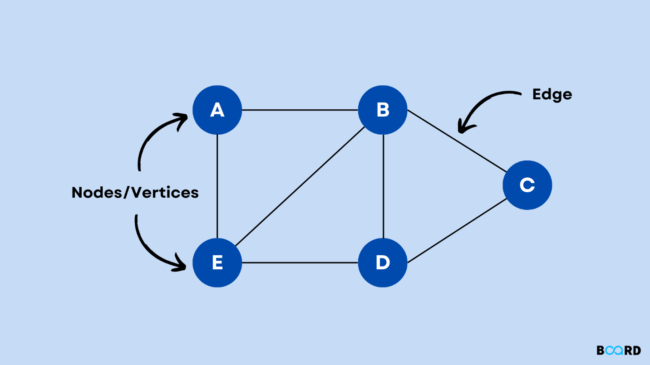

[**Key Properties**](https://k4y0x13.github.io/CSF101-Programming-Methodology/unit3/3.6-graph-ds.html#key-properties)

1. **Vertices**: The fundamental units of the graph.
2. **Edges**: Connections between pairs of vertices.
3. **Direction**: Graphs can be directed (edges have direction) or undirected.
4. **Weight**: Edges can have weights to represent costs, distances, etc.
5. **Connectivity**: A graph can be connected or disconnected.
6. **Cyclicity**: A graph can be cyclic or acyclic.

[**Types of Graphs**](https://k4y0x13.github.io/CSF101-Programming-Methodology/unit3/3.6-graph-ds.html#types-of-graphs)

1. **Undirected Graph**: Edges have no direction.
2. **Directed Graph (Digraph)**: Edges have direction.
3. **Weighted Graph**: Edges have associated weights.
4. **Complete Graph**: Every vertex is connected to every other vertex.
5. **Bipartite Graph**: Vertices can be divided into two disjoint sets.
6. **Tree**: A connected acyclic graph.

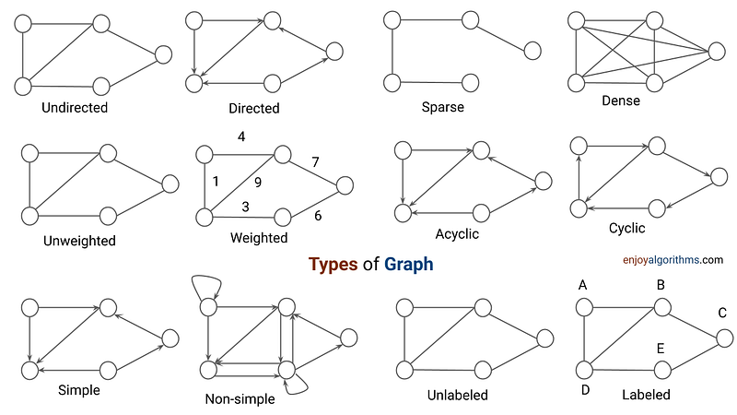

[**Basic Components**](https://k4y0x13.github.io/CSF101-Programming-Methodology/unit3/3.6-graph-ds.html#basic-components)

1. **Vertex**: A node in the graph.
2. **Edge**: A connection between two vertices.
3. **Path**: A sequence of vertices connected by edges.
4. **Cycle**: A path that starts and ends at the same vertex.

[**Basic Operations**](https://k4y0x13.github.io/CSF101-Programming-Methodology/unit3/3.6-graph-ds.html#basic-operations)

1. **Add Vertex**: Insert a new vertex into the graph.
2. **Add Edge**: Add a new edge between two vertices.
3. **Remove Vertex**: Delete a vertex and all its incident edges.
4. **Remove Edge**: Delete an edge between two vertices.
5. **Graph Traversal**: Visit all vertices in a graph (BFS, DFS).
6. **Search**: Find a path between two vertices.

[**Representations**](https://k4y0x13.github.io/CSF101-Programming-Methodology/unit3/3.6-graph-ds.html#representations)

1. **Adjacency Matrix**: 2D array where rows and columns represent vertices.
2. **Adjacency List**: Array of lists, each representing connections of a vertex.
3. **Edge List**: List of all edges in the graph.

[**Time Complexity (for V vertices and E edges)**](https://k4y0x13.github.io/CSF101-Programming-Methodology/unit3/3.6-graph-ds.html#time-complexity-for-v-vertices-and-e-edges)

* Adjacency Matrix:
  + Add Vertex: O(V^2)
  + Add Edge: O(1)
  + Remove Vertex: O(V^2)
  + Remove Edge: O(1)
  + Query: O(1)
  + Storage: O(V^2)
* Adjacency List:
  + Add Vertex: O(1)
  + Add Edge: O(1)
  + Remove Vertex: O(V + E)
  + Remove Edge: O(E)
  + Query: O(V)
  + Storage: O(V + E)

[**Advantages**](https://k4y0x13.github.io/CSF101-Programming-Methodology/unit3/3.6-graph-ds.html#advantages)

1. Model real-world relationships and networks
2. Solve complex problems like shortest path, network flow
3. Flexible structure for representing various types of data
4. Efficient for certain operations depending on representation

[**Disadvantages**](https://k4y0x13.github.io/CSF101-Programming-Methodology/unit3/3.6-graph-ds.html#disadvantages)

1. Can be complex to implement and manage
2. Some operations can be inefficient for large graphs
3. Memory intensive, especially for dense graphs

[**Common Use Cases**](https://k4y0x13.github.io/CSF101-Programming-Methodology/unit3/3.6-graph-ds.html#common-use-cases)

1. Social Networks (Facebook friends, LinkedIn connections)
2. Geographic Maps and Navigation Systems
3. Computer Networks and Communication Systems
4. Recommendation Systems
5. Dependency Resolution in Software Engineering
6. Circuit Design in Electronics

[**Real-World Applications of Graph and Tree Data Structures**](https://k4y0x13.github.io/CSF101-Programming-Methodology/unit3/3.6-graph-ds.html#real-world-applications-of-graph-and-tree-data-structures)

1. Social Networks
   1. Friend recommendations
   2. Influence analysis
   3. Community detection
   4. Shortest path between two users
2. Transportation and Navigation
   1. GPS and route planning
   2. Traffic flow optimization
   3. Airline flight paths
   4. Public transit systems
3. Computer Networks
   1. Internet routing protocols
   2. Network topology analysis
   3. Data packet routing
   4. Network flow optimization
4. Biology and Genetics
   1. Phylogenetic trees (evolutionary relationships)
   2. Protein interaction networks
   3. Gene regulatory networks
   4. Ecological food webs
5. Computer Science and Software Engineering
   1. File system hierarchies
   2. Syntax trees in compilers
   3. Dependency resolution in package managers
   4. State machines and game trees
6. Artificial Intelligence and Machine Learning
   1. Decision trees in machine learning
   2. Knowledge representation
   3. Neural networks
   4. Game-playing algorithms (e.g., chess, Go)
7. Business and Organization
   1. Company hierarchies
   2. Supply chain management
   3. Project management (PERT charts)
   4. Customer relationship mapping
8. Web Technologies
   1. Web crawling and indexing
   2. DOM (Document Object Model) in web browsers
   3. Website sitemaps
   4. Hyperlink structure analysis
9. Telecommunications
   1. Call routing in telephone networks
   2. Network capacity planning
   3. Cellular tower placement

These applications demonstrate the versatility and power of graph and tree data structures in modeling and solving complex real-world problems across various domains. The ability to represent relationships, hierarchies, and networks makes these structures fundamental tools in computer science and beyond.

[**Algorithms**](https://k4y0x13.github.io/CSF101-Programming-Methodology/unit3/3.6-graph-ds.html#algorithms)

1. **Breadth-First Search (BFS)**: Level-wise traversal
2. **Depth-First Search (DFS)**: Explore as far as possible along branches
3. **Dijkstra's Algorithm**: Find shortest paths in weighted graphs
4. **Bellman-Ford Algorithm**: Find shortest paths with negative weights
5. **Floyd-Warshall Algorithm**: All pairs shortest paths
6. **Kruskal's and Prim's Algorithms**: Minimum Spanning Tree
7. **Topological Sorting**: Ordering of vertices in a directed acyclic graph

[**Memory Techniques for Retention**](https://k4y0x13.github.io/CSF101-Programming-Methodology/unit3/3.6-graph-ds.html#memory-techniques-for-retention)

1. **Visualization**: Imagine a social network diagram with people as nodes and friendships as edges.
2. **Analogy**: Compare to a road map where cities are vertices and roads are edges.
3. **Acronym**: VENOM (Vertices and Edges in a Network Object Model)
4. **Mnemonic**: "Vertices vex, edges express, in graphs we connect and progress"

[**Code Example (Python)**](https://k4y0x13.github.io/CSF101-Programming-Methodology/unit3/3.6-graph-ds.html#code-example-python)

from collections import defaultdict

class Graph:

def __init__(self):

self.graph = defaultdict(list)

def add_edge(self, u, v):

self.graph[u].append(v)

def bfs(self, start):

visited = set()

queue = [start]

visited.add(start)

while queue:

vertex = queue.pop(0)

print(vertex, end=" ")

for neighbor in self.graph[vertex]:

if neighbor not in visited:

visited.add(neighbor)

queue.append(neighbor)

def dfs_util(self, v, visited):

visited.add(v)

print(v, end=" ")

for neighbor in self.graph[v]:

if neighbor not in visited:

self.dfs_util(neighbor, visited)

def dfs(self, start):

visited = set()

self.dfs_util(start, visited)

# Usage example

g = Graph()

g.add_edge(0, 1)

g.add_edge(0, 2)

g.add_edge(1, 2)

g.add_edge(2, 0)

g.add_edge(2, 3)

g.add_edge(3, 3)

print("BFS starting from vertex 2:")

g.bfs(2)

print("\nDFS starting from vertex 2:")

g.dfs(2)

[**Hash Table (Hash Map) Data Structure**](https://k4y0x13.github.io/CSF101-Programming-Methodology/unit3/3.7-map-ds.html#hash-table-hash-map-data-structure)

[**Definition**](https://k4y0x13.github.io/CSF101-Programming-Methodology/unit3/3.7-map-ds.html#definition)

A Hash Table is a data structure that implements an associative array abstract data type, a structure that can map keys to values. It uses a hash function to compute an index into an array of buckets or slots, from which the desired value can be found.

[**Key Properties**](https://k4y0x13.github.io/CSF101-Programming-Methodology/unit3/3.7-map-ds.html#key-properties)

1. **Key-Value Pairs**: Stores data as key-value pairs.
2. **Hash Function**: Uses a hash function to map keys to array indices.
3. **Collision Resolution**: Handles situations where different keys hash to the same index.
4. **Dynamic Sizing**: Can resize to maintain efficiency as the number of elements grows.
5. **Load Factor**: Ratio of occupied slots to total slots, affects performance.

[**Basic Components**](https://k4y0x13.github.io/CSF101-Programming-Methodology/unit3/3.7-map-ds.html#basic-components)

1. **Hash Function**: Converts keys into array indices.
2. **Array**: Stores the key-value pairs.
3. **Collision Resolution Method**: Handles multiple keys mapping to the same index.

[**Basic Operations**](https://k4y0x13.github.io/CSF101-Programming-Methodology/unit3/3.7-map-ds.html#basic-operations)

1. **Insert**: Add a new key-value pair.
2. **Delete**: Remove a key-value pair.
3. **Search**: Find the value associated with a given key.
4. **Update**: Modify the value associated with a given key.

[**Time Complexity**](https://k4y0x13.github.io/CSF101-Programming-Methodology/unit3/3.7-map-ds.html#time-complexity)

* Average Case (with a good hash function):
  + Insert: O(1)
  + Delete: O(1)
  + Search: O(1)
* Worst Case (many collisions):
  + All operations: O(n)

[**Space Complexity**](https://k4y0x13.github.io/CSF101-Programming-Methodology/unit3/3.7-map-ds.html#space-complexity)

* O(n), where n is the number of key-value pairs stored

[**Collision Resolution Techniques**](https://k4y0x13.github.io/CSF101-Programming-Methodology/unit3/3.7-map-ds.html#collision-resolution-techniques)

1. **Chaining**: Each array index points to a linked list of entries.
2. **Open Addressing**:
   * Linear Probing: Check next slot sequentially.
   * Quadratic Probing: Check slots at quadratic intervals.
   * Double Hashing: Use a second hash function.

[**Advantages**](https://k4y0x13.github.io/CSF101-Programming-Methodology/unit3/3.7-map-ds.html#advantages)

1. Fast average-case access, insertion, and deletion (O(1))
2. Flexible keys (can use strings, objects, etc. as keys)
3. Efficient for large datasets when properly tuned
4. Implements dictionary/map abstract data type

[**Disadvantages**](https://k4y0x13.github.io/CSF101-Programming-Methodology/unit3/3.7-map-ds.html#disadvantages)

1. Poor worst-case performance
2. May require resizing, which is expensive
3. Not efficient for small datasets
4. No ordering of keys

[**Common Use Cases**](https://k4y0x13.github.io/CSF101-Programming-Methodology/unit3/3.7-map-ds.html#common-use-cases)

1. Database indexing
2. Caches (e.g., web browser cache)
3. Symbol tables in compilers
4. Spell checkers
5. Implementing associative arrays
6. Counting distinct elements

[**Real-World Applications of Hash Maps**](https://k4y0x13.github.io/CSF101-Programming-Methodology/unit3/3.7-map-ds.html#real-world-applications-of-hash-maps)

1. Web Development and Databases

* Caching frequently accessed data to reduce database load
* Session storage in web applications
* URL shorteners
* Implementing database indexes for faster querying

1. Network and Systems

* IP address to domain name mapping (DNS lookups)
* Load balancing in distributed systems
* Implementing routing tables in network routers
* Storing configuration settings for quick access

1. Computer Science and Programming

* Symbol tables in compilers and interpreters
* Implementing sets and dictionaries in programming languages
* Memoization in dynamic programming to store computed results
* Counting sort algorithm implementation

1. Data Processing and Analytics

* Counting word frequencies in large text documents
* Deduplication of data entries
* Implementing sparse matrices
* Histogram creation for data analysis

1. Cybersecurity

* Password hashing and verification
* Bloom filters for malware detection
* Storing and checking against blacklists (e.g., IP addresses, email domains)
* Implementing hash-based message authentication codes (HMAC)

1. Gaming

* Storing game states for quick save/load operations
* Implementing inventory systems in RPGs
* Collision detection in 2D games
* Caching pre-computed game scenarios

1. File Systems and Operating Systems

* File system implementation (mapping file names to inodes)
* Implementing disk cache for faster file access
* Process and thread management in operating systems
* Storing environment variables

1. E-commerce and Finance

* Shopping cart implementation in online stores
* Currency conversion tables
* Implementing stock symbol lookups
* Caching product information for quick display

1. Social Media and Communication

* Storing user profiles for quick access
* Implementing friend lists or follower systems
* Message deduplication in chat applications
* Caching recent posts or tweets

1. Artificial Intelligence and Machine Learning

* Feature hashing in machine learning models
* Implementing associative memories in neural networks
* Storing and retrieving trained model parameters
* Implementing efficient nearest neighbor search algorithms

1. Graphics and Multimedia

* Color mapping in image processing
* Texture caching in 3D rendering engines
* Storing and retrieving media metadata
* Implementing sprite sheets in 2D game development

1. Biotechnology and Bioinformatics

* DNA sequence analysis (k-mer counting)
* Protein structure prediction (storing intermediate results)
* Implementing genome databases for quick lookups
* Drug discovery (molecular fingerprinting)

[**Variations**](https://k4y0x13.github.io/CSF101-Programming-Methodology/unit3/3.7-map-ds.html#variations)

1. **Bloom Filter**: Space-efficient probabilistic data structure
2. **Cuckoo Hashing**: Uses multiple hash functions for better worst-case performance
3. **Perfect Hashing**: Achieves O(1) worst-case lookup time for static sets

[**Memory Techniques for Retention**](https://k4y0x13.github.io/CSF101-Programming-Methodology/unit3/3.7-map-ds.html#memory-techniques-for-retention)

1. **Visualization**: Imagine a library where books (values) are placed on shelves (array slots) based on a code (hash) derived from their titles (keys).
2. **Analogy**: Compare to a valet parking system where car placement is determined by a function of the license plate number.
3. **Acronym**: HASH (Hashed Array Stores Haplessly)
4. **Mnemonic**: "Key to index, value in place, constant time access, at lightning pace"

[**Code Example (Python)**](https://k4y0x13.github.io/CSF101-Programming-Methodology/unit3/3.7-map-ds.html#code-example-python)

class HashTable:

def __init__(self, size=10):

self.size = size

self.table = [[] for _ in range(self.size)]

def _hash(self, key):

return hash(key) % self.size

def insert(self, key, value):

index = self._hash(key)

for item in self.table[index]:

if item[0] == key:

item[1] = value

return

self.table[index].append([key, value])

def get(self, key):

index = self._hash(key)

for item in self.table[index]:

if item[0] == key:

return item[1]

raise KeyError(key)

def remove(self, key):

index = self._hash(key)

for i, item in enumerate(self.table[index]):

if item[0] == key:

del self.table[index][i]

return

raise KeyError(key)

def __str__(self):

return str(self.table)

# Usage example

ht = HashTable()

ht.insert("apple", 5)

ht.insert("banana", 7)

ht.insert("orange", 3)

print(ht.get("banana")) # Output: 7

ht.remove("apple")

print(ht) # Output: [[], [['banana', 7]], [], [], [], [], [], [], [], [['orange', 3]]]